Hymns of the Church (Hymn 355 – All Hail the Power of Jesus’ Name) – 10 February 2015, Anno Domini (In the Year of our Lord)

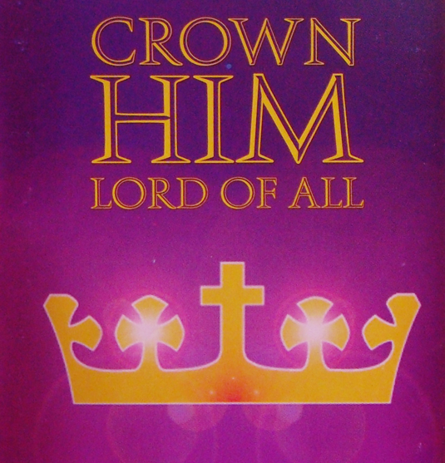

Let this mind be in you, which was also in Christ Jesus: Who, being in the form of God, thought it not robbery to be equal with God: But made himself of no reputation, and took upon him the form of a servant, and was made in the likeness of men: And being found in fashion as a man, he humbled himself, and became obedient unto death, even the death of the cross. Wherefore God also hath highly exalted him, and given him a name which is above every name: That at the name of Jesus every knee should bow, of things in heaven, and things in earth, and things under the earth; And that every tongue should confess that Jesus Christ is Lord, to the glory of God the Father. (Phil 2:5-11)

Mothers and fathers give their children names, often, in hopes of predetermining a certain quality of character of the namesake. Michael is a common boy’s name which is called after the great Archangel of God called Michael. Mary is a name commonly given girls to hopefully attest to that same virtuous character of Mary, the mother of Jesus. Names are important. It was customary of the father to name the son and, appropriately, God the Father gave Jesus His Name before He was yet conceived in the womb of the Virgin. “And, behold, thou shalt conceive in thy womb, and bring forth a son, and shalt call his name JESUS.” (Luke 1:31) The name is from the Hebrew, Jehoshua – or Joshua, or, in the Greek, Jesus. The meaning of the name is “God’s Salvation!” How appropriate!

The hymn today is often referred to as the ‘National Anthem of the Church,’ and certainly the Church constitutes a New Nation and Kingdom – the Kingdom of Heaven – of which all who are true disciples of Jesus are citizens. Though customary to stand during the singing of all hymns in the church, it is almost impossible to remain seated during the playing of the majestic and heavenly strains of this anthem hymn.

The lyrics were composed by Edward Perronet and first appeared as a published work in 1779. The most popular and rousing tune to which this great hymn is sung is Coronation by Oliver Holden. Alternate tunes are Diadem (Ellor) and Miles Lane (Shrubsole) – Miles is a common corruption for St. Michael’s Church which stood on Miles Lane near London.

There is an interesting story associated with the hymn published by CyberHymnal:

One of the most dramatic instances of [this hymn’s] use was found in the experience of the Rev. E. P. Scott in India. His friends had urged him not to venture near a certain barbarous inland tribe, whom he wished to evangelize. But he went forth with high courage, never wavering in his duty, and trusting in God to protect him. When at last he reached their country among the hills, he came upon a company of these savages. Immediately they surrounded him, pointing their spears at him with threatening scowls. He had nothing in his hand but his violin; and so, closing his eyes, he began to play and sing, “All Hail the Power of Jesus’ Name.” When at last he opened his eyes he expected to be killed instantly. But his life had been spared through the singing of the hymn. Their spears had dropped, and they received him first with curiosity and interest, and then later with eagerness, as he told them the gospel story and won their hearts to the will of Jesus Christ.

All Hail the Power of Jesus' Name
All hail the power of Jesus' name!
Let angels prostrate fall;
bring forth the royal diadem,
to crown him, crown him, crown him Lord of all!

Let highborn seraphs tune the lyre, and as they tune it, fall
Before His face Who tunes their choir, and crown Him Lord of all.
Before His face Who tunes their choir, and crown Him Lord of all.
(not included in Hymnal)

Crown him, ye morning stars of light,
who fixed this floating ball;
now hail the Strength of Israel's might,
and crown him, crown him, crown him Lord of all!

Crown him ye martyrs of your God,
who from his altar call:
extol the stem of Jesse's rod,
and crown him, crown him, crown him Lord of all!

Ye seed of Israel's chosen race,
ye ransomed of the fall,
hail him who saves you by his grace.
and crown him, crown him, crown him Lord of all!

Hail him, ye heirs of David's line,
whom David Lord did call,
the God incarnate, Man divine,
and crown him, crown him, crown him Lord of all!

Sinners, whose love can ne'er forget
the wormwood and the gall,
go spread your trophies at his feet,
and crown him, crown him, crown him Lord of all!

Let every tribe and every tongue
that bound creation's call,
now shout in universal song
the crowned, the crowned, the crowned Lord of all!

“All hail the power of Jesus' name! Let angels prostrate fall; bring forth the royal diadem, to crown him, crown him, crown him Lord of all!” It is true that EVERY knee shall bow at the coming of the Lord Jesus Christ – some in ecstasy, and others in horror. The hosts of Heaven worship Him whose Name is Salvation and whose DIADEM is love and beauty. “In that day shall the LORD of hosts be for a crown of glory, and for a diadem of beauty, unto the residue of his people.” (Isaiah 28:5)

“Let highborn seraphs tune the lyre, and as they tune it, fall Before His face Who tunes their choir, and crown Him Lord of all. Before His face Who tunes their choir, and crown Him Lord of all.” As stated above, this verse does not appear in the 1940 Hymnal but was included in the original work. It is beautiful for meaning and disappointing that it was omitted. The angels and seraphs fall down in unison to worship the Lord of Lords, and King of Kings. He it is that places the song in the hearts of choirs - both angelic and mortal.

“Crown him, ye morning stars of light, who fixed this floating ball; now hail the Strength of Israel's might, and crown him, crown him, crown him Lord of all!” At the moment of their creation, the morning stars (angels of antiquity) sang together – there heavenly voices reverberating from one quarter of heaven to the other – as they beheld the beauty at the early dawn of God’s Creation. “When the morning stars sang together, and all the sons of God shouted for joy?” (Job 38:7)

“Crown him ye martyrs of your God, who from his altar call: extol the stem of Jesse's rod, and crown him, crown him, crown him Lord of all!” The martyrs of God, many of whom were martyred by the false church of Revelations 17, call from the dust of the earth unto the Lord: “I saw under the altar the souls of them that were slain for the word of God, and for the testimony which they held: And they cried with a loud voice, saying, How long, O Lord, holy and true, dost thou not judge and avenge our blood on them that dwell on the earth?” (Rev 6:9-10)

“Ye seed of Israel's chosen race, ye ransomed of the fall, hail him who saves you by his grace. and crown him, crown him, crown him Lord of all!” Are you the seed of Israel’s chosen race? If you belong to Christ, you certainly are! “For the promise, that he should be the heir of the world, was not to Abraham, or to his seed, through the law, but through the righteousness of faith. For if they which are of the law be heirs, faith is made void, and the promise made of none effect: Because the law worketh wrath: for where no law is, there is no transgression. Therefore it is of faith, that it might be by grace; to the end the promise might be sure to all the seed; not to that only which is of the law, but to that also which is of the faith of Abraham; who is the father of us all.” (Romans 4:13-16) We were all fallen in our federal head who was Adam, but we are all made alive to salvation by grace in the Lord Jesus Christ.

“Hail him, ye heirs of David's line, whom David Lord did call, the God incarnate, Man divine, and crown him, crown him, crown him Lord of all!” Being heirs of the promise given unto father Abraham, and consummated through the sacrifice of our Lord Jesus Christ, we also shall fall heir to the royal line of David in Christ. David, too, knew Him and looked toward the Morning Star of the distant horizon for his own salvation. “As for me, I will behold thy face in righteousness: I shall be satisfied, when I awake, with thy likeness.” (Psalms 17:15)

“Sinners, whose love can ne'er forget the wormwood and the gall, go spread your trophies at his feet, and crown him, crown him, crown him Lord of all!” SINNERS! Thank God, He included you and me for “While we were yet dead in trespasses and sin, Christ died for us.” Remember how He suffered for us without a single word of regret; how He suffered the lashes of the whip; the lacerating spurs of the crown of thorns; the humiliation of being publicly stripped and displayed for all to see on His agonizing cross; how He thirsted for water but refused the wine – all for you!

“Let every tribe and every tongue that bound creation's call, now shout in universal song the crowned, the crowned, the crowned Lord of all!” We may not care for those Christians of other lands of different races and tribes who languish under the hard persecution of cruel oppressors; and, if so, we will not enjoy the company of Heaven which is comprised of such – first and foremost! “And I saw another angel fly in the midst of heaven, having the everlasting gospel to preach unto them that dwell on the earth, and to every nation, and kindred, and tongue, and people, Saying with a loud voice, Fear God, and give glory to him; for the hour of his judgment is come: and worship him that made heaven, and earth, and the sea, and the fountains of waters.” (Rev 14:6-7) Will your soul be present among that gathering?

This is truly a glorious hymn of the Church. Let us all stand, not only on our feet, but in our hearts, when the strains of this majestic anthem are sounded.

