Hymn 355 – Beneath the Cross of Jesus – 6 September 2016, Anno Domini (In the Year of our Lord)

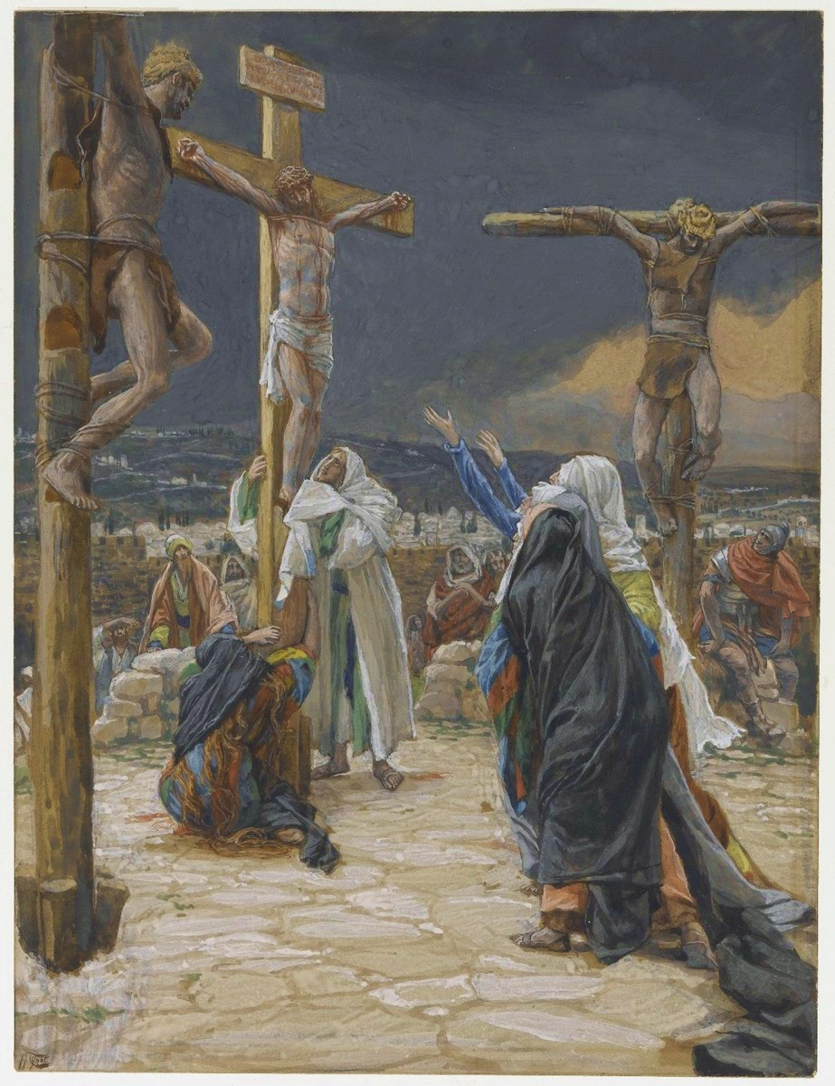

25 Now there stood by the cross of Jesus his mother, and his mother's sister, Mary the wife of Cleophas, and Mary Magdalene. 26 When Jesus therefore saw his mother, and the disciple standing by, whom he loved, he saith unto his mother, Woman, behold thy son! 27 Then saith he to the disciple, Behold thy mother! And from that hour that disciple took her unto his own home. (John 19:2527)

This is a touching hymn filled with sweet expressions and comforting illustrations of love and courage. The hymn lyrics were written by Elizabeth C. Clephane of Edinburg in 1868 – one of only two hymns that Clephane ever wrote. The other hymn was The Ninety and Nine. The most popular tune is composed by Frederick C. Maker. Elizabeth was a quiet and reserved young lady who graduated at the head of her class in school. She loved poetry and to help the less fortunate. The hymn was not published until after her death. A great minister and devotional writer of the period, and a favorite of mine, William Arnot, wrote of this hymn: These lines express the experiences, the hopes and the longings of a young Christian lately released. Written on the very edge of life, with the better land fully in view of faith, they seem to us footsteps printed on the sands of time, where these sands touch the ocean of Eternity. These footprints of one whom the Good Shepherd led through the wilderness into rest, may, with God’s blessing, contribute to comfort and direct succeeding pilgrims.

Beneath the Cross of Jesus

Beneath the cross of Jesus I fain would take my stand,
The shadow of a mighty rock within a weary land;
A home within the wilderness, a rest upon the way,
From the burning of the noontide heat, and the burden of the day.

O safe and happy shelter, O refuge tried and sweet,

O trysting place where Heaven’s love and Heaven’s justice meet!
As to the holy patriarch that wondrous dream was given,
So seems my Savior’s cross to me, a ladder up to heaven.

There lies beneath its shadow but on the further side

The darkness of an awful grave that gapes both deep and wide
And there between us stands the cross two arms outstretched to save
A watchman set to guard the way from that eternal grave.

Upon that cross of Jesus mine eye at times can see
The very dying form of One Who suffered there for me;
And from my stricken heart with tears two wonders I confess;
The wonders of redeeming love and my unworthiness.

I take, O cross, thy shadow for my abiding place;
I ask no other sunshine than the sunshine of His face;
Content to let the world go by to know no gain or loss,
My sinful self my only shame, my glory all the cross.

Beneath the cross of Jesus I fain would take my stand, The shadow of a mighty rock within a weary land; A home within the wilderness, a rest upon the way, From the burning of the noontide heat, and the burden of the day. What brings the believer to the foot of the cross? Is it fear? No, it was fear that kept most of the disciples AWAY from the Cross at Calvary on the day of the passion of Jesus. I aver that fear is not nearly so compulsive as LOVE. In fact, LOVE survives death and is a power beyond mortal measurement. (see Romans 8:3739) Little did the world know that sorrowful day of the crucifixion that the only safe place in all of the world was beneath that Cross with the disciple John, and the courageous women who were there. It was unabated love that drew them there. Love gives us manly courage. Truly, the Jerusalem of that day was a weary land devoid of joy or true faith. The Jewish Temple was only a few hundred yards away, yet, the true Temple of God was on that Cross of Calvary. Jesus did endure the noonday heat, but far more than that in His suffering, shame, and the wrath that all of the sins of the world engendered. His burden was unbearable in human terms.

O safe and happy shelter, O refuge tried and sweet, O trysting place where Heaven’s love and Heaven’s justice meet! As to the holy patriarch that wondrous dream was given, So seems my Savior’s cross to me, a ladder up to heaven. What a quiet and secure rest we enjoy beneath the Cross. It was a free purchase for us yet it cost God the Father His most beloved possession. The Cross proved the full measure of God’s love for us. Not only was the Father willing to pay that sacrifice, but the Son as well was full able and willing to make it. God is Love, but God is also Just. He can condone no sinner in His Heaven; and we are all sinners saved by grace. So the Cross was the meeting place whereby Justice and Mercy converge. Christ paid the wages of sin for us. Mercy and truth are met together; righteousness and peace have kissed each other. (Psalm 85:10) As Jacob dreamed of that Ladder up to Heaven, his dream was of the Savior and that Cross. The vertical beam joins the believer to Christ; and the horizontal beam joins the believers to one another in LOVE.

There lies beneath its shadow but on the further side The darkness of an awful grave that gapes both deep and wide And there between us stands the cross two arms outstretched to save A watchman set to guard the way from that eternal grave. The near side of the cross is mortality and death. The shadow of death is beyond its threatening beams. And yet, that shadow is merely perceived and not real. That grave of Jesus was not such an awful grave for it was only a grave borrowed for three days! Of course, it was DEEP. Its depth reached to the very gates of Hell. Of course, it was WIDE for its width was sufficient to include all who die to self and live for Christ. The cross of the unbeliever is very deep and has no exit. But the elect believer has a borrowed and open tomb from which he shall rise, as did his Lord, to heights unknown. The WAY from that eternal grave is the same Lord Jesus Christ in whom you trust.

Upon that cross of Jesus mine eye at times can see The very dying form of One Who suffered there for me; And from my stricken heart with tears two wonders I confess; The wonders of redeeming love and my unworthiness. In moments of our deep remorse for sin, we behold the grim visage of the cross standing erect in a darkened shadow; but beyond, the sunny banks of Jordan Waters glistering in the brightness of His love and forgiveness. The only heart that our Lord counts of worth is a BROKEN HEART, because His Son was Broken, as the Bread of Communion, for us. The only one of worth to God is the one who is able to admit his own UNWORTHINESS.

I take, O cross, thy shadow for my abiding place; I ask no other sunshine than the sunshine of His face; Content to let the world go by to know no gain or loss, My sinful self my only shame, my glory all the cross. Any ground upon which we stand, apart from the Cross, is an eternal grave. We must take up, bear, suffer, and rest in that Cross. Upon His Countenance is LIGHT personified. It matters not the suffocating darkness, His Presence is a LIGHT shining in a dark place. We have also a more sure word of prophecy; whereunto ye do well that ye take heed, as unto a light that shineth in a dark place, until the day dawn, and the day star arise in your hearts. (2 Peter 1:19) The midnight winds of winter may be blowing in our faces, but the Daystar may still arise in our hearts. The world can offer no profit at all to us – only misery and loss. Our great shame is not of circumstances beyond our control, but those of our own making; and, in a sense, those, too, are beyond our control since it is in the blood we inherited from Adam that makes us children of that worldly father. But the Cross in which we glory makes us children of our Heavenly Father. It was a purchase of the Father, and of the Son, that signs, seals, and delivers our freedom and looses our chains of bondage to sin and the devil.

I hope you will join those redeemed of God, along with John, Mary the mother of Jesus, and the others who staked their eternity on the shelter of the cross. 25 Now there stood by the cross of Jesus his mother, and his mother's sister, Mary the wife of Cleophas, and Mary Magdalene. 26 When Jesus therefore saw his mother, and the disciple standing by, whom he loved, he saith unto his mother, Woman, behold thy son! (John 19:2526)

It is my prayer that Jesus, today, sees the readers of this devotion standing valiantly beneath the Cross, and that we are all bound by a boundless love for one another as sons, daughters, mothers, fathers, and children of the Lord our God.

