Hymn 337– When I Survey the Wondrous Cross – 4 October 2016, Anno Domini

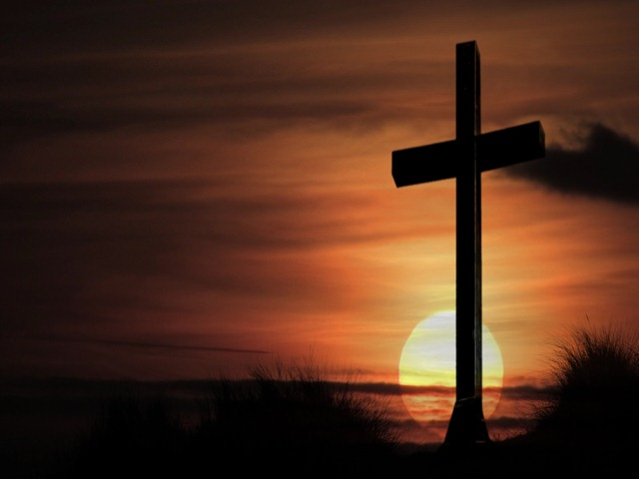

But God forbid that I should glory, save in the cross of our Lord Jesus Christ, by whom the world is crucified unto me, and I unto the world. (Gal 6:14)

The authorship of this most devotional hymn has often been erroneously attributed to Charles Wesley, but the author is actually Isaac Watts. Perhaps the misattribution derives from the fact that Charles Wesley once said that he would give all of the hymns he had written if he only could have written this one hymn. The tune to the hymn is Hamburg by Lowell Mason (1824).

The beauty and sentiments expressed in this hymn make it a fitting Communion hymn.

When I Survey the Wondrous Cross

When I survey the wondrous cross
where the young Prince of Glory died,
my richest gain I count but loss,
and pour contempt on all my pride.

Forbid it, Lord, that I should boast,
save in the cross of Christ, my God:
all the vain things that charm me most,
I sacrifice them to his blood.

See, from his head, his hands, his feet,
sorrow and love flow mingled down!
Did e'er such love and sorrow meet,
or thorns compose so rich a crown?

Were the whole realm of nature mine,
that were an offering far too small;
love so amazing, so divine,
demands my soul, my life, my all.

When I survey the wondrous cross where the young Prince of Glory died, my richest gain I count but loss, and pour contempt on all my pride. Surveying land, battlefields, rivers, mountains – and even the cross – depend upon the perspective from which you conduct the survey. For one thing, the surveyor must start from a known point. In land survey, this is called a landmark. All property lines are measured with reference to that landmark. In spiritual matters, one must begin with the Ancient and Immutable Landmark of the Word of God. All truth is derived therefrom, and nothing needful for our souls and its salvation can be gathered from any other source. The Ancient Landmark is steadfast and immovable. But this fact does not prevent men without scruples, and without faith, from tampering with the Word of God in our day by means of modern Bible corrupt versions. 28 Remove not the ancient landmark, which thy fathers have set. (Prov 22:28) The Cross of Christ is the Crux of all time and Eternity having measured both Eternity Past and Eternity Future in two parts – BC and AD. In fact, the word ‘crux’ derives from the Latin for Cross. Pain of intense nature is also classified in terms derived therefrom ‘ex’ (from) & ‘- cruciating’ (pain) – excruciating ; or the pain as from the cross! The atoning sacrifice Christ made for us would make all of our pelf and pride, good works and losses, pale in comparison.

The disciple who Jesus loved especially remained with the women at the foot of the cross. To these, exposed to the grave dangers of being accounted His friends, the cross loomed large and tall. The closer we approach the cross, the larger it becomes, and the less we appear in size. That is the Survey of the Cross we make.

Forbid it, Lord, that I should boast, save in the cross of Christ, my God: all the vain things that charm me most, I sacrifice them to his blood. This line is based upon the leading text of this devotion from Galatians 6:14. And we see this truth starkly manifested in Ephesians: 8 For by grace are ye saved through faith; and that not of yourselves: it is the gift of God: 9 Not of works, lest any man should boast. 10 For we are his workmanship, created in Christ Jesus unto good works, which God hath before ordained that we should walk in them. (Eh 2:8-10) We cannot boast even of some imagined decision we made to follow Christ. He drew us to Himself, not the other way around. All that we have, all that we do, must be surrendered to Christ.

See, from his head, his hands, his feet, sorrow and love flow mingled down! Did e'er such love and sorrow meet, or thorns compose so rich a crown? The ordeal Christ experienced on the cross was not a pleasant one. He endured suffering of excruciating proportions, shame and humiliation beyond measure, and a spiritual depth of despondency that our mortal frames cannot comprehend. But none of these diminished that overflowing Fountain of Love that gushed, by water and blood, from a broken heart. It is difficult for us to concentrate on the love we have for others in the course of unrivaled sorrow. We often believe our capacity to love is ameliorated by sorrow. But not so with our Lord! He was mocked by the painful crown of thorns He wore, and by His naked form exposed to all to see. His virtuous modesty was deeply offended; yet He never relented to suffer the full cup of miseries placed before Him – FOR US!

Were the whole realm of nature mine, that were an offering far too small; love so amazing, so divine, demands my soul, my life, my all. Isaac Watts, being a great minister of God, knew full well that the first line of this stanza was rhetorical only since it is impossible to realize. We can truly own NOTHING since all belongs to God including every cell of our own bodies. But if we did own all of the mountains, valleys, the sea and all that is in them, and title to every other living creature; that would be a humiliating offering to our Lord for that which He has done for us. It is not the size of the talent we cast into the offering plate that is an offering to God; but rather our own self (free) – wills that we do own in shame which we can offer to Him. Those wills are, too, quite worthless; but we surrender them in return for His will which is priceless beyond measure. There is an old hymn entitled, The Love of God which I have written about in the past. In that hymn, we find a closer statement of the dimensions of that Love of God then in any other human works, yet it cannot approach the fullness of the matter:

The Love of God

Could we with ink the ocean fill,
And were the skies of parchment made,
Were every stalk on earth a quill,
And every man a scribe by trade;
To write the love of God above
Would drain the ocean dry;
Nor could the scroll contain the whole,
Though stretched from sky to sky.

That is a considerable amount of ink, but it does not even begin to seal the measure of the Love of God. If you love Him, it is not a sign of personal virtue of which to boast since He loved you so dearly FIRST!

