Hymn 331 – When Jesus left His Father’s Throne – 13 November 2016, Anno Domini

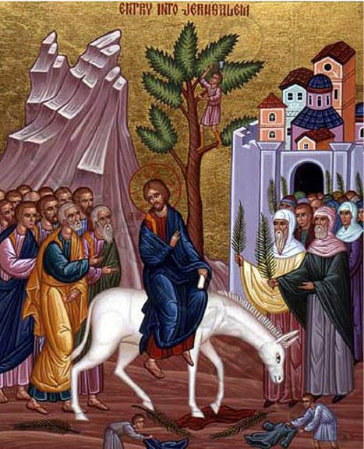

W
ho, being in the form of God, thought it not robbery to be equal with God: 7 But made himself of no reputation, and took upon him the form of a servant, and was made in the likeness of men: 8 And being found in fashion as a man, he humbled himself, and became obedient unto death, even the death of the cross. (Phil 2:6-8)

Here is a graceful and contemplative hymn composed in 1816 by James Montgomery, author of 400 other hymns. This hymn was written for the Hallam Sunday School near Sheffield, England. The music, KINGSFOLD, is a traditional English melody arranged by Ralph Vaughan Williams in 1906.

This hymn is #331 in the 1940 Hymnal of the Protestant Episcopal Church, and # 280 in the Book of Worship for United Sates Forces, 1972.

When Jesus left His Father’s Throne

When Jesus left his Father's throne,
He chose a humble birth;
Like us, unhonored and unknown,
He came to dwell on earth.
Like him may we be found below,
In wisdom's paths of peace;
Like him in grace and knowledge grow,
As years and strength increase.

Sweet were his words and kind his look,
When mothers round him pressed;
Their infants in his arms he took,
And on his bosom blessed.
Safe from the world's alluring harms,
Beneath his watchful eye,
Thus in the circle of his arms
May we for ever lie.

When Jesus into Zion rode,
The children sang around;
For joy they plucked the palms and strowed
Their garments on the ground.
Hosanna our glad voices raise,
Hosanna to our King!
Should we forget our Savior's praise,
The stones themselves would sing.

When Jesus left his Father's throne, He chose a humble birth; Like us, unhonored and unknown, He came to dwell on earth. Like him may we be found below, In wisdom's paths of peace; Like him in grace and knowledge grow, As years and strength increase. It was decreed before the worlds were formed that Christ should come a suffering Savior to redeem God’s people from their sins. If He had appeared in royal regalia and in the company of legions of angels, His coming would have been less exceptional; but for the King of Heaven to come as a humble little child, born in a barn in tiny Bethlehem, makes a profound statement of how we should behold our blessed Redeemer. Prideful religion is no religion at all. If our Lord would deign to come as a common child, leaving the grandeur of His Father’s Home, to save us from our sins, how much less must we be prideful of our heritage in Godly faith and practice. He was born as a poor babe to be placed in a wooden manger designed for the feeding of the beast of the field. In like manner, He died on a comparable wooden cross to provide Manna from Heaven for fallen man. Peace is the way of Heaven, but wickedness must be repulsed. Our Lord grew in stature and wisdom just as His elect must do from the day of first Light in Christ. And Jesus increased in wisdom and stature, and in favour with God and man. (Luke 2:52) We accomplish that growth by feeding daily on His Word.

Sweet were his words and kind his look, When mothers round him pressed; Their infants in his arms he took, And on his bosom blessed. Safe from the world's alluring harms, Beneath his watchful eye, Thus in the circle of his arms May we for ever lie. Regardless the tide of years which have swept over our days before the warming call of the Holy Spirit presses us before the Throne of Grace, we are yet children in the eyes of God. We must be, at first, nourished with the milk of the Gospel; but then, as our spiritual understanding matures into seasoned followers of Christ, we must be fed with the strong meat of every Word that proceedeth from the mouth of God. It is written, Man shall not live by bread alone, but by every word that proceedeth out of the mouth of God. (Matt 4:4) I love the loving manner and gentle embrace with which Jesus received the little children. 2 And Jesus called a little child unto him, and set him in the midst of them, 3 And said, Verily I say unto you, Except ye be converted, and become as little children, ye shall not enter into the kingdom of heaven. 4 Whosoever therefore shall humble himself as this little child, the same is greatest in the kingdom of heaven. 5 And whoso shall receive one such little child in my name receiveth me. 6 But whoso shall offend one of these little ones which believe in me, it were better for him that a millstone were hanged about his neck, and that he were drowned in the depth of the sea. (Matt 18:1-6) Those wicked men and women of our day who so wickedly use little children in all manner of lust and sinfulness will face a dire consequence at His Coming again. But we MUST also become as little children in the House of our Father – trusting, believing, gentle, obedient, and full of hope.

When Jesus into Zion rode, The children sang around; For joy they plucked the palms and strowed Their garments on the ground. Hosanna our glad voices raise, Hosanna to our King! Should we forget our Savior's praise, The stones themselves would sing. What a reception did our Lord receive when entering Jerusalem for the last time before being crucified less than a week following. It was a reception ‘fit for a King’ and indeed, He was King of Kings! The children were especially joyous in their innocence, but the fickle-hearted adults who threw down palm branches shouted, in unison, for His crucifixion five days later. These did forget their praise, but His death offered a remediation to those who heard the Voice of the Holy Spirit calling their dead ears to life in Christ! Yes, if we say nothing of His glory and righteousness, His redemption and Salvation, the very stones would cry out. Stones own no personal qualities, and neither do we apart from Christ. The Gospel of the Lord Jesus Christ bears the same authority whether spoken by a seasoned minister, or else a little child. It is not the distinction of the human voice that gives it power; it is its own authority! There is a mysterious power in the reading of Holy Scripture. One meal of bread and water each week is not sufficient to sustain our physical strength to labor and to move about. So, neither does one hearing of the Word preached from a pulpit once per week suffice to feed our famished souls on the Manna of Heaven. We must daily resort to the reading and study of God’s Word if we will grow strong spiritual bones and muscles.

Have you had your three meals today in God’s Word?

