Devotion on Hymns of the Church - Hymn 32 – All my Heart this Night Rejoices – 1 January 2019, Anno Domini (In the Year of our Lord)

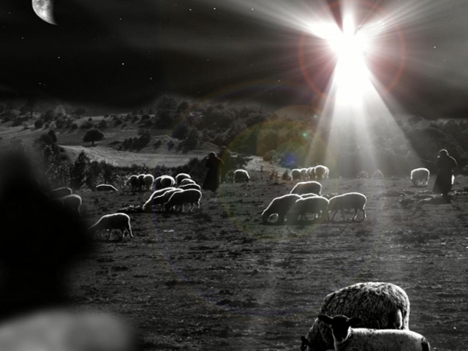

A
nd there were in the same country shepherds abiding in the field, keeping watch over their flock by night. 9 And, lo, the angel of the Lord came upon them, and the glory of the Lord shone round about them: and they were sore afraid. 10 And the angel said unto them, Fear not: for, behold, I bring you good tidings of great joy, which shall be to all people. 11 For unto you is born this day in the city of David a Saviour, which is Christ the Lord. 12 And this shall be a sign unto you; Ye shall find the babe wrapped in swaddling clothes, lying in a manger. 13 And suddenly there was with the angel a multitude of the heavenly host praising God, and saying, 14 Glory to God in the highest, and on earth peace, good will toward men. (Luke 2:8-14)

This is an older Christmas hymn which I have yet to hear sung by a church choir; but its meaning fills us with our own recollection of the moment the Holy Ghost drew us to the Throne of Grace and we learned of Christ as our personal Savior and Redeemer. The hymn is a Lutheran hymn by Paul Gerhardt in 1656. The original tune is EBELING by Johann G. Ebeling in 1666 (which is the tune found in the 1940 Hymnal, and the one most preferred). Alternate tunes are BRIESEN by Johann A. Freylinghausen(1704), and NATIVITY NEW by Frederick C. Maker (1881).

All my Heart this Night Rejoices

All my heart this night rejoices,
As I hear, far and near, sweetest angel voices;
“Christ is born,” their choirs are singing,
Till the air, everywhere, now with joy is ringing.

Hark! a voice from yonder manger,
Soft and sweet, doth entreat, “Flee from woe and danger;
Brethren, come; from all that grieves you
You are freed; all you need I will surely give you.”

Come, then, let us hasten yonder;
Here let all, great and small, kneel in awe and wonder,
Love Him Who with love is yearning;
Hail the star that from far bright with hope is burning.

Thee, dear Lord, with heed I'll cherish,
Live to Thee, Faithfully: Dying, never perish;
But abide in life eternal, Where with thee
I shall be Filled with joy supernal.

All my heart this night rejoices, As I hear, far and near, sweetest angel voices; “Christ is born,” their choirs are singing, Till the air, everywhere, now with joy is ringing. The night was chilly and quiet on that first Christmas night on the hills overlooking Bethlehem much like other nights on the high deserts of the Middle East. The lonely shepherds were less than common men, and were shunned by almost all other classes of people. They were usually a bit dirty from their labors and smelled of sheep. In the eyes of society, these men were of no worth or note; but our thoughts are not God’s thoughts. He chose just such men to whom to send the Heavenly Host to herald the news of our Lord’s birth. I can imagine, in my mind’s eye, those poor men sitting on the grassy slopes discussing the brilliant night sky and the mundane affairs of their family life. Suddenly, the fields were bathed in a strange and brilliant light! They must have been startled for they had never seen such light at that hour. God is Light, and His glory shown upon the fields of the lonely shepherds. A great angel appeared in the heavens overlooking them – they probably fell to the ground in fear. But the approach of an angel of God is never a cause for fear to those who love the Lord. The angel put their fears to rest and informed these poor men of the birth of Christ. It was not King Herod, nor the Jewish rulers in Jerusalem, nor the High Priest or Temple workers to whom the news first came, but to these men of little means or reputation.

Hark! a voice from yonder manger, Soft and sweet, doth entreat, “Flee from woe and danger; Brethren, come; from all that grieves you You are freed; all you need I will surely give you. A great peace and comfort fell upon the shepherds and the fields surrounding. Even the shepherds had heard of the promised Messiah, but not in endless studies of the Temple masters. When God sends us a message, He will make it absolutely certain – no chance of misunderstanding. So, the great angel spoke: “And the angel said unto them, Fear not: for, behold, I bring you good tidings of great joy, which shall be to all people. For unto you is born this day in the city of David a Saviour, which is Christ the Lord. And this shall be a sign unto you; Ye shall find the babe wrapped in swaddling clothes, lying in a manger. And suddenly there was with the angel a multitude of the heavenly host praising God, and saying, 14 Glory to God in the highest, and on earth peace, good will toward men” Notice, the first message God always gives us is to “Fear not!” The shepherds now entertain no worries about their livelihood or other mundane concerns, for something of far greater importance was at hand. No time to go and sale a piece of property, or be with your newlywed wife, or bury a loved one – this was the event of all time and eternity just being revealed. The Messiah (our Lord Jesus Christ) is all we need. No earthly worries or impediments will brook our joy. The heavens were soon filled with the angelic host praising God. Have you heard the Voice calling you to the Manger, friends?

Come, then, let us hasten yonder; Here let all, great and small, kneel in awe and wonder, Love Him Who with love is yearning; Hail the star that from far bright with hope is burning. There is no time to delay at the call of the Lord. Now is the hour! Now is the time for salvation! But we MUST hear the Voice of God that calls us to salvation. The spiritually blind and deaf will not hear. The shepherds did not weigh the wisdom of leaving all and going into Bethlehem. They went immediately without delay just as we must do in the service of our Lord. We do not ask the salary, the benefits, or the size of the church – but go on faith into the field to which the Lord calls. Though we find ourselves among kings, emperors, the wealthy, the poor and indigent – we all alike kneel in the presence of the Lord. We will love the Lord if we have heard the Voice, and that love is an echo of Love from the One who first loved us. That Star is the same Star of Malachi 4:2 – the Sun of Righteousness, and that Day Star spoken of in 2 Peter 1:19 We have also a more sure word of prophecy; whereunto ye do well that ye take heed, as unto a light that shineth in a dark place, until the day dawn, and the day star arise in your hearts: (2 Peter 1:19)

Thee, dear Lord, with heed I'll cherish, Live to Thee, Faithfully: Dying, never perish; But abide in life eternal, Where with thee I shall be Filled with joy supernal. Having been made One in Christ, we are no longer subject to death as He is no longer subject to death, having paid the penalty for our sins on the cross at Calvary. He is our Ark of Salvation in which we abide the floods and storms – the fires of the consuming judgment coming upon the earth. As our Lord asked Martha before the tomb of Lazarus: I am the resurrection, and the life: he that believeth in me, though he were dead, yet shall he live: And whosoever liveth and believeth in me shall never die. Believest thou this? (John 11:25-26) If we die, and have believed on the Lord, we live on in the bliss of the Paradise of God. But note the second part of the above passage by Christ – we must believe while we yet live. There is no salvation in the grave. And whosoever liveth and believeth in me shall never die. Believest thou this? So, just as the shepherds heard and believed the Angelic Voice, and followed on immediately, so must we.

