Hymns of the Church (Hymn 296 – For the Beauty of the Earth) – 2 September 2014, Anno Domini (In the Year of our Lord)

1 O sing unto the LORD a new song: sing unto the LORD, all the earth. 2 Sing unto the LORD, bless his name; shew forth his salvation from day to day. 3 Declare his glory among the heathen, his wonders among all people. 4 For the LORD is great, and greatly to be praised: he is to be feared above all gods. 5 For all the gods of the nations are idols: but the LORD made the heavens. 6 Honour and majesty are before him: strength and beauty are in his sanctuary. 7 Give unto the LORD, O ye kindreds of the people, give unto the LORD glory and strength. 8 Give unto the LORD the glory due unto his name: bring an offering, and come into his courts. 9 O worship the LORD in the beauty of holiness: fear before him, all the earth. (Psalms 96:1-9)

In that day shall the branch of the LORD be beautiful and glorious, and the fruit of the earth shall be excellent and comely for them that are escaped of Israel. (Isaiah 4:2)

What is beauty, and what is the end of every masterpiece of art – whether canvas, stone, or chorus? Is it not to imitate the beauty of God’s Creation? Anything that passes itself off as art which corrupts or vulgarizes the works of the Lord is not art, but profane abuses thereof. Art should lift our souls above the common plane of the worldly. It should inspire and uplift, not degrade and depress. The point of today’s great hymn of praise is to inspire and lift up our souls by asking nothing of the Lord, but only praising His Holy Name.

The lyrics are by Folliot Sandford Pierpoint, 1864, who was, unfortunately, an avid Tractarian of the Oxford Movement. As a result of that high Roman view, the last three verses were excluded in the 1940 Hymnal; however, I have included one of those verses as it has no Roman implication, but reference to the Church of Christ. The hymn’s intended purpose was that of Holy Communion and draws inspiration from the Prayer Book prayer of Invocation: “And earnestly desire thy fatherly goodness, mercifully to accept this our sacrifice of praise and thanksgiving.” The music is by Dix, England's Lane, Lucerna laudoniae, or, St. Hugh.

For the Beauty of the Earth

For the beauty of the earth,
for the beauty of the skies,
for the love which from our birth
over and around us lies,
Refrain:
Christ our God, to thee we raise
this our sacrifice of praise.

For the beauty of each hour
of the day and of the night,
hill and vale, and tree and flower,
sun and moon, and stars of light, Refrain

For the joy of ear and eye,
for the heart and brain's delight,
for the mystic harmony
linking sense to sound and sight, Refrain

For the joy of human love,
brother, sister, parent, child,
friends on earth, and friends above,
for all gentle thoughts and mild, Refrain

For each perfect gift of thine
to our race so freely given,
graces human and divine,
flowers of earth and buds of heaven, Refrain

For thy Bride that evermore
lifteth holy hands above,
offering up on every shore
this pure sacrifice of love, Refrain

“For the beauty of the earth, for the beauty of the skies, for the love which from our birth over and around us lies.” The beauty of the Lord is everywhere and in all His creatures. The fragile butterfly speaks of His gentle art and so does the unkempt main of the African lion. The mountains, rivers, and clouds, also point to that immeasurable beauty that is the Art of God. The tender love of a mother for her newborn baby is truly beautiful, and all love yearnings are imparted to her heart by the God who made her – and her baby.

“For the beauty of each hour, of the day and of the night, hill and vale, and tree and flower, sun and moon, and stars of light.” Each beautiful hour of life is a gift from our Father in Heaven. Each night and its dawning day are given for our rest and labors. All of the heavenly bodies, flung into their orbits, in the primordial gloom of time, by the Hand of God are for our admiration, hope, and beauty. 1 O come, let us sing unto the LORD: let us make a joyful noise to the rock of our salvation. 2 Let us come before his presence with thanksgiving, and make a joyful noise unto him with psalms. 3 For the LORD is a great God, and a great King above all gods. 4 In his hand are the deep places of the earth: the strength of the hills is his also. 5 The sea is his, and he made it: and his hands formed the dry land. 6 O come, let us worship and bow down: let us kneel before the LORD our maker. (Psalms 95:1-6)

“For the joy of ear and eye, for the heart and brain's delight, for the mystic harmony linking sense to sound and sight.” If any man believes there is beauty in a painting by Picasso, he has yet to learn the beauty of God’s Creation, for Picasso and his ilk have profaned the beauty of that which God made and saw that it was “very good.” There are two colors that science has classified as the most restful to the human mind – green and blue. The green earth is a pleasant sight, and so is the overarching blue of canopy of heaven. What of contemporary so-called Christian music. Does it fulfill the bill given in this phrase? “. . . mystic harmony linking sense to sound and sight.”

Is there sense and sound of the beauty of a Bach or a Handel in that mush that passes for inspirational today? When you are grieving the loss of a loved one, or preparing your heart for Communion, does the little kindergarten ditty, God is so Good, do you much benefit? Yet, it is sung endlessly as a mantra in many churches today. What of the songs that the Lord gives you in the night. Do they emerge from the depth of your soul, or are they the flippant variety of our contemporary days? I believe that song of the night that moves your heart in times of darkness to be more of the “Abide with Me” variety. What do you wish to utter when courage fails? Would it be consistent with the words of Job? “Where is God my maker, who giveth songs in the night; 11 Who teacheth us more than the beasts of the earth, and maketh us wiser than the fowls of heaven?” (Job 35:10-11)

“For the joy of human love, brother, sister, parent, child, friends on earth, and friends above, for all gentle thoughts and mild.” I have always thought it an amazing miracle that God is able to instill love in a mother’s heart for a newborn baby that does not yet love her, or even KNOW her. He is a dirty, sniveling, helpless little creature that needs feeding and cleaning 24 hours a day. Yet, mother diligently sees to his needs. This verse speaks of the Church Militant as well as the Church Glorious. God, being the God of Abraham, Isaac, and Jacob, is also the God of those loved ones who have passed into Glory. He is not the God of the dead, but of the living! The very essence of what identities us as the children of God is that unaccountable love we bear for one another in the Lord. It is the evidence of who we are as a Church. “A new commandment I give unto you, That ye love one another; as I have loved you, that ye also love one another. By this shall all men know that ye are my disciples, if ye have love one to another.” (John 13:34-35) I believe those two verses to say more than volumes of the books of men can say.
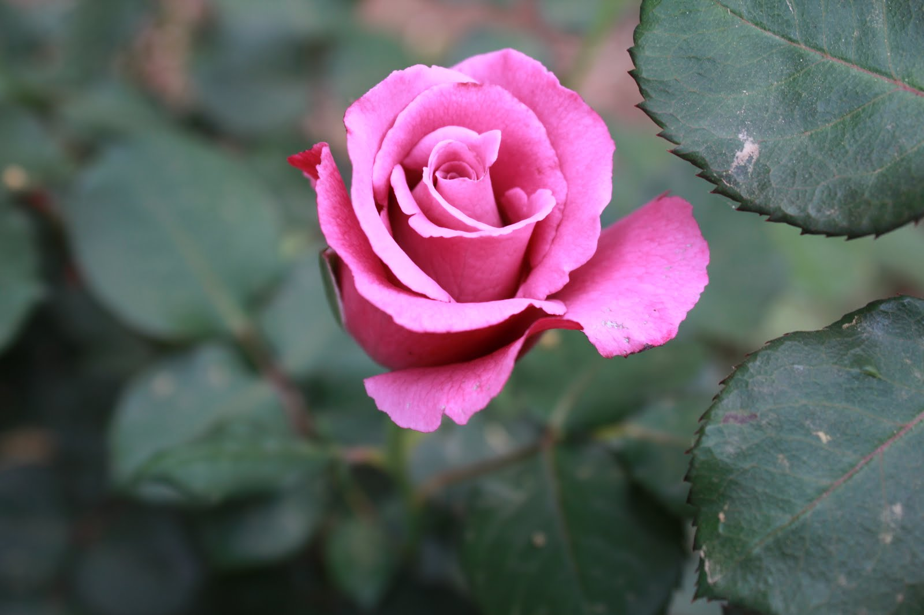

“For each perfect gift of thine, to our race so freely given, graces human and divine, flowers of earth and buds of heaven.” I need not remind any reader that there are no divisions by race in Heaven. This refers to the Human Race who are in Christ, but also to those who know Him not. We do have human graces of love, beauty, art, kindness, knowledge, and movement; but there will be far greater graces experienced in Heaven. The beautiful Rose of the Garden will appear paltry and undeveloped when we compare it to the beautiful Rose of Sharon in Heaven.

“For thy Bride that evermore, lifteth holy hands above, offering up on every shore, this pure sacrifice of love.” Here is a heavenly and poetic reference to the Church. Does she still, in our day, lift Holy Hands to Heaven? Are her hands yet Holy? Perhaps in the remnant churches, this is yet true. It is likely that the holier hands are lifted on foreign strands rather than from our once holy halls in America. But there are yet some, perhaps thousands and millions, who have yet to bow the knee to Baal in America. God will always preserve His Remnant among the heathen. There is only ONE sacrifice we can offer God – LOVE! And even love is not native to our hearts, but streams as a River of Life, from God’s heart to ours.

REFRAIN: “Christ our God, to thee we raise this our sacrifice of praise.” Certainly, our songs and prayers of praise are a sacrifice, but such praise is germinated in the springs of love in the depths of the heart that knows God.

Do you know Him in this way?

