Hymn 276 – Now Thank We All our God – 25 November 2014, Anno Domini (In the Year of our Lord)

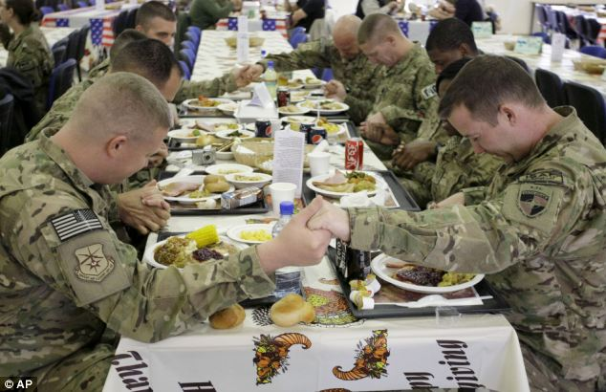

In every thing give thanks: for this is the will of God in Christ Jesus concerning you.
(1 Thessalonians 5:18)

Allow me to head off the gnat-chokers at the start by saying that I am fully aware that this hymn is not listed in the Hymnal as a Thanksgiving Day National Hymn, but my last week’s devotion did cover a selection from that category. The hymn today (found in General Hymns), barely beating out – We Gather Together to Ask the Lord’s Blessing - is certainly an appropriate hymn to be sung on Thanksgiving Day, and I hope all who read this devotion will sing it before the Thanksgiving meal with heart and gusto. It may even serve to replace the prayer of Grace before Meals.

Today’s hymn, like countless others, has a testimony, in real life, of its own. Its lyrics were written by a Lutheran minister, Martin Rinkart (1586-1649) during the ravages of the Thirty Years War. The tune, Nun danket alle Gott, is composed by Johann Crüger in 1646 the harmony of which was adapted by Mendelssohn in Lobgesang, opus 52 (Hymn of Praise).

Now Thank We All Our God

Now thank we all our God,
with heart and hands and voices,
who wondrous things hath done,
in whom his world rejoices;
who from our mother's arms
hath blessed us on our way
with countless gifts of love,
and still is ours today.

O may this bounteous God
through all our life be near us,
with ever-joyful hearts
and blessèd peace to cheer us;
and keep us in his grace,
and guide us when perplexed,
and free us from all ills
in this world and the next.

All praise and thanks to God
the Father now be given,
the Son, and Holy Ghost,
supreme in highest heaven,
the one eternal God,
whom earth and heaven adore;
for thus it was, is now,
and shall be evermore.

The Rev. Martin Rinkart lived in the small village of Eilenberg in Saxony and was the son of a coppersmith. He felt called to the ministry and began his ministry following theological training in the same village. His ministry began just as the Thirty Years War was commencing – a tragic and troublesome time for all who lived through the ordeal. As the Swedish army encompassed the walled city of Eilenberg, floods of refugees from the surrounding areas filled her gates. Due to depravation and exposure, all sorts of diseases broke out inside the gates of Eilenberg including the dreaded plague. Famine and fear ruled in her streets. Thousands died of either disease or hunger. The pastors of the city were over-taxed in preaching the Gospel, caring for the sick and dying, and conducting funerals for the dead. Slowly, the pastors themselves took ill and died until there was only Martin Rinkart left alone with the burden of providing the spiritual needs of the inhabitants. At last, Martin Rinkart went forth boldly from the safety of the city walls to negotiate a peace with the Swedes. Peace came as a result of his efforts. Rinkart then composed this song knowing that healing comes not without thanksgiving.

The hymn is written in three parts – the first stanza is a thanksgiving; the second is a prayer; and the third is a doxology. In fact, German Christians sing the entire hymn in the same way we, in America, sing the Doxology. Traditionally, in Anglican churches, the 1st stanza is sung by the choir; the 2nd by the congregations: and the 3rd by all voices combined.

The Thanksgiving
“Now thank we all our God, with heart and hands and voices, who wondrous things hath done, in whom his world rejoices; who from our mother's arms, hath blessed us on our way, with countless gifts of love, and still is ours today.” Perhaps we do not always acknowledge or realize the importance of simple thanksgiving. There are 138 scriptural references to ‘thanksgiving’ in Holy Writ. One of those references of great power and meaning is Colossians 3:17 – “And whatsoever ye do in word or deed, do all in the name of the Lord Jesus, giving thanks to God and the Father by him.” (Col 3:17) Read that verse again: “whatsoever ye do in word or deed, do all in the name of the Lord Jesus, giving thanks to God and the Father by him.” That leaves very little unsaid. We give thanks in all things, and there are a very many things that never cross our minds to thank Him for, such as our next breath, or next heartbeat. God has done marvelous and wondrous things – not only in this world – but in our own lives. Not only has He blessed us from our mother’s arms, but also by placing our tiny forms in the arms of a loving mother. He blesses us in times of joy, as well as in times of the stormy blast. His greatest gifts evidence His Fatherly love for us – and He blesses us through every avenue of life – even through the way of the “Valley of the Shadow of Death.”

The Prayer
“O may this bounteous God through all our life be near us, with ever-joyful hearts, and blessèd peace to cheer us; and keep us in his grace, and guide us when perplexed, and free us from all ills in this world and the next.” We pray for the enforcing truth of Emmanuel, “God with us,” in Jesus Christ. He will never forsake or leave us – do we remember that? He is with us always, even until the end of the world. The knowledge of His presence makes our hearts joyful – often the silent joy and warmth we feel at the Communion rail. He relieves our minds of worries and doubts that may assault in times of fear and trouble. It is by His unmerited Grace that we are kept pure and without sin in His eye.

The Doxology
“All praise and thanks to God, the Father now be given, the Son, and Holy Ghost,
supreme in highest heaven, the one eternal God, whom earth and heaven adore; for thus it was, is now, and shall be evermore.” What a wonderful and fitting doxology to our Thanksgiving Praises, and our Prayer! There is none that is due praise of man but God the Father, and God the Son, and God the Holy Ghost – our Triune God! Not only is He supreme on earth and the lower heavens, but the highest heaven above all heavens. He is the Eternal God that has ever been, and ever shall be. All creatures on earth and in heaven adore Him. Those who do not adore Him are destined for Outer Darkness. He is the same YESTERDAY, TODAY, and FOREVER! He is the GREAT I AM which has ever been beyond the scope of our space-time continuum which He created for the lives of men and beasts.

May this be a glorious Thanksgiving for you, your families, the Church everywhere, and our nation – and may it continue day in, and day out, until the Lord appears at last. AMEN.

