Hymn 273 – Holy God, We Praise Thy Name – 2 October 2018, Anno Domini (In the Year of our Lord)

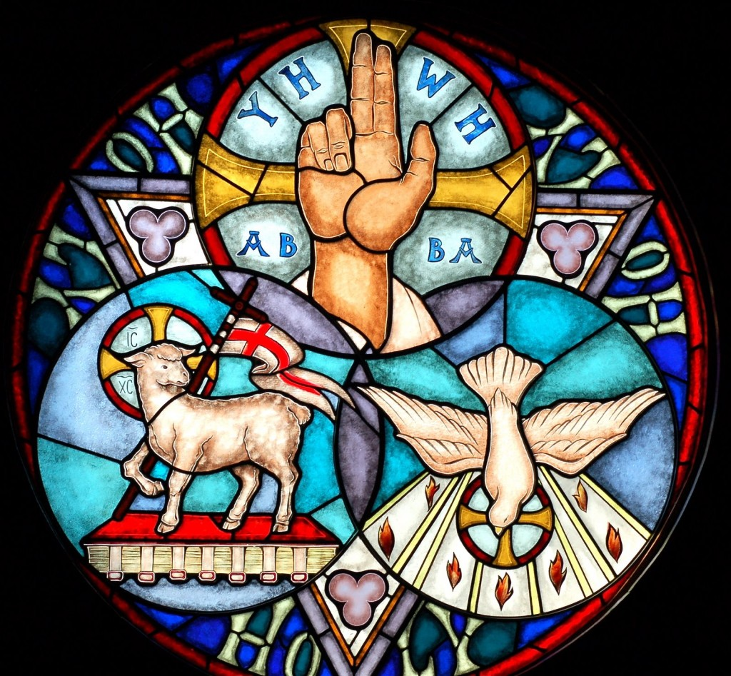

This richly spiritual hymn is most often used as a recessional hymn. The 1940 Hymnal makes significant changes in the original text which, to me, is disappointing. The original seems far more powerful than the version in the Hymnal. Moreover, the original was comprised of eight stanza’s while the Hymnal has reduced that number to three. I have included the concluding stanza of the original. The hymn is one of Triune nature and significance.

The author of the lyrics was the German priest, Franz Ignaz, wrote the original German lyrics in 1771 as a paraphrase of the Te Deum, a hymn of the Book of Common Prayer descended from the Church of the 4th century. The tune is, Vienna, of 1774. There was a bit of controversy that had no part with the spiritual meaning of the author’s original lyrics that sprang up in 1939 when the Evangelical Church added a verse to their military service book for American soldiers praising the Führer Adolf Hitler. This had no relevance to the original author’s intentions.

This hymn, as originally written, is a beautiful and biblical expression of praise for the Holy God.

Holy God, We Praise Thy Name

Holy God, we praise Thy Name;
Lord of all, we bow before Thee!
All on earth Thy scepter claim,
All in Heaven above adore Thee;
Infinite Thy vast domain,
Everlasting is Thy reign.

Hark! the loud celestial hymn
Angel choirs above are raising,
Cherubim and seraphim,
In unceasing chorus praising;
Fill the heavens with sweet accord:
Holy, holy, holy, Lord.

Holy Father, Holy Son,
Holy Spirit, Three we name Thee;
While in essence only One,
Undivided God we claim Thee;
And adoring bend the knee,
While we own the mystery.

Spare Thy people, Lord, we pray,
By a thousand snares surrounded:
Keep us without sin today,
Never let us be confounded.
Lo, I put my trust in Thee;
Never, Lord, abandon me.

Holy God, we praise Thy Name; Lord of all, we bow before Thee! All on earth Thy scepter claim, All in Heaven above adore Thee; Infinite Thy vast domain, Everlasting is Thy reign. From the first utterance of this hymn, let us agree in acknowledging that God is, above all else, HOLY! We bow before no man, but we do, indeed, bow before God. He rules in the affairs of men and nations and bears mystical sovereignty over all kingdoms and empires of the world. Since we are made in the image of God, we must, too, be holy if we will abide in His will and in His Kingdom: But as he which hath called you is holy, so be ye holy in all manner of conversation; Because it is written, Be ye holy; for I am holy. (1 Peter 1:15-16)

Hark! the loud celestial hymn Angel choirs above are raising, Cherubim and seraphim, In unceasing chorus praising; Fill the heavens with sweet accord, Holy, holy, holy, Lord. One day, each faithful reader of this devotion will witness a concert that excels all earthly concerts combined – the angelic host in chorus. It is that same chorus to which Job makes reference – that Creation morning whose joy overwhelmed the heavenly hosts: When the morning stars sang together, and all the sons of God shouted for joy? (Job 38:7) Please observe the oft repeated refrain in Scripture of Holy, Holy, Holy. It would not be possible to praise God with less than that meaning. In the Holy Communion Service of the Book of Common Prayer, both priest and laity respond in unison to these words following the Proper Preface, or if there be none, these words alone:

T
HEREFORE with Angels and Archangels, and with all the company of heaven, we laud and magnify thy glorious Name; evermore praising thee, and saying, HOLY, HOLY, HOLY, Lord God of hosts, Heaven and earth are full of thy glory: Glory be to thee, O Lord Most High. Amen.

This characterizes our Prayer Book worship of reverence and honor to God in our services and not to man. Holy, holy, holy, is the LORD of hosts: the whole earth is full of his glory. (Isaiah 6:3) Why the three repetitions of the word HOLY? Because of the nature of the Triune God – God the Father, God the Son, and God the Holy Ghost. Three represents perfection, and God is perfect in His Three-in-One Being. See how classical hymns reinforce doctrinal truth in the next stanza.

Holy Father, Holy Son, Holy Spirit, Three we name Thee; While in essence only One, Undivided God we claim Thee; And adoring bend the knee, While we own the mystery. It is true that we name those three Persons of the Godhead, but the last Person – the Holy Ghost – is silent in posting His Name before us. Instead, His purpose is to always point to Christ, and in bringing all things to our remembrance written in the Scriptures concerning Him. He will not speak of Himself. Our Lord is the Great I AM that pervades all Scripture and all time and Eternity. Holy, holy, holy, Lord God Almighty, which was, and is, and is to come. (Rev 4:8) This stanza is a full and meaningful definition of the Holy Trinity. The Trinity to many is a mystery, but not to those who know and love the Lord. We love Him; we praise Him; we honor Him; and we ADORE Him. We do, indeed, own the mystery.

Spare Thy people, Lord, we pray, By a thousand snares surrounded: Keep us without sin today, Never let us be confounded. Lo, I put my trust in Thee; Never, Lord, abandon me. This verse begins with a plea of contemporary application to our own time as a nation among the nations of the earth: Spare thy people, Lord. Our churches of today are not only surrounded by a thousand snares, but with sinful men of deceiving hearts within their walls – many of whom occupy the pulpits. Let the priests, the ministers of the LORD, weep between the porch and the altar, and let them say, Spare thy people, O LORD, and give not thine heritage to reproach, that the heathen should rule over them: wherefore should they say among the people, Where is their God? (Joel 2:17) In America, it is obvious that the heathen ALREADY rule over us.

The heathen are justified in asking Where is their God? because we have vanquished Him from every public place in our society. Neither we, nor the heathen, know where is our God. If we do not very soon raise up the banner of Godly LIBERTY and FREEDOM in our Land, God may make Himself very hard to find. He may make a famine of hearing the Word of the Lord as has already begun in our fair land. Behold, the days come, saith the Lord GOD, that I will send a famine in the land, not a famine of bread, nor a thirst for water, but of hearing the words of the LORD: And they shall wander from sea to sea, and from the north even to the east, they shall run to and fro to seek the word of the LORD, and shall not find it. (Amos 8:11-12) The devil is working overtime to extinguish the word from our churches – through politics, through manipulation of the Bible in his corrupt translations, and through indoctrination instead of education in our schools.

You may get sick and tired of me warning about these things in many of my devotions, but we live in a day when such warnings are dire and completely germane to the manner in which our American Republic is collapsing on every hand. We need to shore up the foundations by turning back to God who will lead us, once again, from the Bondage of the Soul into a Liberty of Conscience.

