Hymn 272 – Lord, Your Almighty Word – 28 July 2020, Anno Domini (In the Year of our Lord)

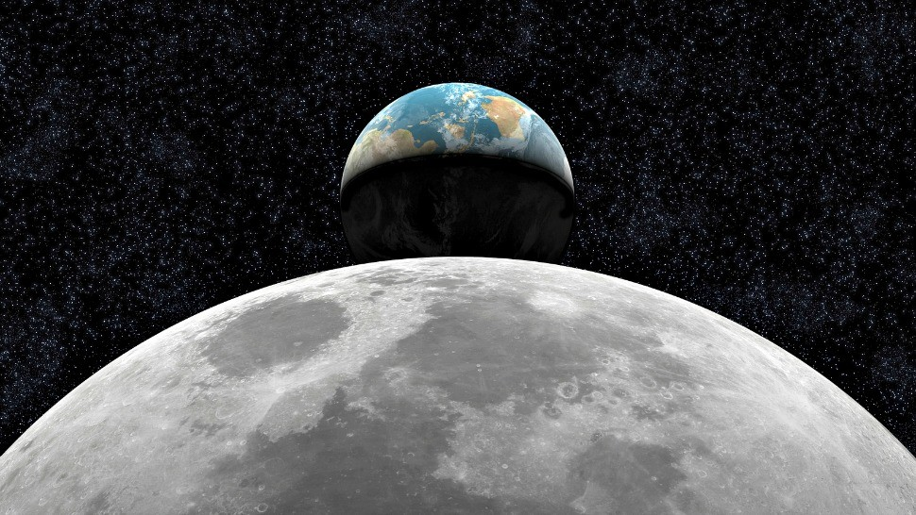

F
OR ever, O LORD, thy word is settled in heaven. (Psalm 119:89)
﻿
F
OR he spake, and it was done; he commanded, and it stood fast. (Psalm 33:9)

H
EAVEN and earth will pass away, but my words will never pass away. (Matthew 24:35)
﻿
A
ND God said, Let there be light: and there was light. (Genesis 1:3)

God’s Word is an immutable Force that requires neither concession on the part of the created, nor acquiescence of any other power of angels or other heavenly beings. This hymn honors and praises that Almighty and Invincible Word in terms reverent and majestic. The lyrics are the work of John Marriott (1780-1825) in 1813 of Cottesbach, England. The tune author is unknown beyond the fact that it is of Italian origin and, therefore, titled, ITALIAN HYMN.

Lord, Your Almighty Word

Lord, your almighty Word
Chaos and darkness heard,
And took their flight;
Hear us, we humbly pray,
And where the gospel day
Sheds not its glorious ray,
Let there be light!

Savior, you came to give
Those who in darkness live
Healing and sight,
Health to the sick in mind,
Sight to the inly blind,
Now to all humankind
Let there be light!

Spirit of truth and love,
Life giving, holy dove,
Speed forth your flight!
Move on the water's face
Bearing the lamp of grace,
And in earth's darkest place
Let there be light!

Holy and blessed three,
Glorious Trinity,
Wisdom, love, might;
Boundless as ocean's tide,
Rolling in fullest pride,
Through the world far and wide,
Let there be light!

1 Lord, your almighty Word Chaos and darkness heard, And took their flight; Hear us, we humbly pray, And where the gospel day Sheds not its glorious ray, Let there be light! Before that which God terms the Beginning, there was nothing that had yet begun. There was only smothering darkness and energy-less ether. Matter and energy came into existence simultaneously along with the space-Time-Matter Continuum. God created TIME just as He created Matter and Energy. But these rudimentary evidences of Creation were in a complete state of disorganization much like a glob of clay ere the potter’s wheel gives it form and beauty. The Darkness to which the author makes reference stood as a powerless lack of any force whatsoever before the Voice that thundered from the heights of Heaven. It shrank as a vapor before the mighty power of Light which God spoke into existence. All that was made came at the precise Word of God. We have that Light of the World today codified in the Holy Scriptures. The Word is our Lord personified in His Word.

2 Savior, you came to give Those who in darkness live Healing and sight, Health to the sick in mind, Sight to the inly blind, Now to all humankind Let there be light! Without Light, there can be no sight. The Light of God’s Word shines brightly before the Way of every believer – “Thy word is a lamp unto my feet, and a light unto my path.” Psalms 119:105 Before the glistening Light of the Gospel entered our hearts, we all walked and sat in darkness. Just as the Prodigal remained in poverty and despondency until the moment he came to his right mind: “﻿And when he came to himself.” (Luke 15:17) I aver none apart from faith in their Lord and Maker are in their right mind. It is a perversion of God’s creative intent to deny one’s Maker. Even those who do not believe share, to a limited extent, in the Light of the Gospel. Civility, social conscience, charity, and benevolent government are all fruits of that Gospel. But that benefit is limited to the carnal existence of the unbeliever, and is a glorious sunbeam of eternal beauty to the faithful.

3 Spirit of truth and love, Life giving, holy dove, Speed forth your flight! Move on the water's face Bearing the lamp of grace, And in earth's darkest place Let there be light! Just as that Holy Spirit moved upon the face of the waters at the beginning (﻿﻿And the Spirit of God moved upon the face of the waters), so do we beseech that Holy Spirit to move upon the face of the waters of our souls, families and nations. Grace is an agent of that Light, and mercy is its right arm. The darkness that prevailed on earth at the beginning was vanquished by the Light of God. In times of great faith, that Beacon Light of Truth and Love as burned brightly and broadly; but today, the Light has been artificially subdued by the wicked imaginations of men so that rape, beheadings and rampant hedonism prevails in many parts of the world.

4 Holy and blessed three, Glorious Trinity, Wisdom, love, might; Boundless as ocean's tide, Rolling in fullest pride, Through the world far and wide, Let there be light! In the beginning was Darkness. God began His Creation in Darkness. He began in darkness, and ended in LIGHT. “ . . . . and the EVENING and the MORNING was the first Day!” The Lord Jesus Christ was the executive agent of Creation morning. “﻿1 In the beginning was the Word, and the Word was with God, and the Word was God. 2 The same was in the beginning with God. 3 All things were made by him; and without him was not any thing made that was made.” We need not wonder which member of the Godhead is represented by the Word. “﻿14 And the Word was made flesh, and dwelt among us, (and we beheld his glory, the glory as of the only begotten of the Father,) full of grace and truth.” (John 1:14) The only member of the Triune Godhead that has become flesh has been the incarnate Jesus Christ. Love is the fuel of true Light. It enables obedience to both Tables of the Law. The only thing that obstructs light from shining is when we allow a physical object or a worldly consideration to come between.

