Hymns of the Church – Hymn 263 – In Christ there is no East or West – 6 November 2018, Anno Domini (In the Year of our Lord)

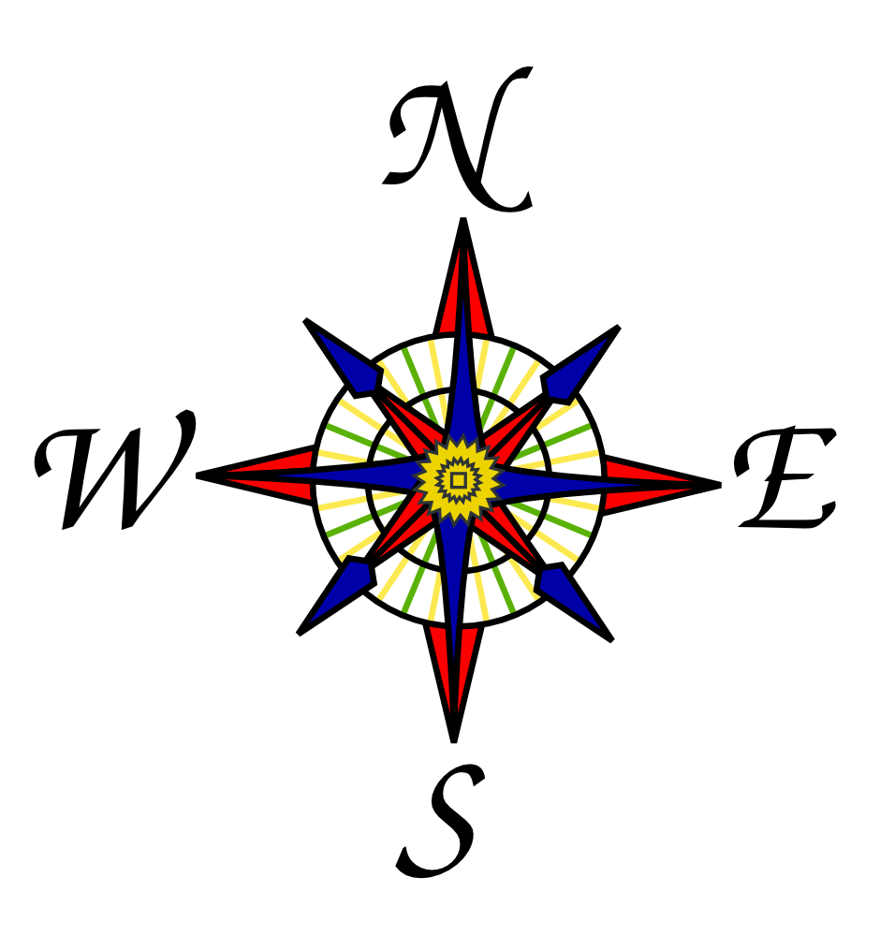

A
nd I say unto you, That many shall come from the east and west, and shall sit down with Abraham, and Isaac, and Jacob, in the kingdom of heaven. 12 But the children of the kingdom shall be cast out into outer darkness: there shall be weeping and gnashing of teeth. (Matt 8:11-12)

This is a missionary hymn composed by William A. Dunkerly in 1908. There are two excellent tunes to which the song may be sung – ST. PETER by Reinagle; and MCKEE by Harry T. Burleigh. Though I prefer St. Peter, it is McKee that is provided in the 1940 Hymnal (#263). The latter is a quaint African tune.
In Christ there is no East or West

In Christ there is no East or West,
In Him no South or North;
But one great fellowship of love
Throughout the whole wide earth.

In Him shall true hearts everywhere
Their high communion find;
His service is the golden cord,
Close binding humankind.

Join hands, then, members of the faith,
Whatever your race may be!
Who serves my Father as His child
Is surely kin to me.

In Christ now meet both East and West,
In Him meet North and South;
All Christly souls are one in Him
Throughout the whole wide earth.

In Christ there is no East or West, In Him no South or North; But one great fellowship of love Throughout the whole wide earth. In his intriguing book, Trinity in the Universe, Dr. Nathan R. Wood points out the many physical evidences of the Trinity revealed in the laws and motion of the Universe. One such comparison is represented in the Three Dimensions of God and Matter. All matter is measured in three dimensions – height, width, and depth. So, there is no measurement of a physical object that is not so identified. If one dimension is missing, there can be not matter – only a LINE or a PLANE. The same is demonstrated in the Trinity. If one of the Godhead is discounted, there is no Godhead. Jesus Christ gives testimony of Himself as the ‘fulness of the Godhead’– that is the union of the Three in Him, and He in Them. One major difference in considering the dimensions of the Godhead is this – His dimensions are infinite in all directions and, therefore, encompasses all time and eternity of the Universe. The Maker of the earth is not dimension-limited by our geographical computations. He is as much present on the Mongolian plains as in the sub-Saharan deserts, and in the icy snows of Iceland as in the tropical waters of Polynesia. His people in all quarters of the world enjoy a spiritual bond and communion that is stronger than the bonds of human blood.

In Him shall true hearts everywhere Their high communion find; His service is the golden cord, Close binding humankind. I shall never forget the harmonious choruses sung in the Islands of the Solomons on our visits there. Isabel Island Christians build their churches in the geographic centers of their villages. The ladies sit on one side of the church, the men on the other, and sing antiphonally in rich, deep voices and angelic tones of lofty, melodious airs during worship. I was reminded of the word of God in the Book of the Psalms of David: The LORD reigneth; let the earth rejoice; let the multitude of isles be glad thereof. (Psalm 97:1) That Golden Cord would best be named the Red Thread of Salvation, for it is the blood of Christ that makes us all blood brothers in Him regardless of tribe, race, or nationality.

Join hands, then, members of the faith, Whatever your race may be! Who serves my Father as His child Is surely kin to me. Can you imagine what Heaven would be like if we hated each other there because of race? That cannot happen since God is no respecter of persons. He is the Great Unifier, and He will separate the chaff from the wheat ere He allows any to live with Him. All in Heaven will be, as they should have been on earth, of One Mind with the Mind of God. If we cannot get along owing to racial differences here on earth, we would not be able in Heaven either; therefore, race will not be a consideration among those admitted there. It is a reasonable truth that those of us who share the same Father will share that same bond as brothers and sisters.

In Christ now meet both East and West, In Him meet North and South; All Christly souls are one in Him Throughout the whole wide earth. The only descriptive terms that can be applied to God our Father is discovered in His promise of a great salvation: 10 He hath not dealt with us after our sins; nor rewarded us according to our iniquities. 11 For as the heaven is high above the earth, so great is his mercy toward them that fear him. 12 As far as the EAST IS FROM THE WEST, so far hath he removed our transgressions from us. 13 Like as a father pitieth his children, so the LORD pitieth them that fear him. 14 For he knoweth our frame; he remembereth that we are dust. (Psalm 103:10-14) Perhaps you are such a master of geographic measurement that you can tell us of how great is that distance of east from west? I cannot! We may forgive our neighbor and family members of past indiscretions, but the moment they slip again, all of the old memories return of those past offences. This is true of mortal man, but not of God. After those days, saith the LORD, I will put my law in their inward parts, and write it in their hearts; and will be their God, and they shall be my people. And they shall teach no more every man his neighbour, and every man his brother, saying, Know the LORD: for they shall all know me, from the least of them unto the greatest of them, saith the LORD: for I will forgive their iniquity, and I WILL REMEMBER THEIR SIN NO MORE. (Jer 31:33-34) God does not say that He will FORGET our sin, because that would be involuntary failure of memory; but God says that He will REMEMBER our sins no more! He deliberately chooses to not remember (volitional).` Furthermore, He will turn again, he will have compassion upon us; he will subdue our iniquities; and thou wilt cast all their sins into the DEPTHS OF THE SEA. (Micah 7:19)

Friends, what is the state of your sins today? Do you still lug them about as your grievous burden, or have you cast your burdens upon the Lord? He knows what to do with them.

