Devotion on Hymns of the Church - Hymn 236 – Once in Royal David’s City – 10 December 2019, Anno Domini (In the Year of our Lord)

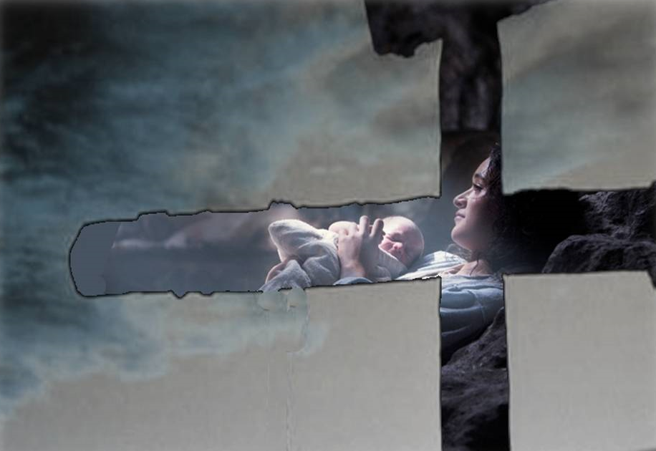

A
ND it came to pass in those days, that there went out a decree from Caesar Augustus, that all the world should be taxed. ² (And this taxing was first made when Cyrenius was governor of Syria.) ³ And all went to be taxed, every one into his own city. ⁴ And Joseph also went up from Galilee, out of the city of Nazareth, into Judaea, unto the city of David, which is called Bethlehem; (because he was of the house and lineage of David ⁵ To be taxed with Mary his espoused wife, being great with child. ⁶ And so it was, that, while they were there, the days were accomplished that she should be delivered. ⁷ And she brought forth her firstborn son, and wrapped him in swaddling clothes, and laid him in a manger; because there was no room for them in the inn. (Luke 2:1-7)

This Christmas Hymn is one of particular warmth and merit for its sharing of biblical truth to children as well as adults. The author, Cecil Francis Alexander, belong to the Church in a day when all hymns were written to spread biblical truth and understanding. She was the wife of William Alexander, a bishop in the Church of Ireland. The hymn was written out of a desire to enlighten the minds of children with profound truths which the modern ditties of that day (and of our own day) omitted. Written in 1848, it was designed to be a commentary on the third article of the Apostles’ Creed. The reverence of the tune (IRBY by Henry J. Gauntlett)), too, comports with that of the lyrics.

Once in Royal David’s City

Once in royal David’s city,
Stood a lowly cattle shed,
Where a mother laid her Baby,
In a manger for His bed:
Mary was that mother mild,
Jesus Christ, her little Child.

He came down to earth from heaven,
Who is God and Lord of all,
And His shelter was a stable,
And His cradle was a stall:
With the poor, and mean, and lowly,
Lived on earth our Saviour holy.

And thro’ all His wondrous childhood
He would honor and obey,
love and watch the lowly maiden
in whose gentle arms he lay:
Christian children all must be
mild, obedient, good as He.

For He is our childhood’s pattern;
Day by day, like us, He grew;
He was little, weak, and helpless,
Tears and smiles, like us He knew;
And He cares when we are sad,
And he shares when we are glad.

And our eyes at last shall see Him,
Through His own redeeming love;
For that Child so dear and gentle,
Is our Lord in heaven above:
And He leads His children on,
To the place where He is gone.

Not in that poor lowly stable,
with the oxen standing by,
we shall see Him, but in heaven,
set at God’s right hand on high;
when like stars his children crowned
all in white shall wait around.

Once in royal David’s city, Stood a lowly cattle shed, Where a mother laid her Baby, In a manger for His bed: Mary was that mother mild, Jesus Christ, her little Child. The event of our Lord’s birth was a once-and-for-all-time event which pierced the scale of eternity at its mid-point betwixt eternity past, and eternity future. There being no room for Him in the inn, or in the hearts of men then and now, He was born in a stable. The most blessed creatures of earth were the lambs and cattle that were witnesses to that event. He was laid in a manger (a trough for feeding beast) though He was the Bread of Heaven for feeding all of faith. The stables, I will remind you, were crowded on that eve due to travelers coming for the tax registration. Mary was a virgin of tender age who traveled a three-days’ journey by donkey just prior to His birth. He was conceived by the Holy Ghost and born of a Virgin.

He came down to earth from heaven, Who is God and Lord of all, And His shelter was a stable, And His cradle was a stall: With the poor, and mean, and lowly, Lived on earth our Saviour holy. Leaving the pristine and opulent environs of His Father’s Throne, our Lord humbled Himself to become like unto one of us so that we may know the Father and be reconciled to Him through the Son’s redemption. Not only did He live a life among the poor, the powerful and the lost, He also was born among the blessed animals of the stall. He became man but not one who could be persuaded to sin in the least.

For He is our childhood’s pattern; Day by day, like us, He grew; He was little, weak, and helpless,Tears and smiles, like us He knew; And He cares when we are sad, And he shares when we are glad. Little children are capable of relating to our Lord far better than those of us stained with years of sin and weakness. “Verily I say unto you, Except ye be converted, and become as little children, ye shall not enter into the kingdom of heaven. Whosoever therefore shall humble himself as this little child, the same is greatest in the kingdom of heaven.” THESE ARE THE WORDS OF THE LORD! He is able to feel our joys and sorrows with a heart of compassion. Children can easily understand how to follow Christ in gentleness.

And our eyes at last shall see Him, Through His own redeeming love; For that Child so dear and gentle, Is our Lord in heaven above: And He leads His children on, To the place where He is gone. Our eyes shall see what our hearts have already known by faith. He leads us in a life of love and sacrifice – along the gentle shores of the Sea of Galilee, to the hill country of Samaria, to the Temple courts, to the Garden at Gethsemane, to the courtyard of the High Priest and Roman Pontiff – and then to Calvary and an open Tomb. That is where, and how, we follow Him. Then we shall ascend on high to be with Him forever as He is with the Father.

Not in that poor lowly stable, with the oxen standing by, we shall see him, but in heaven, set at God’s right hand on high; when like stars his children crowned all in white shall wait around. It matters not in degrees of joy where we see Him, as long as we do see Him. But we shall come face-to-face at our journey’s end with the one whose blood purchased our redemption. We shall wear our Wedding Garments of pure white which He has provided for us by means of the greatest price ever paid in eternity.

When we sing this hymn, and others like it, of that wonderful night 2,000 years ago, let us look in awe to the Heavens who sent down this gift of love and of such immense value to us. Let us remember that cold December night, the lowing cattle and the bleating lambs – and the soothing words of a blessed young girl who was called by God to such a glorious purpose to her precious Baby, and Lord, lying in a manger!

