Hymn 217 – Lord, Who at Cana’s Wedding Feast – 21 January 2020, Anno Domini (In the Year of our Lord)

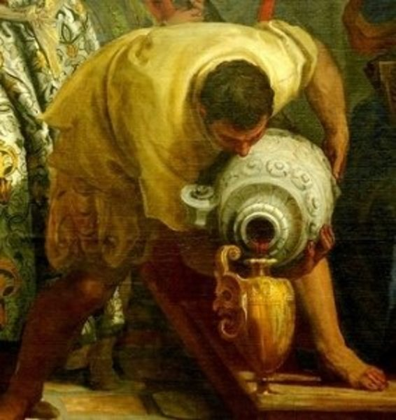

A
ND the third day there was a marriage in Cana of Galilee; and the mother of Jesus was there: ² And both Jesus was called, and his disciples, to the marriage. ³ And when they wanted wine, the mother of Jesus saith unto him, They have no wine. ⁴ Jesus saith unto her, Woman, what have I to do with thee? Mine hour is not yet come. ⁵ His mother saith unto the servants, Whatsoever he saith unto you, do it. ⁶ And there were set there six waterpots of stone, after the manner of the purifying of the Jews, containing two or three firkins apiece. ⁷ Jesus saith unto them, Fill the waterpots with water. And they filled them up to the brim. ⁸ And he saith unto them, Draw out now, and bear unto the governor of the feast. And they bare it. ⁹ When the ruler of the feast had tasted the water that was made wine, and knew not whence it was: (but the servants which drew the water knew;) the governor of the feast called the bridegroom, ¹⁰ And saith unto him, Every man at the beginning doth set forth good wine; and when men have well drunk, then that which is worse: but thou hast kept the good wine untilnow.
¹¹ This beginning of miracles did Jesus in Cana of Galilee, and manifested forth his glory; and his disciples believed on him. (John 2:1-11)

This gentle and simple hymn commemorates one of the most significant miracles of our Lord – in fact, His first of His ministry. It is an Epiphany hymn of an event which the Lord used to bear witness to the sacred estate of Holy Matrimony and its Holy symbolism in the Kingdom of God. Our Lord created only two institutions – the first was that of the marriage of one man and one woman in Eden; the second is the Church as the Bride of Christ to one Man only – the Son of God.

The author of this hymn is Adelaide Thrupp (1831-1908) of Sussex, England in 1853. The tune is by the same artist entitled, CHARLOTTE. Adelaide Thrupp is also the author of that wonderful hymn, ‘Savior, Like a Shepherd Lead us.’ She was twenty years of age at the time of writing today’s hymn.

Lord, Who at Cana’s Feast

Lord, Who at Cana’s wedding feast
Didst as a guest appear,
Thou dearer far than earthly guest,
Vouchsafe Thy presence here;
For holy Thou indeed dost prove
The marriage vow to be,
Proclaiming it a type of love
Between the Church and Thee.

The holiest vow that man can make,
The golden thread in life,
The bond that none may dare to break,
That bindeth man and wife;
Which, blest by Thee, whate’er betides,
No evil shall destroy,
Through care-worn days each care divides,
And doubles every joy.

On those who at Thine altar kneel,
O Lord, Thy blessing pour,
That each may wake the other’s zeal
To love Thee more and more:
Oh, grant them here in peace to live,
In purity and love,
And, this world leaving, to receive
A crown of life above!
Amen.

1 Lord, Who at Cana’s wedding feast Didst as a guest appear, Thou dearer far than earthly guest, Vouchsafe Thy presence here; For holy Thou indeed dost prove The marriage vow to be, Proclaiming it a type of love Between the Church and Thee. As with all proper hymns, this hymn reinforces and reminds us of God’s Word herein revealing the beauty of our Lord’s first miracle at Cana of Galilee. The traditional marriage service, adopted by many churches even outside the Anglican faith, summarizes quite well the deep meaning of the Estate of Holy Matrimony in the opening charge:

D
EARLY beloved, we are gathered together here in the sight of God, and in the face of this company, to join together this Man and this Woman in holy Matrimony; which is an honourable estate, instituted of God, signifying unto us the mystical union that is betwixt Christ and his Church: which holy estate Christ ﻿adorned and beautified with his presence and first miracle that he wrought in Cana of Galilee, and is commended of Saint Paul to be honourable among all men: and therefore is not by any to be entered into unadvisedly or lightly; but reverently, discreetly, advisedly, soberly, and in the fear of God. Into this holy estate these two persons present come now to be joined. If any man can show just cause, why they may not lawfully be joined together, let him now speak, or else hereafter for ever hold his peace.” (1928 Book of Common Prayer)

To emphasize the importance of the direct relationship of the Marriage Institution at Eden, and that between the Lord and His Church, Jesus performed His first miracle at such a setting. Note that in this marriage, our Lord is a guest according to the words of the hymn as well as in the narrative in John 2. Truly, if our Lord is not the honored guest of every marriage, the marriage is not consummated fully. He is the central figure of every Godly marriage, and the Very Bridegroom of that Heavenly Marriage which is between all believers of the Church and the Beloved Son of God. We made a vow at our marriage which is sacred to God for it is in His presence that such a vow is made. We make a vow as well when we confess Christ as Lord and Savior which is not to be abrogated. We must remain faithful in both marriages!

2 The holiest vow that man can make, The golden thread in life, The bond that none may dare to break, That bindeth man and wife; Which, blest by Thee, whate’er betides, No evil shall destroy, Through care-worn days each care divides, And doubles every joy. Marriage between a man and woman must be a lifelong commitment. We do not lightly enter into such an estate, but in all seriousness, we commit our entire lives to the vow made. If we break that vow, we dishonor God and our life’s mate. A loving marriage will become the golden thread that enriches our lives, not only in youth, but in the fading years of life. In marriage joys are shared and MULTIPLIED by two; and in marriage our cares are DIVIDED by two.

3 On those who at Thine altar kneel, O Lord, Thy blessing pour, That each may wake the other’s zeal To love Thee more and more: Oh, grant them here in peace to live, In purity and love, And, this world leaving, to receive A crown of life above! Amen. The home, too, must be an altar – not to sacrifice the once-and-for-all sacrifice already made by our Lord, but of our time, energy, resources, love and sharing with our marriage mate. As a Godly man and woman are drawn ever closer together in enduring love, so will they be made one, more and more, with the Father. Purity and faithfulness to one another should mirror the same to God above. The modern church has committed adultery, perhaps owing to the low regard for the Holy Estate of Matrimony. The Marriage Service of the Book of Common Prayer, ends with the same word as this, and every proper hymn, the AMEN!

Here are the concluding words of the marriage service from the Book of Common Prayer:

F
ORASMUCH as N. and N. have consented together in holy wedlock, and have witnessed the same before God and this company, and thereto have given and pledged their troth, each to the other, and have declared the same by giving and receiving a Ring, and by joining hands; I pronounce that they are Man and Wife, In the Name of the Father, and of the Son, and of the Holy Ghost. Amen. (1928 Book of Common Prayer)

In whose name have you given YOUR marriage vows?

