Devotion on Hymns of the Church - Hymn 213 – Shepherd of Souls, Refresh and Bless – 23 April 2019, Anno Domini (In the Year of our Lord)

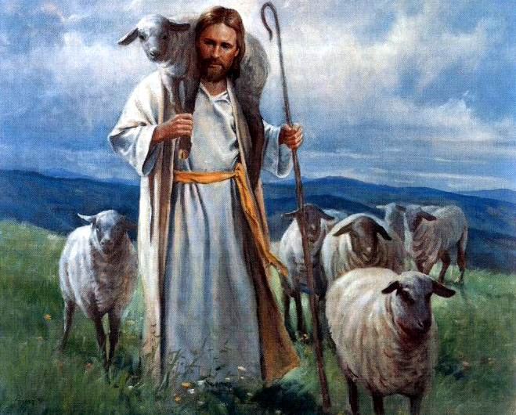

B
EHOLD, the Lord GOD will come with strong hand, and his arm shall rule for him: behold, his reward iswith him, and his work before him. ¹¹ He shall feed his flock like a shepherd: he shall gather the lambs with his arm, and carry themin his bosom, andshall gently lead those that are with young. (Isaiah 40:10-11)

This hymn is most suitable for the Week following Easter proper. The lyrics are by James Montgomery, a Moravian Minister, and first published in 1832. The tune is an old classic, ST. AGNES, and is the composition of John B. Dykes in 1866.

Shepherd of Souls, Refresh and Bless

Shepherd of souls, refresh and bless
your chosen pilgrim flock
with manna in the wilderness,
with water from the rock.

We would not live by bread alone,
but by your word of grace,
in strength of which we travel on
to our abiding place.

Be known to us in breaking bread,
but do not then depart;
Saviour, abide with us, and spread
your table in our heart.

Lord, sup with us in love divine,
your body and your blood,
that living bread, that heavenly wine,
be our immortal food.

Shepherd of souls, refresh and bless, your chosen pilgrim flock, with manna in the wilderness, with water from the rock. The Shepherd of Souls is the sublime title of the Lord Jesus Christ. The flock is comprised of both sheep and goats, and is as unwieldly to manage as a herd of cats. The sheep are short-sighted and not very situationally aware; and the goats are of the opinion that they should make their own decisions which leads, inevitably, to ruin. But the Shepherd knows His sheep and even has given them a name which, when called at the Last Trump shall be responded to even from the grave. The flocks of the Middle East, as I have personally witnessed scores of them, are very much pilgrims. They only travel with their own bodies and no material accoutrements. They seek a green pasture for provender, and clear, still waters for drink. But the sheep have no clue as to where to find these – they must rely upon their Shepherd to lead them to such blessings. Due to the close proximity of a lamb’s nostrils to its mouth, sheep require still waters for drinking. “The LORDismy shepherd; I shall not want. He maketh me to lie down in green pastures: he leadeth me beside the still waters. He restoreth my soul: he leadeth me in the paths of righteousness for his name's sake.” (Psalm 23:1-3)

NOTE: I hope the reader is reminded of how a classical hymn reinforces and reminds of biblical truth!

We would not live by bread alone, but by your word of grace, in strength of which we travel on to our abiding place. No man or woman can travel the path of a pilgrim without bread and water. But the greater Bread for the pilgrim is not that of the earth, but of Heaven, “Then Jesus said unto them, Verily, verily, I say unto you, Moses gave you not that bread from heaven; but my Father giveth you the true bread from heaven. For the bread of God is he which cometh down from heaven, and giveth life unto the world. Then said they unto him, Lord, evermore give us this bread. And Jesus said unto them, I am the bread of life: he that cometh to me shall never hunger; and he that believeth on me shall never thirst.” (John 6:32-35) If we travel for many days without the Bread of Heaven or the Water of Life, we shall famish and perish in the wilderness of sin. Our souls, as well as our bodies, need bread and water. The Bread and Water of the Soul is the Word of God. We do not make a pretended study thereof one day out of seven, but rather every day if we will grow strong spiritual bones and muscles.

Be known to us in breaking bread, but do not then depart; Saviour, abide with us, and spread your table in our heart. The Table of the Lord is spread with emblems of our salvation – the Wine Cup of His redeeming Blood, and the Bread of His Body – the WORD! That Table must take the most sacred position in one’s heart. The men on the Road to Emmaus walked and talked with the Lord until they arrived at their destination. But they did not realize that He was the same Lord whose death they mourned three days earlier. When He sat with them and broke Bread to serve them, their eyes were opened to His Presence. This same experience is felt by those who take the Cup and Bread of the Communion worthily. Our Lord has not promised to visit us, or sojourn with us – no, not at all. He has promised to ABIDE with us! That means to dwell in our hearts forever.

Lord, sup with us in love divine, your body and your blood, that living bread, that heavenly wine, be our immortal food. Immortal food indeed! If we sup with Him in truth and Spirit in this life, we shall sup with Him forever in New Jerusalem. We do not look for the tattered hope of that sordid little village in old Israel which is full of bloodshed and violence, but that Heavenly Jerusalem which shall descend from Heaven as a Bride adorned for her Husband. “Fear not; for thou shalt not be ashamed: neither be thou confounded; for thou shalt not be put to shame: for thou shalt forget the shame of thy youth, and shalt not remember the reproach of thy widowhood any more. For thy Maker isthine husband; the LORDof hosts ishis name; and thy Redeemer (the same Redeemer Husband of the Church) the Holy One of Israel; The God of the whole earth shall he be called.” Isaiah 54:4-5Though we can never hope to gain Heaven by the merits of our works, we do gain the entrance by the imputed righteousness of the Lord Jesus Christ who paid our sin debt on the cross. We will not, at that day, be ashamed. We shall be given a White Stone of innocence upon which is written a new name that no one else will know – so no charge of guilt or shame can be uttered against that new name. “He that hath an ear, let him hear what the Spirit saith unto the churches; To him that overcometh will I give to eat of the hidden manna, and will give him a white stone, and in the stone a new name written, which no man knoweth saving he that receiveth it.” (Revelation 2:17)

We never know the time nor day upon which the Lord shall call our name, and we shall respond. I had a good friend who worshiped and praised God on this past Sunday, but was dead and ready to be buried on Monday evening. We will conduct her funeral on Wednesday; so be ready at all times for the coming of the Lord. Do not be deceived by false prophets proclaiming the time and date of His coming. He may come for you before sundown today, my friend.

