Hymn 212 – Bread of Heaven, On Thee We Feed – 7 February 2017, Anno Domini (In the Year of our Lord)

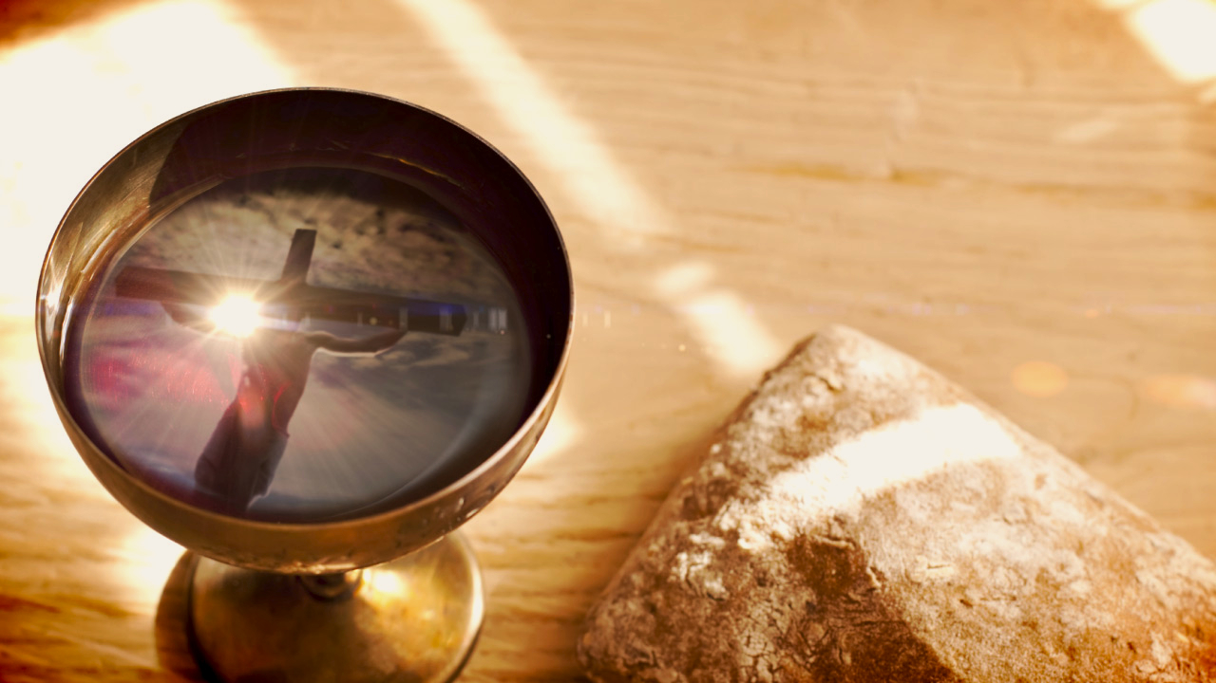

32 Verily, verily, I say unto you, Moses gave you not that bread from heaven; but my Father giveth you the true bread from heaven. 33 For the bread of God is he which cometh down from heaven, and giveth life unto the world. 34 Then said they unto him, Lord, evermore give us this bread. 35 And Jesus said unto them, I am the bread of life: he that cometh to me shall never hunger; and he that believeth on me shall never thirst. 36 But I said unto you, That ye also have seen me, and believe not. 37 All that the Father giveth me shall come to me; and him that cometh to me I will in no wise cast out. 38 For I came down from heaven, not to do mine own will, but the will of him that sent me. 39 And this is the Father's will which hath sent me, that of all which he hath given me I should lose nothing, but should raise it up again at the last day. 40 And this is the will of him that sent me, that every one which seeth the Son, and believeth on him, may have everlasting life: and I will raise him up at the last day. 41 The Jews then murmured at him, because he said, I am the bread which came down from heaven. (John 6:32-41)

This is one of the shortest hymns in the 1940 Hymnal (#212); however, like the writings of the Gospel, Prophets, and Epistles, it says much in few words. It is an excellent Communion hymn for any church season. The great divide over the Real Presence, whether spiritual, physical or only memorial, is not an issue in this hymn; but it plainly states the case of the Bread that came down from Heaven, and that is the Lord Jesus Christ.

This is the best loved hymn of Josiah Conder written in 1824. The tune is Bread of Heaven by William D. Maclagan.

Bread of Heaven, On Thee We Feed

Bread of heaven, on thee we feed,
for thy Flesh is meat indeed;
ever may our souls be fed
with this true and living Bread;
day by day with strength supplied
through the life of him who died.

Vine of heaven, thy Blood supplies
this blest Cup of sacrifice;
'tis thy wounds our healing give,
to thy cross we look and live:
Thou our life! oh let me be
grafted, rooted, built in thee.

Bread of heaven, on thee we feed, for thy Flesh is meat indeed; ever may our souls be fedwith this true and living Bread; day by day with strength supplied through the life of him who died. The love and esteem in which we hold Christ is the most important issue we face this side of Jordan Banks. I dare say that many will forego their hunger for more than a day without feeling the deep and abiding pangs of the fast. Our physical world may loom large when our physical needs are wanting. But the desire for physical gratification is NOTHING compared to that of the soul that leans upon that Everlasting Arm of the Almighty. We do feed daily upon the physical bread that God has provided in nature; but it is far more important to feed upon the Heavenly Bread that cost the Father such an enormous fortune in its purchase at Calvary. It is far better to perish of physical hunger holding a treasure chest of spiritual wealth than it is to perish of a spiritual death with the cupboard full of nature’s bread.

Precisely what IS the Bread of Heaven? Is it not the Word made flesh? And the Word was made flesh, and dwelt among us, (and we beheld his glory, the glory as of the only begotten of the Father,) full of grace and truth. (John 1:14) Our Lord is the Bread that came down from Heaven in the flesh. He has risen to the Father, as well, in the flesh. The living bread is not made with grains of wheat baked together, but rather the spiritual nourishment that we lay claim to by the assurance of His Presence among us, not only at His imminent Presence at the Lord’s Table, but ALWAYS – even unto the end of the world.

Our Lord not only died in remission of our sins, but He also rose again to life eternal. Through that act of Divine Power, He has granted title and deed to each of us who are accounted the elect of God through faith and by grace. He is our bread that gives life and health to the believer.

There are two kinds of bread. One is the food of the saints; the other the bread of disbelief and false doctrine. There is an abundant supply of this latter bread in churches today. It is that bread to which Christ referred in the Gospel of St. Matthew: 6 Then Jesus said unto them, Take heed and beware of the leaven of the Pharisees and of the Sadducees. (Matt 16:6) There is no disputing what this bread is for Jesus defines it in the following verses to this. It is the great preponderance of spiritual poison being served up in churches everywhere today: O ye of little faith, why reason ye among yourselves, because ye have brought no bread? 9 Do ye not yet understand, neither remember the five loaves of the five thousand, and how many baskets ye took up? 10 Neither the seven loaves of the four thousand, and how many baskets ye took up? 11 How is it that ye do not understand that I spake it not to you concerning bread, that ye should beware of the leaven of the Pharisees and of the Sadducees? (Matt 16:8-11) The leaven of false doctrine is abundantly available from pulpit to false Bible versions today.

Vine of heaven, thy Blood supplies this blest Cup of sacrifice; 'tis thy wounds our healing give,to thy cross we look and live: Thou our life! oh let me be grafted, rooted, built in thee. We not only have physical bodies that need nourishment, but souls, too, that need a lively spirit. Bread gives life, and the spiritual wine of God gives spirit and understanding. That wine of the Holy Communion is the blood of Christ symbolized in the Cup. As we consume the bread, it represents the tangible Presence of Christ and His Word with us. He truly is present under the emblems of Bread and Wine. But He was made flesh so that we could know God, see God, touch God, and live on God. Had He only come to live among us and then depart, we would have profited not an iota. But He came, lived and walked among us, healed the sick, restored sight to the blind, restored the leper, and raised the dead; and then He died as a propitiation for our sins. That is the clincher!

We look to the Blood of the Cross for spiritual healing in the same way as the Children in the Wilderness looked to the Brazen Serpent for physical healing.

But to know the Word well is not enough! We must know Him in Spirit AND in Truth! Remember the words of our Lord to the Samaritan Woman at the Well: 22 Ye worship ye know not what: we know what we worship: for salvation is of the Jews. 23 But the hour cometh, and now is, when the true worshippers shall worship the Father in spirit and in truth: for the Father seeketh such to worship him. 24 God is a Spirit: and they that worship him must worship him in spirit and in truth. (John 4:22-24) There are some who hold to the absolutes of truth, but deny mercy and grace, unjustly. There are others who have an abundance of spirit (some spirit) but lack truth. Truth and Spirit must be joined together in order to bear fruit. Today not only in philosophy but in politics, government, and individual morality, our generation sees solutions in terms of synthesis and not absolutes. When this happens, truth, as people have always thought of truth, has died. ~ Francis Schaeffer (http://www.whatchristianswanttoknow.com/bible-verses-about-truth-20-great-scripture-quotes/#ixzz4Y2xJLI00)

The Wine of the Communion represents the Blood of Christ which delivers that spiritual life to all of our being and senses. If we are affixed to the Vine which is Christ, that is our Bread from Heaven; and the nourishment that is delivered through that Vine (His Blood) gives us spiritual understanding and life to act. We are not natural limbs of the Vine for we cannot be Holy of our own right. We are grafted into the Vine so that we are as adopted sons and daughters. What a high privilege!

Are YOU?

