Devotion on Hymns of the Church (Hymn 21 - O Little Town of Bethlehem) – 24 December 2013, Anno Domini

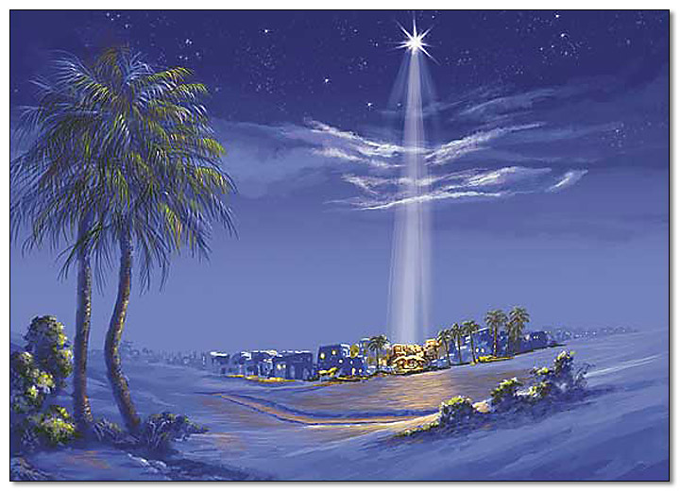

But thou, Bethlehem Ephratah, though thou be little among the thousands of Judah, yet out of thee shall he come forth unto me that is to be ruler in Israel; whose goings forth have been from of old, from everlasting. Micah 5:2 (KJV)

This prophetic utterance of Micah was made approximately 700 years before the birth of Christ. We refer to that date, by the way, as 700 B.C. (Before Christ) – not B.C.E. (Before the Common Era). The latter designation is being promulgated by modern agnostics in science, the social arena, and government to detract from that great event that happened 2,000 years ago. By the same token, they attempt to reclassify Anno Domini (in the year of our Lord) to C.E. (Common Era) in order to remove the proper designation of Christ’s birth. The world is at enmity with God and, especially, His Son, Jesus Christ – so every mention of His Name, or His birthday, is anathema to those who hate Him. The Jehovah Witnesses began this ‘sleight of hand,’ and atheist and agnostics gladly took it up. I refuse to bow the knee to the intimidation and intrigue of the modern apostates, so I proudly proclaim at every opportunity the basis of our calendar – and I proclaim “MERRY CHRISTMAS” at every appropriate occasion.

The little town of Bethlehem bears a prominence that exceeds it’s size many times over. Rachel, the mother of Joseph died there and is buried there. Ruth and Boaz, grandparents of David lived there, and King David was born there – hence, the name, City of David. The prophets tell us that the Messiah would be born in this sleepy little hamlet, and it was so. The powers of Heaven move and the lower powers of earth respond in absolute obedience. Even the emperor of Rome decreed a tax enrollment in the fullness of time to bring all the stars in alignment for the fulfillment of Scripture for the venue of Christ’s birth.

Phillips Brooks, Bishop of Massachusetts, wrote the lines to this sweet and precious carol in 1868, inspired by his trip to Bethlehem three years earlier. He had ridden to Bethlehem by horseback on Christmas Eve of 1865 and stood on the very hills overlooking Bethlehem where it is supposed the poor shepherds were first to hear the Good News of Christ’s birth. The tune was composed by Lewis Redner. This carol became an immediate Christmas favorite and its lilting lyrics make us to stand, in figure, on those same hills with the shepherds as the bright angels descended and hovered there in the purple-canopied heavens.

O Little Town of Bethlehem

O little town of Bethlehem,
how still we see thee lie!
Above thy deep and dreamless sleep
the silent stars go by;
yet in thy dark streets shineth
the everlasting Light;
the hopes and fears of all the years
are met in thee tonight.

For Christ is born of Mary;
and gathered all above,
while mortals sleep, the angels keep
their watch of wondering love.
O morning stars, together
proclaim the holy birth!
and praises sing to God the King,
and peace to men on earth.

How silently, how silently,
the wondrous gift is given!
So God imparts to human hearts
the blessings of his heaven.
No ear may hear his coming,
but in this world of sin,
where meek souls will receive him,
still the dear Christ enters in.

Where children pure and happy
pray to the blessed Child,
where misery cries out to thee,
Son of the Mother mild;
where charity stands watching
and faith holds wide the door,
the dark night wakes, the glory breaks,
and Christmas comes once more.

O holy Child of Bethlehem,
descend to us, we pray;
cast out our sin and enter in,
be born in us today.
We hear the Christmas angels
the great glad tidings tell;
O come to us, abide with us,
our Lord Emmanuel!

1st Stanza: Yes, it is true that Bethlehem lay still and sleepy under those silent stars that traversed the skies above the village those two thousand years ago. No one there, save Mary and Joseph, were aware of the immensity and importance of the event that lay ahead that night in the Providence of God – and even Mary and Joseph only had a simple knowledge and not one informed by the profundity of all of the prophetic words uttered concerning the event. It was quite dark in that semi-rural little town that night. The lamps had been extinguished, and the feet of both men and cattle were stilled from commerce and travel in the lateness of the hour. It is from the darkest shadows that light burst forth with greatest brilliance and impact. But regardless the intensities of the light, the spiritually blind will not see it. The culmination of the hopes of the chosen of Israel were about to be realized, and their yearning to see this coming Light from the days of Abraham even unto John would also be satisfied. Malachi, in 4:2, had spoken of the effulgent and bright heavenly Light of the World that would dawn on the entire world in due time: “But unto you that fear my name shall the Sun of righteousness arise with healing in his wings; and ye shall go forth, and grow up as calves of the stall .” (Mal 4:2) Isaiah also gives us a glimpse of that Light: “The people that walked in darkness have seen a great light: they that dwell in the land of the shadow of death, upon them hath the light shined.” (Isaiah 9:2)

All of Time and Eternity Past have marched toward the very hour of this event, and little Bethlehem is the scene of it.

2nd Stanza: Mary is the young virgin prophesied of old to bring forth the only Begotten Son of God. She was not mother of His Godhead, but of His carnal body. The men and women of Bethlehem were soundly sleeping save the lonely shepherd boys who were watching over their flocks at all hours of the night. There were other beings that remained wide awake and alert as well – the Angels of God! The morning stars sang together that climactic night in Bethlehem. Bethlehem was least among the cities of Judah, but the most profound event in all of history, and of the world, occurred in that small and unassuming little village. God does not need a grand cathedral from which to proclaim His Word. He may choose the rocky hills of a small country town miles away from Jerusalem. He may even shun the elaborate and hypocritical opulence of the great centers of worship.

3rd Stanza: God often performs His grandest miracles in silent darkness. The gifts of the Spirit come wafting on wings of silence just as the dews distill in silence and darkness on the pre-dawn flowers of the garden. No one sees the dew’s coming, but they can readily see the benefits of its moisture-granting nature after the fact. God does not usually come with pomp and circumstance, but in small, still whispers. Those who are seeking an emotional experience may miss that voice altogether. In fact, the meek souls are far outnumbered by the greedy proud who cannot see the beauty and simplicity of Christ. Regardless the rejection of the world, God will enter into His people’s heart and His will shall be done in spite of all.

4th Stanza: Please observe with what awe and expectant joy a little child looks to Christmas. How greater would the joy be if they were fully aware that the day was about Jesus Christ alone and not about a human Santa Claus and elaborately wrapped packages! Perhaps it would be best to teach the children that this day is the birthday of Christ without anything added – what gifts have we brought unto Him? Christ well informed us that “lest ye (we) become as these little children, we shall in no wise enter in the Kingdom of Heaven.,” The dark night of the soul of the world is about to awake to a new and promised hope. Centuries of man-centered error and hatred will now be punctuated with light and love. Much of the world will remain in self-imposed darkness, but those who receive the Lord Jesus shall have a new birth that only God can give. The old, old story is repeated in homes and churches year after year. Even the dark and snow laden landscape becomes beauty and light at Christmas. The season is endowed with the grace of brotherly love.

5th Stanza: Why do men search vainly in the Scriptures to determine the exact moment of Christ’s return? He comes to each of those who believe daily. Every day is Christmas to the devout Christian. Our rough and unhewn hearts are very much light the crude wooden manger that was the simple receptacle for baby Jesus on that first night of Christmas. It is just as important to us that Christ be born in our own hearts as in that small village at Christmas. “We hear the Christmas angels the great glad tidings tell; O come to us, abide with us, our Lord Emmanuel!” As we attend this Christmas Eve Service at Church, and the continuing celebration of the Twelved Days , we, too, shall again hear the words of the Great Angel of Bethlehem proclaiming the glad tidings. We, too, hopefully, will be drawn to the Lord Jesus Christ just as the shepherd hurried to find Him. When we search out the place that Christ dwells, just as did the shepherds and Wise Men, we will come to abide with Him and He with us. After all, by His very nature, He is “God with Us!” (Our Emmanuel)

