Hymn 173 – Hail. Gladdening Light, of His Pure Glory Poured – 28 April 2020, Anno Domini (In the Year of our Lord)

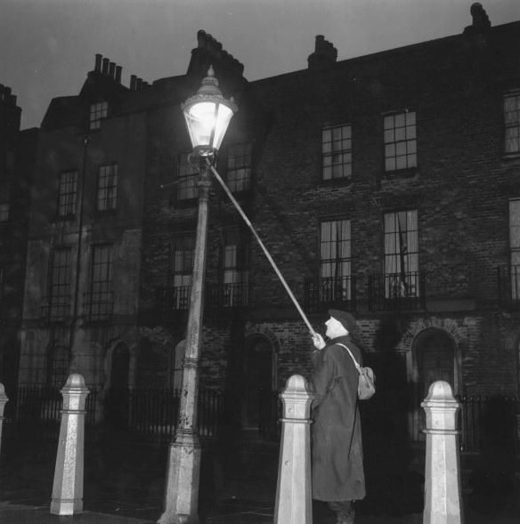

An Ancient Hymn from the 2nd Century AD

F
OR he received from God the Father honour and glory, when there came such a voice to him from the excellent glory, This is my beloved Son, in whom I am well pleased. 18 And this voice which came from heaven we heard, when we were with him in the holy mount. 19 We have also a more sure word of prophecy; whereunto ye do well that ye take heed, as unto a light that shineth in a dark place, until the day dawn, and the day star arise in your hearts. (2 Peter 1:19)

I was born at a peculiar age during the Second World War. In those days, steam engines were common on the rails, telephones hung on the wall and needed to be cranked to place a call, and horse-drawn carriages and wagons were not uncommon on the rural roads of Georgia and Tennessee. So, my memory covers a period of time when life was not so bustling and continued into the space age. There are many improvements in quality of life and health since my childhood; however, there were many treasures of World War II America that we should have retained faith, loyalty, patriotism, a love for the Constitution, a love of God and a high regard for the Holy Estate of Matrimony between one man and one woman.

In some older towns of the rural south, there were usually aged men called Lamplighters who went about the streets lighting the lamps of the sidewalks at eventide. His progress was well marked by an increasing brightness of light. There was even a popular song of the 50’s or 60’s entitled the Old Lamplighter performed by a group named ‘The Browns.’ The first two verses:

He made the night a little brighter
Wherever he would go
The old lamplighter
Of long, long ago
His snowy hair was so much whiter
Beneath the candle glow
The old lamplighter
Of long, long ago

This is a truly ancient hymn common to the Church within one hundred years of the crucifixion of our Lord. It was commonly sang at Evening Prayer and at a time when all worshippers risked death by the sword for attending – men and women have changed much since those precarious times. The hymn was written by ‘Athenogenes’ in the early 2ndcentury and translated by John Keble. The tune is SEBASTE. The hymn is a lamp-lighting hymn which comprised the early Evening Worship Service of the ancient Church. Light was not as easy to come by in those days – not with the flip of a switch as in our time – it had to be planned for with sufficient oil, lamps, and a fire. When secretly worshipping in the Catacombs under the streets of Rome, care was necessary to conceal the light from curious Roman officials. So the high regard for Light as a symbol of God’s Holy Spirit and His only Begotten Son was quite common to the ancients. It should be for us as well. Here is a quote from Clement of Alexandria concerning the service of Light:

Clement of Alexandria (c. 150–c. 211), in his Protrepticus (Exhortation to the Greeks) admonished believers to greet God with a similar expression, “Hail, O light”:

Away then, away with our forgetfulness of the truth! Let us remove the ignorance and darkness that spreads like a mist over our sight, and let us get a vision of the true God, first raising to Him this voice of praise, “Hail, O light.”

This particular lamp-lighting hymn seems to draw from this tradition, and it may also have drawn from vesper prayers, such as those found in The Statutes of the Apostles (3rd century) and The Constitutions of the Holy Apostles (ca. 380):

Concerning the bringing in of lamps at the supper of the congregation. When the evening has come, the bishop being there, the deacon shall bring in a lamp, and standing in the midst of all the faithful, being about to give thanks, the bishop shall first give the salutation, thus saying: “The Lord (be) with you all.” And the people also shall say: “With thy spirit.” . . . And he prays thus, saying: “We give thee thanks, God, through thy Son Jesus Christ our Lord, because thou hast enlightened us by revealing the incorruptible light, we having therefore finished the length of a day and having come to the beginning of the night, and having been satiated with the light of the day which thou hast created for our satisfaction, and now since we have not been deficient of the light of the evening by thy grace, we sanctify thee and we glorify thee through thine only Son our Lord Jesus Christ, through whom to thee with him (be) glory and might and honour with the Holy Spirit now, etc.” And they shall all say: “Amen.”

We praise Thee, we sing hymns to Thee, we bless Thee for Thy great glory, O Lord our King, the Father of Christ the immaculate Lamb, who taketh away the sin of the world. Praise becomes Thee, hymns become Thee, glory becomes Thee, the God and Father, through the Son, in the most holy Spirit, for ever and ever. Amen.

When it is evening, thou, O bishop, shalt assemble the church; and after the repetition of the psalm at the lighting up of the lights, the deacon shall bid prayers for the catechumens, the energumens, the illuminated, and the penitents, as we have formerly said. . . . And let the bishop say: “O God of our fathers, and Lord of mercy, who didst form man of Thy wisdom a rational creature, and beloved of God more than the other beings upon this earth, and didst give him authority to rule over the creatures upon the earth, and didst ordain by Thy will rulers and priests — the former for the security of life, the latter for a regular worship — do Thou now also look down, O Lord Almighty, and cause Thy face to shine upon Thy people, who bow down the neck of their heart, and bless them by Christ, through whom Thou hast enlightened us with the light of knowledge, and hast revealed Thyself to us; with whom worthy adoration is due from every rational and holy nature to Thee, and to the Spirit, who is the Comforter, for ever. Amen.”

Hail. Gladdening Light, of His Pure Glory Poured

Hail, gladdening Light, of his pure glory poured
who is the immortal Father, heavenly, blest,
holiest of holies, Jesus our Lord.

Now we are come to the sun's hour of rest,
the lights of evening round us shine,
we hymn the Father, Son, and Holy Spirit divine.

Worthiest art thou at all times to be sung with undefilèd tongue,
Son of our God, giver of life, alone:
therefore in all the world thy glories, Lord, they own.

1 Hail, gladdening Light, of his pure glory poured who is the immortal Father, heavenly, blest, holiest of holies, Jesus our Lord. Like all great and classic hymns, the lyrics are simple – like the Gospel – in communicating their precious gems of truth. In the great old hymns, there is much praise and reverence for God, not claiming any personal rights as a believer or special treatment from God. It is enough that He has accepted us. The best will be provided as well. Jesus Christ is that ‘gladdening Light’ of the Holiest of Hoilies.

2 Now we are come to the sun's hour of rest, the lights of evening round us shine, we hymn the Father, Son, and Holy Spirit divine. At the moment of retiring for the day, the light sinks on the distant sands, and the shadows lengthen. Just as we gave our thanks to God at our earliest wakening hours, we do so as well at the last gleam of heavenly light. We sing our praises to the Triune God even as our physical light diminishes – both for the day, and in this life.

3 Worthiest art thou at all times to be sung with undefilèd tongue, Son of our God, giver of life, alone: therefore in all the world thy glories, Lord, they own. There is no time of day that is not proper to sing praises to our God and our Savior. When we do so, we must not do so with a covet of sin in our hearts, else we pray in vain. “Thou shalt not take the Name of the Lord, they God, in vain.” We sing in conscious acknowledgment of the words we sing. Like the green belt of grasslands that accompany the Jordan River on both sides in its rush to its demise in the Dead Sea, Christ is also our Giver of Life (Zayyanderud in Persian) for everywhere He goes, He gives life and Light.

