Hymn 172 – The Day Thou Gavest Lord – 10 May 2016, Anno Domini (In the Year of our Lord)

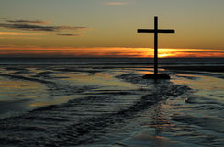

7 Deep calleth unto deep at the noise of thy waterspouts: all thy waves and thy billows are gone over me. 8 Yet the LORD will command his lovingkindness in the daytime, and in the night his song shall be with me, and my prayer unto the God of my life. (Psalm 42:7-8)

The gently lilting words and tune of this beautiful hymn bring out the very spirit of the gloaming when the shadows lengthen and the day of another year, or of an entire life, are coming to a close. There are many different days upon the earth such as a day of the year, a day of trouble, a day of life, etc. Life is a long day compared with the day marked by the transit of the sun across the skies; but compared to the eternity that awaits each of us, there is no day that is more than a whimper or a vapor – except the Eternal Day of the Lord.

John Ellerton, an Anglican cleric, is the composer of lyrics (1870), and the favored tune (of almost everyone I know) is St. Clement by Clement C. Schofield (1874). The older and alternate tune is LES COMMANDEMENS de DIEU by Argowan (1543). The latter tune was composed beautifully for use with the Psalter (Psalm 140).

This hymn was the personal choice of Queen Victoria at her Diamond Jubilee for the 60th year of of her reign in 1897.

The Day Thou Gavest Lord

The day thou gavest, Lord, is ended,
the darkness falls at thy behest;
to thee our morning hymns ascended,
thy praise shall sanctify our rest.

We thank thee that thy Church, unsleeping
while earth rolls onward into light,
through all the world her watch is keeping
and rests not now by day nor night.

As o'er each continent and island
the dawn leads on another day,
the voice of prayer is never silent,
nor dies the strain of praise away.

The sun that bids us rest is waking
our brethren 'neath the western sky,
and hour by hour fresh lips are making
thy wondrous doings heard on high.

So be it, Lord; thy throne shall never,
like earth's proud empires, pass away;
thy kingdom stands, and grows for ever,
till all thy creatures own thy sway.

Which day has the Lord given us? Is it not only this day today, but every day of our lives? Our morning worship should rise to God each morning of our lives to generate joy and comfort for the coming night. Should not the single Day of our lives – whether 15 years, or 90 – be punctuated at the beginning with tribute and worship of the Lord to carry us through the coming days of failing physical presence.

1 Remember now thy Creator in the days of thy youth, while the evil days come not, nor the years draw nigh, when thou shalt say, I have no pleasure in them; 2 While the sun, or the light, or the moon, or the stars, be not darkened, nor the clouds return after the rain: 3 In the day when the keepers of the house shall tremble, and the strong men shall bow themselves, and the grinders cease because they are few, and those that look out of the windows be darkened, 4 And the doors shall be shut in the streets, when the sound of the grinding is low, and he shall rise up at the voice of the bird, and all the daughters of musick shall be brought low; 5 Also when they shall be afraid of that which is high, and fears shall be in the way, and the almond tree shall flourish, and the grasshopper shall be a burden, and desire shall fail: because man goeth to his long home, and the mourners go about the streets: 6 Or ever the silver cord be loosed, or the golden bowl be broken, or the pitcher be broken at the fountain, or the wheel broken at the cistern. 7 Then shall the dust return to the earth as it was: and the spirit shall return unto God who gave it. (Eccl 12:1-7)

One of the Family Prayers for Night in the Book of Common Prayer reflects the lofty sentiments of this hymn: O LORD, support us all the day long, until the shadows lengthen and the evening comes, and the busy world is hushed, and the fever of life is over, and our work is done. Then in thy mercy grant us a safe lodging, and a holy rest, and peace at the last. AMEN

We thank thee that thy Church, unsleeping
while earth rolls onward into light,
through all the world her watch is keeping
and rests not now by day nor night.

One of the Family Prayers for Night in the Book of Common Prayer reflects the lofty sentiments of this hymn: “O LORD, support us all the day long, until the shadows lengthen and the evening comes, and the busy world is hushed, and the fever of life is over, and our work is done. Then in thy mercy grant us a safe lodging, and a holy rest, and peace at the last. AMEN”

We thank thee that thy Church, unsleeping
while earth rolls onward into light,
through all the world her watch is keeping
and rests not now by day nor night.

The rudiments of the New Testament Church slept as our Lord prayed so fervently in the Garden at Gethsemane. Their spirit was willing, but the flesh was weak. It is so today. Quite often, it is more convenient to believe a lie, so long as that lie is preached as truth from the decadent pulpits of decadent churches. Our night watches began with our Lord’s founding of the New Testament Church. Our entire existence here on earth is truly a great night of only the discernible ambient light of the moon and stars to guide us. But that light of the moon is the reflected light of the Sun (our own Light of the World – Jesus Christ). Even that evening Star that is first to appear at the setting of the Sun becomes our Bright and Morning Star, and the last to depart the heavenly field, which also illustrates our Lord. He is with us in the Valley of the Shadow of Death whose specter is only a shadow and not a real substance. But now, we have the presence of the Holy Ghost to guide, direct, and recall to our minds all things written in God’s Word concerning His only Begotten Son, Jesus Christ!

As o'er each continent and island
the dawn leads on another day,
the voice of prayer is never silent,
nor dies the strain of praise away.

It is a great comfort to realize that the sun never sets on our Anglican Orthodox Church. When the Sun sets on the western coast of the United States, it is rising in the islands of the sea where our churches thrive – Solomon Island Chain, the Philippines, and Fiji; and thereafter, in Pakistan, Kenya, Liberia, CAR, Serbia, Macedonia, and even the verdant pastures of France. When winter comes to Canada and the US, Spring is embracing Peru, Cuba, Fiji, and other places where we have brothers and sisters worshipping with the same Word of God with which we have been graced. “And it shall come to pass in that day, that the Lord shall set his hand again the second time to recover the remnant of his people, which shall be left . . . . from the islands of the sea.” Isaiah 11:11 (KJV) To remember the wonderfully deep and harmonious voices of praise lifted on high from Isabel Island (of the Solomons) makes me know that “God is not silent, nor doth He sleep.” (Longfellow)

The sun that bids us rest is waking
our brethren 'neath the western sky,
and hour by hour fresh lips are making
thy wondrous doings heard on high.

There is a cresting wave across the Deep of God’s Word that stretches from East to West. The chorus of voices combined in prayer, praise, and hymn-singing is that cresting wave. It rolls along with the dawning of the sun on each continent and island. When St. Peter’s is sleeping, the village church at Biluro, Solomons, is waking to prayer, and thus around the world. Men, women, and little children at Biluro are anxious to welcome another day in the sunlight of their Lord, and to serve and praise Him at first light. The same sun that sets for us in order that we may rest is rising on the southwestern Pacific so that others may awaken and serve.

So be it, Lord; thy throne shall never,
like earth's proud empires, pass away;
thy kingdom stands, and grows for ever,
till all thy creatures own thy sway.

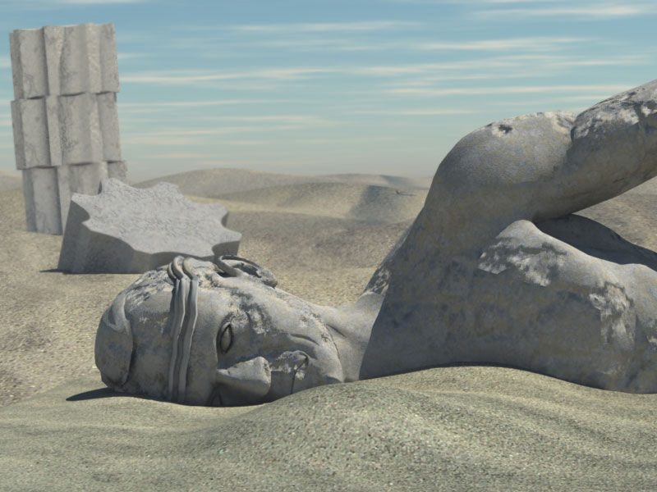
As the once proud, stone image of Ozymandias lies deteriorating on the endless sands and dunes of the wilderness, God’s Throne stands Erect and Eternal unblemished by the winds and sands of mortal time. No one remember the names of the men who drove the nails into the hands and feet of our Lord, or who placed the crown of thorns on His divine brow, or who opened large welts and gashes on His back with a cat-o-nine-tails; but EVERYONE remembers the Name of the One that they treated with such cruelty and irreverence. We even date our calendar on that Name. Caesar, Alexander, Napoleon, and other ten-horned potentates are merely tiny ripples on the vast sea of time. But Christ is the Sea of Eternity itself. There will, suddenly, a Day dawn which will consummate all things in the Will and Sway of God’s rule and sovereignty. Even ALL creatures shall know that sovereignty.

Will you be ready for the Sunrise?

