Devotion on Hymns of the Church - Hymn 160 – At Even Ere the Sun – 20 January 2016, Anno Domini

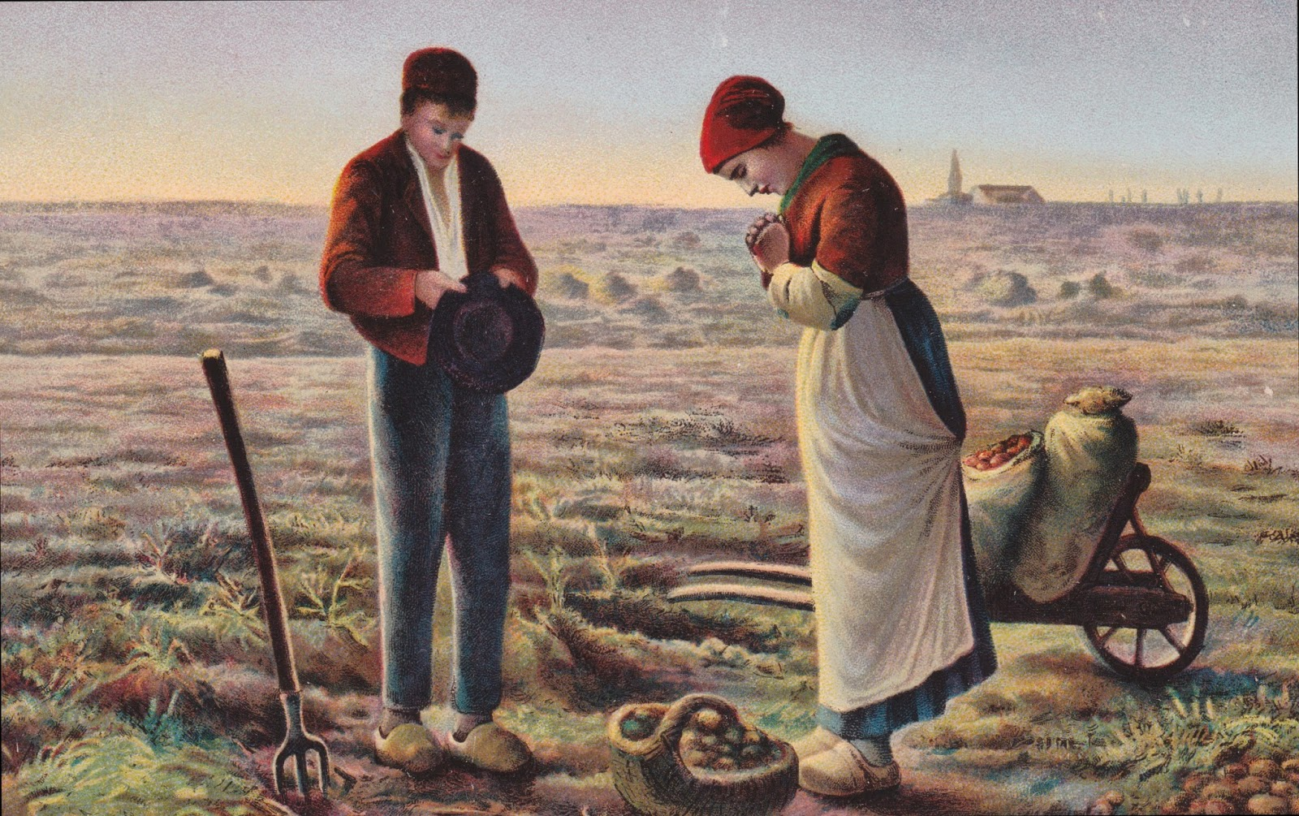

At even when the sun did set…

32 And at even, when the sun did set, they brought unto him all that were diseased, and them that were possessed with devils. 33 And all the city was gathered together at the door. 34 And he healed many that were sick of divers diseases, and cast out many devils; and suffered not the devils to speak, because they knew him. (Mark 1:32-34)

Communion with our Lord often is most enhanced by the falling of the evening shadows. And they heard the voice of the LORD God walking in the garden in the cool of the day: and Adam and his wife hid themselves from the presence of the LORD God amongst the trees of the garden. (Gen 3:8) Of course, man has not always been cheered by the Voice of the Lord, especially if he has drifted apart from Him in sin; because sin separates man from God.

The words to the old classic were written by Henry Twells in 1868, and the musical score, ANGELUS, published in Heilige Seelenlust (Lutheran and definitely not Irish) in 1657. The hymn is number 168 in the 1940 Hymnal and #557 in the Lutheran Hymnal.

The name of the tune itself, Angelus, bears strong testimony to faith of by-gone days. When I was a very young boy, I remember a painting that hung in our parlor entitle, The Angelus. It depicted a man and his wife standing in a cultivated field, heads bowed in prayer. In the far distance was a church steeple from when, presumably, sounded the Angelus Bell, or call to evening prayer at close of the work day. The painting is by Jean-François Millet, completed in 1859. It strikes me as regrettable that evening prayer, and very little of any other, is offered by the common Christian populace today unless it is made a public and false demonstration of piety.

At Even, Ere The Sun Was Set

1 At even, ere the sun was set,
the sick, O Lord, around thee lay;
O in what divers pains they met!
O with what joy they went away!

2 Once more 'tis eventide, and we,
oppressed with various ills, draw near:
what if thy form we cannot see
? we know and feel that thou art here.

3 O Saviour Christ, our woes dispel:
for some are sick, and some are sad,
and some have never loved thee well,
and some have lost the love they had.

4 And none, O Lord, have perfect rest,
for none are wholly free from sin;
and they who fain would serve thee best
are conscious most of wrong within.

5 O Saviour Christ, thou too art man;
thou hast been troubled, tempted, tried;
thy kind but searching glance can scan
the very wounds that shame would hide.

6 Thy touch has still its ancient power;
no word from thee can fruitless fall:
Hear in this solemn evening hour,
and in thy mercy heal us all.

1 At even, ere the sun was set, the sick, O Lord, around thee lay; O in what divers pains they met! O with what joy they went away! Like every other common folk, the Lord Jesus Christ did not rest during daylight hours, and very little during the hours of darkness. He travelled with sandal-shod foot over great distances across Judaea, Galilee, and Samaria. He got little rest because His burden was great: and his most fervent prayers were most often said in the late hours of the evening. In our own evening hours of life, we, too, can only receive solace at the feet of Jesus.

2 Once more 'tis eventide, and we, oppressed with various ills, draw near: what if thy form we cannot see? we know and feel that thou art here. There are many moments of a Christian’s life when the evening shadows lengthen and our vision is blinded by doubts and fears; yet, our Lord has never left or forsaken His own. He is as near to us as our heart is to our faces. Remember the two men on the Road to Emmaus lamenting the events of the crucifixion while the One whose death they mourned walk right beside; or Mary Magdalen whose profuse tears outside the Garden Tomb were shed before the Gardener whose death she mourned. Those tears were turned to tears of joy at the sound of His Voice. And when he putteth forth his own sheep, he goeth before them, and the sheep follow him: for they know his voice. (John 10:4) The most important and profound moment to feel His presence is that last evening of our earthly years, when at the very moment of parting, we are lifted up by that strong Arm and look into the loving face of our Lord.

3 O Saviour Christ, our woes dispel: or some are sick, and some are sad, and some have never loved thee well, and some have lost the love they had. The greater sickness is sin, for it leads inalterably to eternal death. Those who are bereft of hope do not know the Savior for hope and undying love cannot abide together in a heart full of doubt and hopelessness. Those who have never loved our Lord well are those who really do not recognize His Voice. He loved us with an immeasurable love before we ever knew Him. And love, like energy or matter, is never lost or destroyed. That LOVE that is the currency of the Kingdom of God is legal, and spiritual, tender in all avenues of life. It is not a paper currency that fluctuates with the market, but has its own intrinsic value standard that is immutable.

4 And none, O Lord, have perfect rest, for none are wholly free from sin; and they who fain would serve thee best are conscious most of wrong within. We have no perfect rest because we have not availed ourselves of that perfect rest available in Christ. Come unto me, all ye that labour and are heavy laden, and I will give you rest. Take my yoke upon you, and learn of me; for I am meek and lowly in heart: and ye shall find rest unto your souls. For my yoke is easy, and my burden is light. (Matt 11:28-30) Even the most devoted Christian among us is unable to unload all of his burdens on Christ. And there are some cherished little wedges of God (sins) that we withhold for our own use thinking we can control them – and we cannot! Those who know themselves to have sins of scarlet are more readily received than those who consider themselves righteous. None are righteous. Our only righteousness is defined by that imputed righteousness of Christ.

5 O Saviour Christ, thou too art man; thou hast been troubled, tempted, tried; thy kind but searching glance can scan the very wounds that shame would hide. Yes, our Lord is both Man and God at once. And truly He was tempted in every way in which we are, His blood was stainless from the sin of Adam and He never yielded to the Serpents allurements. Shame is a function of pride; and when we are ashamed to admit our sins, we are truly doing so out of a prideful denial that we have failed and fallen short. Adam and Eve hid in the bushes out of shame for their sin, but also not wanting to reveal their weakness to the One who walked in the Garden at Eventide. But the Lord sees our hiding places and our hearts with sin inscribed on the doors. He read perfectly the heart of the forlorn sinner woman at Jacob’s Well, and it led to her healing!

6 Thy touch has still its ancient power; no word from thee can fruitless fall: Hear in this solemn evening hour, and in thy mercy heal us all. It is in the shadows of the coming night that we feel most alienated from God. We feel the darkness will cover our sins, or we may doubt His power to see us in our dark hours of pain and suffering, but He does indeed see and He knows all. We cannot find Christ in the darkness, but Christ can – and did – find us in the darkness. In fact, if we are in Christ, there is no such thing as darkness: This then is the message which we have heard of him, and declare unto you, that God is light, and in him is no darkness at all. (1 John 1:5) There is much truth in the children’s little hymn – Let the Sun Shine In:

Mommy told me something a little kid should know
It's all about the devil and I learned to hate him so
She said he causes trouble when you let him in your room
He'll never ever leave you if your heart is filled with gloom

So let the sun shine in, face it with a grin
Smilers never lose and frowners never win
So let the sun shine in, face it with a grin
Open up your heart and let the sun shine in

If your road is dark, and the skies are gloomy, fling open the windows of your heart and allow the fresh air and light of God to come in and vanquish the darkness and gloom. This is something that a little child may master better than the hardened consciences of adults, but God is able to break down strongholds, and He will break down yours as well according to His express purpose and will.
