Hymn 143 – God of our Fathers Whose Almighty Hand – 2 June 2015, Anno Domini (In the Year of our Lord)

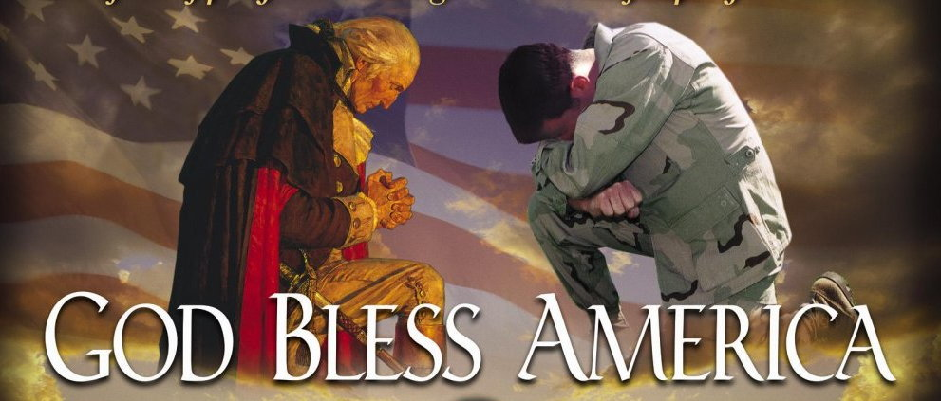

God • Honor • Country

7 And when we cried unto the LORD God of our fathers, the LORD heard our voice, and looked on our affliction, and our labour, and our oppression: 8 And the LORD brought us forth out of Egypt with a mighty hand, and with an outstretched arm, and with great terribleness, and with signs, and with wonders: 9 And he hath brought us into this place, and hath given us this land, even a land that floweth with milk and honey. (Deut 26:6-9)

I am somewhat taken aback I have not before written of this stirring masterpiece of national and patriotic hymnody. (If I have done, I could not find it, so I will do so now)

The hymn lyrics are composed by the Rev. Daniel Crane Roberts, Rector of St. Thomas, Brandon, Vermont, for the Centennial 4th of July in 1876. The original tune was “Russian Hymn” – the same as God the Omnipotent – which would have seemed difficult to match with the lyrics (although God the Omnipotent is beautifully matched with its own lyrics). Later, Mr. George William Warren revised the hymn to the present tune, National Hymn, for the New York Constitutional Centennial, in 1887. Rev. Roberts died in 1907 believing that his famous hymn had never achieved any level of popularity; but it is one of the premier hymns of patriotic and spiritual celebration on American National Holidays today. It relates, in Godly devotion, the blessings showered down upon America, and any nation that has placed the Word of God foremost in its national character.

God of our Fathers, Whose Almighty Hand

God of our fathers, whose almighty hand
leads forth in beauty all the starry band
of shining worlds in splendor through the skies,
our grateful songs before thy throne arise.

Thy love divine hath led us in the past,
in this free land by thee our lot is cast;
be thou our ruler, guardian, guide, and stay,
thy word our law, thy paths our chosen way.

From war's alarms, from deadly pestilence,
be thy strong arm our ever sure defense;
thy true religion in our hearts increase,
thy bounteous goodness nourish us in peace.

Refresh thy people on their toilsome way,
lead us from night to never-ending day;
fill all our lives with love and grace divine,
and glory, laud, and praise be ever thine.

God of our fathers, whose almighty hand, leads forth in beauty all the starry band, of shining worlds in splendor through the skies, our grateful songs before thy throne arise. My heart is moved with emotion at the reading (and, certainly, the singing) of the stirring and rousing words of this great and classical masterpiece of hymns. If our God is also the God in which our fathers trusted, what a spiritual legacy we are heirs to! If we have abandoned the God of our Fathers who placed us in a “good land, flowing with milk and honey,” I daresay the curse that was removed from those multitudes who flocked hither from many lands, will be doubly restored to us in our day. The Almighty Hand of the Lord is without resistance. It sweeps before it all of the chaff and dross of the sinful nations, and sets upon high those people who will pay it obeisance in faith and love. Those who follow and thirst after the Lord are gathered from every land, tribe, nation and tongue – and from every generation in the scale of time – and constitute a marvelous constellation of stars and heavenly bodies! We are reminded when looking into the dark night sky of those who have departed this life and gone on to glory in Christ Jesus. We may not touch them, or see their beloved faces, but we see the trailing glow of light that their passing has left behind in the ambience of the night. Our songs should glorify that true God who has so well guided and blessed us for more than two centuries as a nation.

Thy love divine hath led us in the past, in this free land by thee our lot is cast; be thou our ruler, guardian, guide, and stay, thy word our law, thy paths our chosen way. Love is one of those divine attributes – and the greatest of all – that we can bear in this vessel of clay. Though we will possess that love in lesser degrees than its Giver, we nonetheless express divine character when we love without condition of remuneration. It is heavenly love that has led our fathers, our soldiers, statesmen, and ministers, in building up a nation that has become the desire of all peoples – and one which appears to the world as a Light set upon a Hill. That Light has grown more and more dim with the advent of the modern era as men and women have turned from the God of our fathers and turned to gods of lust and decadence. The shining Light is lower now, and our sins have obscured its gleams of hope and faith to the world. When the paths of God are our chosen way, we will need fear no enemy in the field arrayed against us. But when we embark on a boundless sea without the Chart or Compass of God’s Word, we shall suffer devastating shipwreck. Modern America has fallen victim to the tragic error of old Israel:

Thus saith the LORD; I remember thee, the kindness of thy youth, the love of thine espousals, when thou wentest after me in the wilderness, in a land that was not sown. Israel was holiness unto the LORD, and the firstfruits of his increase: all that devour him shall offend; evil shall come upon them, saith the LORD. Hear ye the word of the LORD, O house of Jacob, and all the families of the house of Israel: Thus saith the LORD, What iniquity have your fathers found in me, that they are gone far from me, and have walked after vanity, and are become vain? (Jer 2:2-5)

He will also remember our obstinate denial of Him in refusing to walk in the old paths. When He inquired and Counseled, our answer damned us as a nation: Thus saith the LORD, Stand ye in the ways, and see, and ask for the old paths, where is the good way, and walk therein, and ye shall find rest for your souls. But they said, We will not walk therein. (Jer 6:16)

From war's alarms, from deadly pestilence, be thy strong arm our ever sure defense; thy true religion in our hearts increase, thy bounteous goodness nourish us in peace. Abraham Lincoln prophesied 150 years ago the clear destiny of a nation that forsakes her God: From whence shall we expect the approach of danger? Shall some trans-Atlantic military giant step the earth and crush us at a blow? Never. All the armies of Europe and Asia...could not by force take a drink from the Ohio River or make a track on the Blue Ridge in the trial of a thousand years. No, if destruction be our lot we must ourselves be its author and finisher. As a nation of free men we will live forever or die by suicide. God may not curse us, but when we turn from Him, He removes His Hand of blessing and protection, and we are cursed with a greater curse than God would deliver to His favored people in a thousand years. Where is that true religion today that governed in the hearts of our Fore Fathers? The war tocsins sound on every hand today, but are our walls secure? Are our hearts stayed upon that Beneficent Providence that guided us at Yorktown; at Fort McHenry; at Santa Cruz; at Chateau-Thierry; at Normandy; at Bastogne (Ardennes Campaign); and at Inchon in the bygone days of divine favor?

Refresh thy people on their toilsome way, lead us from night to never-ending day; fill all our lives with love and grace divine, and glory, laud, and praise be ever thine. America today is sailing against the divine winds of God. We need a refreshing wind-shift, or a change in direction. Our nation has gone where God has not led. The toil of travel grows more and more difficult as we grow farther and farther away from the paths of righteousness. We are as a nation which stumbles as a blind man. We have listened to the babbling of fools instead of the wholesome counsel of God. Well did our English friend, in his prophetic lines of Recessional, state the case for America:

Then beware lest thou forget the Lord which brought thee forth out of the land of Egypt (Deut 6:12)
Recessional
by Rudyard Kipling

God of our fathers, known of old,
Lord of our far-flung battle-line,
Beneath whose awful Hand we hold,
Dominion over palm and pine,
Lord God of Hosts be with us yet,
Lest we forget – lest we forget!

The tumult and the shouting dies;
The Captains and the Kings depart:
Still stands Thine ancient sacrifice,
An humble and a contrite heart.
Lord God of Hosts, be with us yet,
Lest we forget – lest we forget!

Far-called, our navies melt away;
On dune and headland sinks the fire:
Lo, all our pomp of yesterday
Is one with Nineveh and Tyre!
Judge of the Nations, spare us yet,
Lest we forget – lest we forget!

If, drunk with sight of power, we loose
Wild tongues that have not Thee in awe,
Such boastings as the Gentiles use,
Or lesser breeds without the Law
Lord God of Hosts, be with us yet,
Lest we forget – lest we forget!

For heathen heart that puts her trust
In reeking tube and iron shard,
All valiant dust that builds on dust,
And guarding, calls not Thee to guard,
For frantic boast and foolish word
Thy mercy on Thy People, Lord!

