Hymn 142 – Star Spangled Banner – 7 November 2017, Anno Domini (In the Year of our Lord)

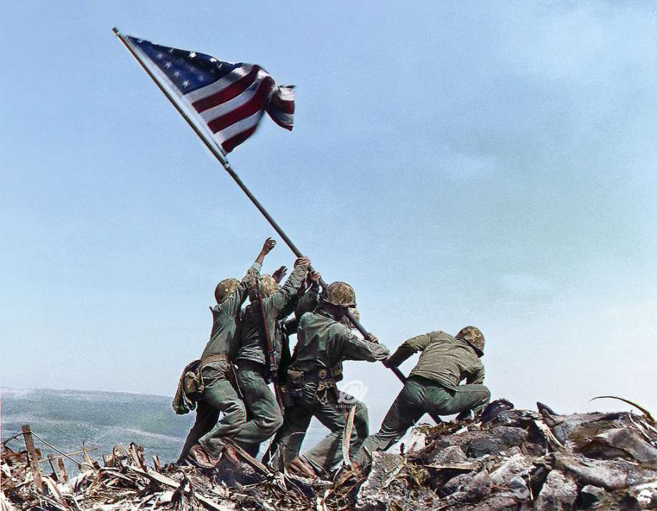

Since Veteran’s Day is fast approaching (11 November) I have decided to write, for the first time, a devotion on our National Anthem.

Most Americans whose heads are graced with at least a few grey hairs will recall the history of the writing of the Star Spangled Banner from a British ship outside the waters surrounding Fort McHenry. Unfortunately today, American history is not well-taught in our public schools and many younger Americans have little knowledge of the history of our National Anthem, or of the circumstances surrounding our Providential founding as a nation among the nations of the earth.

Francis Scott Key penned the words to the anthem while being detained aboard a ship of the British Fleet in Baltimore harbor of Chesapeake Bay during the night of 13-14 September 1814. The Banner whose stripes gave Key hope was the smaller storm flag which flew amidst the smoke, haze and rocket flashes above Fort McHenry. That tattered flag is on display at the Smithsonian Institute in Washington, DC. It served as a registration point for the naval guns of the Fleet. The American force at Fort McHenry held out throughout the barrage of attacks of that massed British Fleet lying offshore. As the dawn of morning illumined the sky, the tattered and torn storm flag was lowered and replaced by the full-sized banner that told Key the Fort had prevailed through such a thunderous assault as he had witnessed throughout the hours of darkness. Hope had seemed forlorn as Washington had recently been burned by the British, but now hope abounded.

The origin of the tune is in question, however, an English composer named John Stafford Smith is believed to have been its composer. The tune was used in an English song called “To Anacreon in Heaven” by Ralph Tomlinson.(1778) Col. Skinner, garrison commander of Fort McHenry, persuaded Key to take his poem to the offices of the Baltimore American where it was printed in handbill form, and within a month, the anthem was widely known and sung.

The STAR SPANGLED BANNER was adopted as the American National Anthem by an act of Congress on March 3, 1931 pursuant to a petition originated by the Veterans of Foreign Wars, garnering more than five million signatures. President Hoover signed the measure into law the next day, March 4, 1931. The anthem is comprised of four stanzas but, unfortunately, only the first is popularly sung today. The second stanza is very much like a prayer and appeals to the Sovereignty of God in preserving us as a nation among those of the earth.

The Star Spangled Banner
O! say can you see by the dawn’s early light
What so proudly we hailed at the twilight’s last gleaming,
Whose broad stripes and bright stars through the perilous fight,
O’er the ramparts we watched, were so gallantly streaming?
And the rockets’ red glare, the bombs bursting in air,
Gave proof through the night that our flag was still there.
O! say does that star spangled banner still wave
O’er the land of the free and the home of the brave?
O! thus be it ever when freeman shall stand,
Between their loved home and the war’s desolation;
Blest with victory and peace, may the Heav’n rescued land,
Praise the Power that hath made and preserved us a nation!
Then conquer we must, when our cause it is just,
And this be our motto, IN GOD IS OUR TRUST.
And the star spangled banner in triumph shall wave
O’er the land of the free and the home of the brave.

The National Motto of the United States is derived from the third to the last line of the second stanza above – IN GOD IS OUR TRUST. An act of Congress adopting the words, IN GOD WE TRUST, was signed into law by President Dwight D. Eisenhower on 30 July 1956, and is codified in 36 USC, para 302 as the National Motto of the United States of America.

The National Anthem, and the National Motto, has come under malicious attack over recent years, but the patriotic zeal of red-blooded Americans have prevailed to retain this rousing tribute to the Providence of God in our Founding and Preservation. One’s heart cannot help but swell with pride mixed with humility at the endearing stains of this wonderful anthem.

I remember when the US State Department ordered an evacuation of US personnel from Iran following the ascension to power of the Godless Khomeini regime in Iran. I was on the next to last evacuation lift. There was great joy when the wheels of the aircraft broke ground at Mehrabad Airport. But when the pilot announced crossing the border into Turkey, we all broke forth with the National Anthem. That anthem brought to our mind’s eye that same tattered flag that had flown over Fort McHenry and every American post since, and the liberty it represents. Needless to say, every veteran’s heart is melted, too, by the memory of that flag being raised over the blood-bought island of Iwo Jima during the Pacific Theater of the Second World War.

Let us never forget God is our Sovereign, and He is the Author of Liberty.

