Hymn 141 – America – 14 October 2014, Anno Domini (In the Year of our Lord)

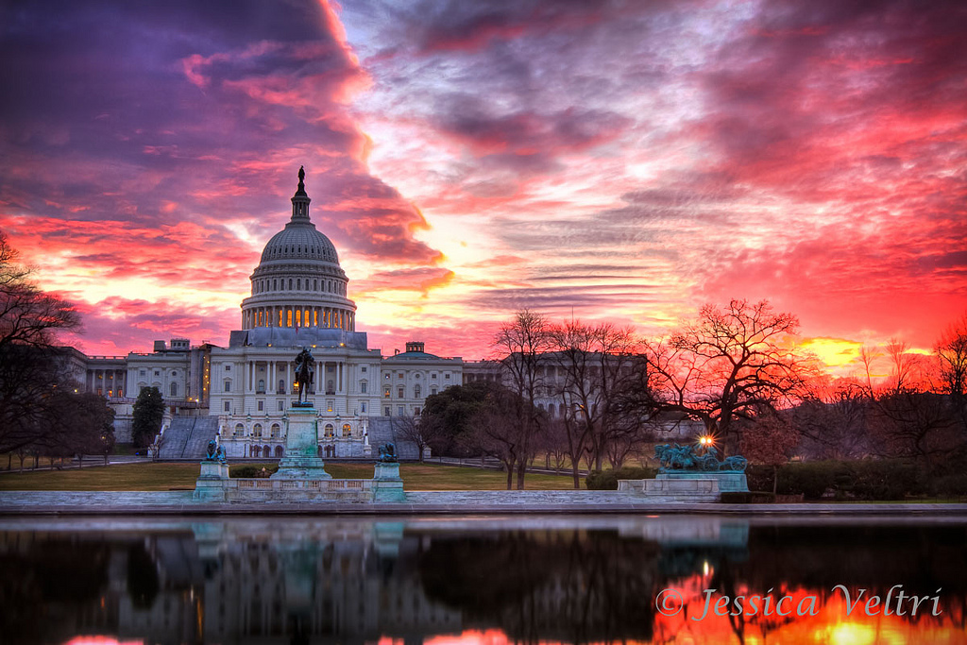
Sunset or Sunrise?

When the righteous are in authority, the people rejoice: but when the wicked beareth rule, the people mourn.
(Prov 29:2)

But whoso looketh into the perfect law of liberty, and continueth therein, he being not a forgetful hearer, but a doer of the work, this man shall be blessed in his deed.
(James 1:25)

Stand fast therefore in the liberty wherewith Christ hath made us free, and be not entangled again with the yoke of bondage.
(Gal 5:1)

As free, and not using your liberty for a cloke of maliciousness, but as the servants of God.
(1 Peter 2:16)

If we only make a cursory review of the Law of Liberty which is perfected in Christ, we will see the profound contrast between Liberty and License. Liberty carries with it the noble claims of responsibility and dedication, while license is a mere form of anarchy that tends to the barren waste of unruliness and famine. The human virtues that attend the maintenance of Liberty are inspired of God and are not natural to the human soul. Only those nations that bear faith and allegiance to God can enjoy the fruits and blessings of Liberty. This is because, apart from the grant of God, there is no Liberty – He being the Author thereof. License is only the expression of man’s supposed free will which is not free at all, but is in bondage to Satan. WE see that unbridled nature of the evil of men’s hearts emerging more and more on the social and political landscape of this once Godly nation. I remember singing this hymn in class with great pride in my elementary school years.

The hymn that is the object of this devotion was once sung in every church across America at Sunday worship, but no more. It has, like the US Constitution and Holy Bible, been relegated to the place of historical record and not a daily living fare of the nation. “Of the Rock (the Lord Jesus Christ) that begat thee thou art unmindful, and hast forgotten God that formed thee.” (Deut 32:18) The lyrics for this great hymn were composed by Samuel F. Smith in 1831, but the tune hails back to around 1740.

America (My Country, 'Tis of Thee)

My country,' tis of thee,
sweet land of liberty, of thee I sing;
land where my fathers died,
land of the pilgrims' pride,
from every mountainside let freedom ring!

My native country, thee,
land of the noble free, thy name I love;
I love thy rocks and rills,
thy woods and templed hills;
my heart with rapture thrills, like that above.

Let music swell the breeze,
and ring from all the trees sweet freedom's song;
let mortal tongues awake;
let all that breathe partake;
let rocks their silence break, the sound prolong.

Our fathers' God, to thee,
author of liberty, to thee we sing;
long may our land be bright
with freedom's holy light;
protect us by thy might, great God, our King.

“My country,' tis of thee, sweet land of liberty, of thee I sing; land where my fathers died, land of the pilgrims' pride, from every mountainside let freedom ring!” The sweet land of Liberty mentioned was once “My country” and, though it still affords a great measure of freedom, that liberty and responsibility that once described her character has faded as a waning star on the distant horizon, because her citizens have forgotten the Lord who has endowed us with such grace and such a rare form of Liberty among the nations of the earth. The land was purchased at great sacrifice – the blood and sweat of her brave men and women of bygone days. The land was first chosen and settled by pilgrims seeking religious freedom from oppression. In the words of Emma Lazarus: “Give me your tired, your poor, Your huddled masses, yearning to breath free, The wretched refuse of your teeming shore, Send these, the homeless, tempest tost to me, I lift my lamp beside the golden door.” Our freedoms are of God, and when God is forgotten, the Liberties will vanish.

“My native country, thee, land of the noble free, thy name I love; I love thy rocks and rills, thy woods and templed hills; my heart with rapture thrills, like that above.” The citizens of a free country exercise a Holy Love for that country which we call patriotism. Those who love freedom are noble because they are children of the Great King, and Lord of Lords. Just as a man may love and admire even the facial blemishes of his beloved spouse, so does the patriot love every meadow, hill, and river of his beloved country. He sees God in every place and under every tree. The rapture the freeborn citizen feels while contemplating his country is also Holy and like that felt in Heaven by the angels.

“Let music swell the breeze, and ring from all the trees sweet freedom's song; let mortal tongues awake; let all that breathe partake; let rocks their silence break, the sound prolong.” When a nation enjoys Liberty, even the air is full of it, and the tall trees sing the wonder of it. Every creature of a free nation profits from the benefits of Liberty. The rocks do, indeed, break their silence in a free nation. Our Capitol, and the parks of our cities, are filled with those stone monuments that herald the benefits of freedom, and the cost in blood paid for the purchase.

The last verse is probably the most powerfully beautiful: “Our fathers' God, to thee, author of liberty, to thee we sing; long may our land be bright with freedom's holy light; protect us by thy might, great God, our King.” Have we forgotten the God of our fathers? Our fathers paid tribute to God for all of their blessings. Those old paths wherein our fathers walked were paths of righteousness and wisdom. “Thus saith the LORD, Stand ye in the ways, and see, and ask for the old paths, where is the good way, and walk therein, and ye shall find rest for your souls. But they said, We will not walk therein.”(Jer 6:16) Those old paths wherein our fathers walked were paths that honored God Almighty, the Author and Finisher of the Liberty we enjoy. The life of the nation was anchored in that Pillar of Faith. A free people are a people who love to sing of those freedoms. The words, “ . . . long may our land be bright with freedom's holy light” is no less than a continual prayer to invoke God’s protection and providence upon us. Our protection resides in the Mighty Arm of God and not that of flesh. The last line refers to the monarchical kingdom to which we belong. When God was our King, our nation blossomed and flourished. Is God still our Great God and King?

