Devotion on Hymns of the Church - Hymn 1 – Come Thou Long Expected Jesus – 15 December 2015, Anno Domini

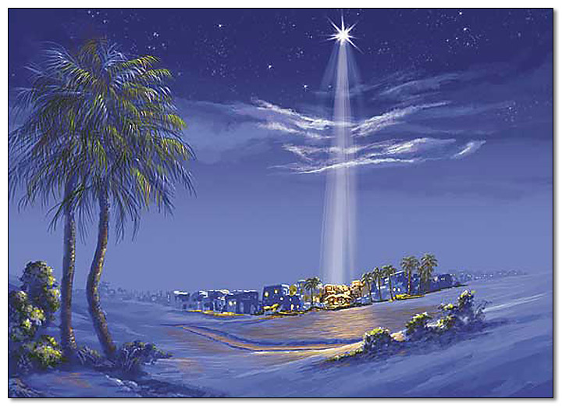

And I will shake all nations, and the desire of all nations shall come: and I will fill this house with glory, saith THE LORD of hosts. (Haggai 2:7)

The people that walked in darkness have seen a great light: they that dwell in the land of the shadow of death, upon them hath the light shined. (Isaiah 9:2)

Quite appropriately, this is the first hymn in the 1940 Hymnal. Advent is the beginning of the Church Calendar at ADVENT; and this hymn expresses the great longing of the human heart for a Messiah during the long, dark night of waiting and watching. In fact, that long night was its darkest during the four hundred years from the last utterance of the prophet Malachi and the first word of the Gospel in Matthew. During that dreaded darkness, there was no word at all from Heaven. The people languished in smothering darkness, and doubts arose concerning God’s promise concerning a coming Redeemer. This abject darkness contrasted starkly, and magnified, the coming brilliance of His Coming. Conditioned by the darkness, many were blinded at the radiance of the Light of Christ.

Those who were most knowledgeable of the prophecies of the Birth of Christ – the Scribes, lawyers and rulers of Israel - were blinded by faithless doubts and a sense of greed for power. Those who with scholarly diligence searched the ancient prophecies, as well as the Heavens, discovered the Star that heralded His coming from far-distant Persia. But God makes allowance for the deficit of the poor to gain knowledge and the capacity to understand matters of the movement of heavenly bodies; so He revealed the Light of the Lord’s coming to those poor shepherds on the dark and lonely hills overlooking sleepy little Bethlehem that wonderful night of 2,000 years ago.

Today’s hymn is by Charles Wesley, brother to the Anglican priest, John Wesley, published in 1745. The music is ‘Hyfrydol’ by Rowland H. Prichard (1830).

Come, Thou Long Expected Jesus

Come, Thou long expected Jesus,
Born to set Thy people free,
From our fears and sins release us,
Let us find our rest in Thee:
Israel's strength and consolation,
Hope of all the earth Thou art,
Dear Desire of every nation,
Joy of every longing heart.

Born Thy people to deliver,
Born a child and yet a king,
Born to reign in us for ever,
Now Thy gracious kingdom bring:
By Thy own eternal Spirit
Rule in all our hearts alone,
By Thy all-sufficient merit
Raise us to Thy glorious throne.

Come, Thou long expected Jesus, Born to set Thy people free, From our fears and sins release us, Let us find our rest in Thee: Israel's strength and consolation, Hope of all the earth Thou art, Dear Desire of every nation, Joy of every longing heart. Israel, from ages past, were accustomed to the dawn and dusk of the prophetic sun of their fathers. But after Malachi, there seemed to begin an interminable night. Their memories were dimmed to the prophesies of old concerning their Redeemer. There is an underground sea in East Tennessee that illustrates their blindness. The Lost Sea is a large body of water more than three hundred feet below the surface in which live purely white fish of different varieties of bass, trout, etc. They are white because there is no light to react to the pigment of their scales. But these fish are also blind. There are bulges on the side of their heads where the eyes once were that are now covered in scales. They became blind, not from blunt trauma, but as a result of living so long in darkness. The spiritual eyes of you and I will likewise become covered in scales if we separate ourselves too long from the Light of God.

The word, COME, is an invitation, but also a plea. My mother used to call to me and my sisters out at play to Come to supper. It was a happy and welcome invitation. But the term is used also to call for help or relief – SOS! Please come quickly! We are sinking! Without Christ, mankind is not sinking, but already sunk to the depths of the sea. We are all, likewise, dead in trespasses and sins (Ephesians 2). Being dead, we cannot save or revive ourselves. Christ is not only the Light of the world, but the life of all whose heart responds to His beckoning call as did that of Lazarus from within the stone walls of the tomb. When someone is long expected and anxiously awaited, our hopes grow faint when that someone tarries in their coming. Israel had grown too accustomed to believing they were making it on their own. In fact, the religious leaders were quite comfortable to be the unchallenged religious leaders and were not at all excited about the coming of the Messiah. But the hearts of the people were empty and yearned for a Bread whose nature they could not know until it should appear. That Bread would satisfy all who partook of it, and eternally! Instead of despair, that Bread of Heaven would create an overflowing joy in those empty hearts.

Born Thy people to deliver, Born a child and yet a king, Born to reign in us for ever, Now Thy gracious kingdom bring: By Thy own eternal Spirit Rule in all our hearts alone, By Thy all-sufficient merit Raise us to Thy glorious throne. There was one overriding purpose for the coming of Christ - to save us from our sins. No one else could qualify as the perfectly righteous to pay the sin-debt for the completely unrighteous; and even had there been such a one, no other would have died for the worthless and teeming humanity of sinful hearts that we are. Though by inherent nature, He was a King; Jesus did not come as a King bearing a scepter, but as child bearing the flesh of humanity, subject to all of the hurt, pain, and burdens shared alike by all humanity. He desires no earthly kingdom, but He will only rule from the Temple of our hearts when he has entered therein to abide forever. His kingdom is not a visible one to the world at large, but only to those whose eyes and hearts have been drawn and lighted by the Holy Ghost. It is By His all-sufficient merit by which we are made worthy to be raised on high to the Heavenly Home. We have no merit or righteousness at all, but it is by His merit and righteousness, imputed to those who are called and chosen, by which we gain the approbation of God.

This is yet another hymn rich in biblical truth and doctrinal soundness that informs our understanding of those glorious truths revealed in the mighty Word of God.

God promised our Redeemer would come in the fullness of time, and so He did come to Bethlehem two thousand years ago. God has promised, as well, that Christ will come again in the fullness of time, to claim those whose hearts are believing and full of faith. He will also come as Judge of those who have rejected the Lord of Glory.

