Devotion on Hymns of the Church - Hymn 1 – Come Thou Long Expected Jesus – 28 November 2017, Anno Domini

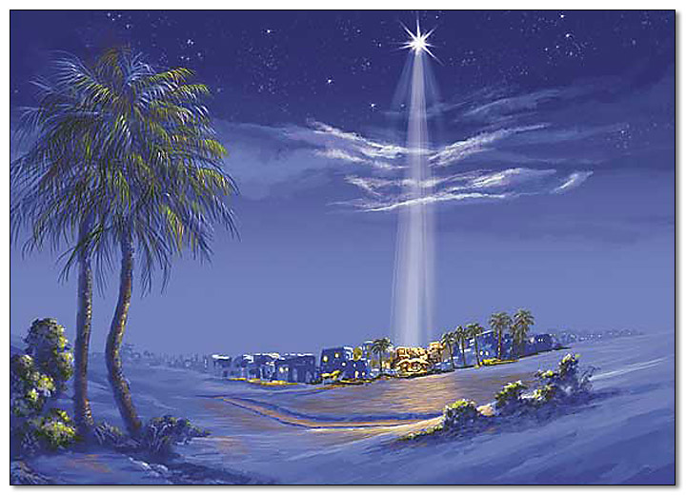

6 For thus saith the Lord of hosts; Yet once, it is a little while, and I will shake the heavens, and the earth, and the sea, and the dry land; 7 And I will shake all nations, and the desire of all nations shall come: and I will fill this house with glory, saith the Lord of hosts. 8 The silver is mine, and the gold is mine, saith the Lord of hosts. 9 The glory of this latter house shall be greater than of the former, saith the Lord of hosts: and in this place will I give peace, saith the Lord of hosts. (Hag 2:5-9)

Today’s hymn is the first in the 1940 Hymnal since it represents the beginning of the Church Calendar. The Church Calendar is a rich spiritual resource since it observes every phase of the life of our Lord Jesus Christ over the period of a year – among them, Advent, Christmastide, Epiphany, and Easter. In addition to hymns appropriate for the occasion, we are provided with a Lectionary that covers Old Testament readings, Psalms, Gospel readings, and Epistle readings for every Sunday in each of those Church seasons. This hymn is first since Advent begins the Church Year, and this next is the first Sunday in the Advent Season.

Come Thou Long Expected Jesus is a hymn of the famous Anglican cleric and proponent of Methodism, Charles Wesley, which he composed in 1745. The most popular tune in many Protestant churches is HYFRYDOL, by Rowland Prichard (1830); but there are others that are commonly sung in Anglican Churches such as Cross of Jesus by John Stainer (1887); St. Hillary (anonymous); Stuttgart, by Charles F. Witt (1715); and my personal favorite, Wilson, arrangement from Felix Mendelsohnn (1905); However, Stuttgart is the tune provided in the Hymnal.

Come, Thou Long Expected Jesus

Come, Thou long expected Jesus,
Born to set Thy people free,
From our fears and sins release us,
Let us find our rest in Thee:
Israel's strength and consolation,
Hope of all the earth Thou art,
Dear Desire of every nation,
Joy of every longing heart.

Born Thy people to deliver,
Born a child and yet a king,
Born to reign in us for ever,
Now Thy gracious kingdom bring:
By Thy own eternal Spirit
Rule in all our hearts alone,

By Thy all-sufficient merit
Raise us to Thy glorious throne.

A great darkness prevailed upon the earth from the Fall of Adam in the Garden at Eden until Abraham (who received the Promise of a Seed to redeem Israel). But that darkness was not abject, for it was punctuated by rays of hope and light from Heaven during the intervening times before Abraham, and for centuries after. Then the Children of God were blessed with prophets who spoke the Mind of God to them. These voices they seldom heeded and often put to death. But there was to come a far more intense darkness of the long night between the last prophet to utter his prophecies and the coming of the Lord Jesus Christ. That long night of silence lasted four hundred years during which there was not a Word or prophecy from the Mind of God to the people.

It is common knowledge that we take for granted the blessings of light until it is extinguished and the smothering darkness is all-pervasive. This was the case for those 400 hundred years of silence and darkness for Israel. Many began to question if a Redeemer would truly come as prophesied by Abraham and others. Job made the wonderful proclamation (according to the Honorable Bishop Ussher’s computations, around 1520 BC): For I know that my redeemer liveth, and that he shall stand at the latter day upon the earth: And though after my skin worms destroy this body, yet in my flesh shall I see God: Whom I shall see for myself, and mine eyes shall behold, and not another; though my reins be consumed within me. (Job 19:25-27)

When a person lives in interminable darkness he begins to forget what light truly is. He no longer appreciates light because he can no longer imagine it in his blinded mind. Spiritual darkness is even more appalling. Such were the circumstances on that first Christmas at the coming of the Promised Seed of Abraham – our Lord Jesus Christ, in the City of David (Bethlehem).

Come, Thou long expected Jesus Born to set Thy people free; From our fears and sins release us, Let us find our rest in Thee. Our Lord was born from a blessed woman’s womb (Mary) just as other men were born of their mothers. But Jesus had no earthly father. His Father was the Almighty God. He would walk as other men walk, only in perfect uprightness. He would suffer every pain and hunger as others, only not give in to it. He was a fulfillment of a great Promise made by God the Father to Abraham, and His coming was typified in the first death on earth of an innocent animal in the Garden to cover the nakedness (sins) of Adam and Eve. He was further typified by the only begotten son, Isaac, who traveled a journey of three days to Mt. Moriah – the same upon which our Lord was crucified. He carried the wood for his own sacrifice up the mount just as did our Lord at Calvary; but Isaac was spared. God would not exact such a heavy debt from man. He used Isaac as an example of what He would do in the fullness of time in sending His own only Begotten Son to die as our atoning sacrifice. Our Lord Jesus would become OUR Passover Lamb, as well as our Sabbath Rest.

Israel’s Strength and Consolation, Hope of all the earth Thou art; Dear Desire of every nation, Joy of every longing heart. He is the only Strength and Consolation that the people of God both need and desire. He is the Desire of Ages. His consoling Word is a blessing to the whole world – even those who live in rebellion to Heaven. There are hearts that do not long to know God, unfortunately. Those have been destined from the foundation of the world to suffer the pains of Hell. But His sheep know the Voice of their Shepherd, and the shepherd knows them, loves them, and calls them by name.

Born Thy people to deliver, Born a child and yet a King, Born to reign in us forever, Now Thy gracious kingdom bring. The beautiful baby boy born at Bethlehem to break an eerily somber darkness, and laid in a manger (a trough for feeding beasts of the field, which we are without God), would also be crucified thirty-three years hence on a device made of the same crude wooden construction – a cross – for us. He came serving and healing, yet, on His Return, He shall come leading the armies of Heaven as Lord of Lords and King of Kings. We should long for that soon return when all things will be brought to consummation and God’s Will shall be the only Will that is realized in Heaven and on Earth.

Our Coming Lord is EMMANUEL. He is WITH US always. He was with us in a physical body, and He is with us now through the agency of the Holy Spirit. By Thine own eternal Spirit Rule in all our hearts alone; By Thine all sufficient merit, Raise us to Thy glorious throne. The only Free Will we have is that which is surrendered to Christ. The wills of the old man belong to Satan for man is incapable of doing anything good except through Christ. We have no native merit either. Whatever merit that God attributes to us is that merit of our Lord Jesus Christ which is imputed to those who are His. For all have sinned, and come short of the glory of God; Being justified freely by his grace through the redemption that is in Christ Jesus. (Romans 3:23-24) For by grace are ye saved through faith; and that not of yourselves: it is the gift of God: Not of works, lest any man should boast. For we are his workmanship, created in Christ Jesus unto good works, which God hath before ordained that we should walk in them. (Eph 2:8-10)

Just as men who had sat in darkness longed to see a great light, let us also look with faith and hope for the Lord’s soon coming for the darkness is pervasive once more in our land. 2 The people that walked in darkness have seen a great light: they that dwell in the land of the shadow of death, upon them hath the light shined. (Isaiah 9:2)

