Hymns of the Church – Zadok the Priest – 26 March 2019, Anno Domini (In the Year of our Lord)

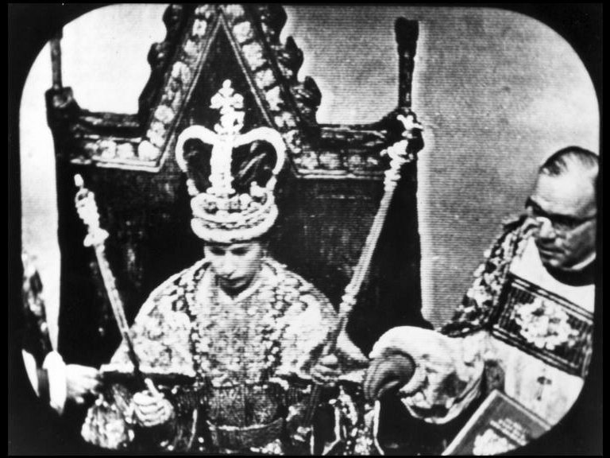

Zadok the Priest, a Coronation Hymn by George Friederic Handel

A
ND Zadok the priest and Nathan the prophet have anointed him king in Gihon: and they are come up from thence rejoicing, so that the city rang again. This is the noise that ye have heard. 46 And also Solomon sitteth on the throne of the kingdom. (1 Kings 1:45-46)

T
HE king also said unto them, Take with you the servants of your lord, and cause Solomon my son to ride upon mine own mule, and bring him down to Gihon: (1 Kings 1:33)

A
ND when they drew nigh unto Jerusalem, and were come to Bethphage, unto the mount of Olives, then sent Jesus two disciples, 2 Saying unto them, Go into the village over against you, and straightway ye shall find an ass tied, and a colt with her: loose them, and bring themunto me. 3 And if any mansay ought unto you, ye shall say, The Lord hath need of them; and straightway he will send them. 4 All this was done, that it might be fulfilled which was spoken by the prophet, saying, 5 Tell ye the daughter of Sion, Behold, thy King cometh unto thee, meek, and sitting upon an ass, and a colt the foal of an ass. 6 And the disciples went, and did as Jesus commanded them, 7 And brought the ass, and the colt, and put on them their clothes, and they set himthereon. 8 And a very great multitude spread their garments in the way; others cut down branches from the trees, and strawed themin the way. (Matthew 21:1-8)

Our hymn for today is a masterpiece by that Master of Music, George Friederic Handel (1685–1759)– author also of the MESSIAH. The career of Handel demonstrates the importance of perseverance. Born in Halle, Germany, Handel mastered composing for the organ, the oboe and the violin alike by the time he was 10 years old. Throughout his early career, Handel composed mostly church musical pieces, and later in life, his work stressed biblical themes such as his oratorios, Samson, Jephtha, Judas Maccabeus, etc. His Baroque style in music was the best in Europe during his age. His greatest Masterpiece was the Messiah, a great hymn whose only words were directly quoted from scripture and presented for the first time in Dublin (1741) to raise money for a charity. Kings of England have always stood for the final movement (Hallelujah Chorus) of the Messiah.

It would not be considered strange Handel was called upon to compose the coronation music, Zadok the Priest, for King George II (Handel’s Coronation Work #). The lyrics require little explanation since they follow the simplicity of biblical expression.. The entire composition is to show the power and predestined will of God in setting up kings and rulers. Since the coronation of George II, every British Monarch has been coronated with this work of Handel. Even when the Queen is coronated as monarch to rule instead of a King successor, the same words are used (King) since the lyrics are directly from the Bible. Please observe with me the simple lyrics to this masterpiece:

Zadok the Priest

Zadok the priest
And Nathan the prophet
Anointed Solomon king
And all the people
Rejoiced, rejoiced, rejoiced
And all the people
Rejoiced, rejoiced, rejoiced
Rejoiced, rejoiced, rejoiced
And all the people
Rejoiced, rejoiced, rejoiced and said:

God save the king
Long live the king
God save the king
May the king live forever
Amen, amen, alleluia, alleluia, amen, amen
Amen, amen, alleluia, amen

(4 measure rest)
God save the king
Long live the king
May the king live forever
Amen, amen, alleluia, alleluia, amen, amen
May the king live
May the king live
Forever, forever, forever
Alleluia, alleluia, alleluia, amen, amen
Alleluia, alleluia, amen, amen, amen
Amen, amen, alleluia, alleluia, alleluia, amen
Long live the king
God save the king
Long live the king
May the king live
May the king live
Forever, forever, forever
Amen, amen, alleluia, alleluia, amen, amen, amen, amen
Amen, amen, alleliua, amen, alleluia,
Amen, amen, alleluia, alleluia

Handel’s grasp of meaning in Scripture is superb, even if his lyrics quote only that source. The reverential musical tone and tenor of Zadok the Priest lends reverential meaning and spirit to the occasion being represented. His intention is to demonstrate the beauty of the King of Kings, and to point out that the lessor kings of Britain are subordinate always to that Lord of Lords and King of Kings.

His lyrics, taken from the First Book of Kings (Chapter 1) point to David as the type of Christ, and a king (David) owing his scepter to Almighty God.

Nathan the prophet was a friend of King David – a friend that did not always tell the King what he desired to hear. That is the mark of a true friend. It was Nathan who advised David of his great sin of adultery with Bathsheba and the ensuing murder of Uriah. But now, in the final days of his life, Nathan remains the steadfast friend who will serve to ensure a godly ruler will succeed David on the throne of Israel – Solomon.

Jesus is considered, in legal descent, the Son of David. David has ordered that his own son, Solomon, to be coronated as King of Israel; and he orders that Solomon be given David’s own mule upon which to ride to the crowning ceremony: “Take with you the servants of your lord, and cause Solomon my son to ride upon mine own mule, and bring him down to Gihon.” Does this remind us of a greater Coronation to follow?

O
N the next day much people that were come to the feast, when they heard that Jesus was coming to Jerusalem, 13 Took branches of palm trees, and went forth to meet him, and cried, Hosanna: Blessed isthe King of Israel that cometh in the name of the Lord. 14 And Jesus, when he had found a young ass, sat thereon; as it is written, 15 Fear not, daughter of Sion: behold, thy King cometh, sitting on an ass's colt. 16 These things understood not his disciples at the first: but when Jesus was glorified, then remembered they that these things were written of him, and thatthey had done these things unto him. (John 12:12-16)

God ordained His own Son would follow the example of Solomon, as son of King David, and ride into Jerusalem on the colt of a young ass. (mule). On the next day—the Lord's day, or Sunday (see John 12:1); the tenth day of the Jewish month Nisan, on which the paschal lamb was set apart to be kept up until the fourteenth day of the same month, when the whole assembly of the congregation of Israel were to kill it in the evening (Ex 12:3, 6). Even so, from the day of this solemn entry into Jerusalem, "Christ our Passover" was virtually set apart to be sacrificed for us (1Cor 5:7). Jesus, consistent with the Law, was crucified on 14 Nisan as our Passover Lamb. Contemplate the Day!

