Hymns of the Church – You Raise Me Up – 10 April 2018, Anno Domini (In the Year of our Lord)

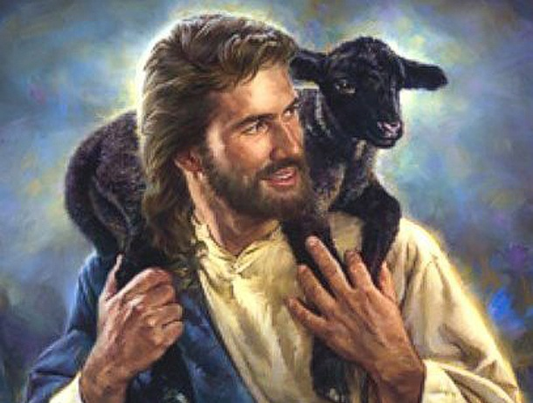

A
nd, behold, two of them went that same day to a village called Emmaus, which was from Jerusalem about threescore furlongs. 14 And they talked together of all these things which had happened. 15 And it came to pass, that, while they communed together and reasoned, Jesus himself drew near, and went with them. (Luke 24:13-15)

B
ut Mary stood without at the sepulchre weeping: and as she wept, she stooped down, and looked into the sepulchre, 12 And seeth two angels in white sitting, the one at the head, and the other at the feet, where the body of Jesus had lain. 13 And they say unto her, Woman, why weepest thou? She saith unto them, Because they have taken away my Lord, and I know not where they have laid him. 14 And when she had thus said, she turned herself back, and saw Jesus standing, and knew not that it was Jesus. 15 Jesus saith unto her, Woman, why weepest thou? whom seekest thou? She, supposing him to be the gardener, saith unto him, Sir, if thou have borne him hence, tell me where thou hast laid him, and I will take him away. 16 Jesus saith unto her, Mary. She turned herself, and saith unto him, Rabboni; which is to say, Master. (John 20:11-16)

How often are we depressed and full of misery, feeling all alone and neglected by God and man! And likewise how often is it that the Lord for whom we seek with diligent eyes and thirsting heart walks right beside us to comfort and sustain? Though a modern hymn, this was composed for a broken heart and for the silent joy that is available to those who will silence themselves and seek His Face in tears.

This song was made famous by Josh Groban in 2004, but predates that performance by many years. The lyrics are the work of the Irish novelist Brendan Graham, and the music is the composition of the Norwegian composer, Rolf Løvland. The song was first performed at the funeral of Løvland’s mother. Its words appeal to the heart of sorrow and dejection when the Lord comes, in His soft and caring way, to give solace.

You Raise Me Up

When I am down and, oh my soul, so weary

When troubles come and my heart burdened be
Then, I am still and wait here in the silence
Until you come and sit awhile with me

You raise me up, so I can stand on mountains

You raise me up, to walk on stormy seas
I am strong, when I am on your shoulders
You raise me up... To more than I can be

You raise me up, so I can stand on mountains

You raise me up, to walk on stormy seas
I am strong, when I am on your shoulders
You raise me up... To more than I can be

There is no life - no life without its hunger

Each restless heart beats so imperfectly
But when you come and I am filled with wonder
Sometimes, I think I glimpse eternity

You raise me up, so I can stand on mountains

You raise me up, to walk on stormy seas
I am strong, when I am on your shoulders
You raise me up... To more than I can be

You raise me up, so I can stand on mountains

You raise me up, to walk on stormy seas
I am strong, when I am on your shoulders

You raise me up... To more than I can be
You raise me up... To more than I can be

When I am down and, oh my soul, so weary When troubles come and my heart burdened be Then, I am still and wait here in the silence Until you come and sit awhile with me Can you imagine the heartache of the two disciples on that lonely Road to Emmaus the Sunday following the Lord’s crucifixion. The highest hopes of their souls had seemingly been dashed on the Hill called Calvary outside the gates of Jerusalem the preceding Friday. The One whom they knew to be the Messiah, and Savior of Israel, was cruelly crucified! So, as misery loves company, they walked and talked together of that horrendous event. The loss was not theirs alone, but of their children, families and loved ones. There was no hope in Israel! Suddenly, a stranger approached them on that road. He inquired of their sad discussion, and then revealed the reasons for all that had happened in Jerusalem from the Law and the Prophets. It was not until they had reached their destinations that they stopped and invited the stranger inside their homes for refreshment. Being a gentleman of precise eastern courtesies, He acted as if He would travel on, but did accept their invitation after their insistence. If our prayers at first fail, persistence will bring an answer. The Stranger did sit a spell with these men and opened their eyes to many mysteries. He will do that for us, too, if we earnestly seek His face. Their eyes were opened at the breaking of the bread.

You raise me up, so I can stand on mountains You raise me up, to walk on stormy seas I am strong, when I am on your shoulders You raise me up... To more than I can be Consider your grave disappointment if your beloved son, daughter or best friend had died a tragic death. You buried them with hurried honors due to some urgent cause. Afterwards, you return to pay honors due, and find the body missing and the tomb in disarray. No sign of the body either in the tomb or elsewhere! How would you mourn the loss of that dead body. Imagine how Mary Magdalene felt that early Sunday morning! The one Person who had done more kindness to her than any man could have done was brutally murdered and now, to add insult to injury, His tomb has been opened and His body is missing! Already mourning deeply His death, she now loses all composure and begins to weep bitterly and uncontrollably. Suddenly, the Gardener approaches and asks why she is weeping. She responds, Sir, if thou have borne him hence, tell me where thou hast laid him, and I will take him away. All alone, in the stillness of a Garden (the place for creating life) Mary is blinded by her tears. But when Jesus calls her name, Mary she recognizes Him immediately for none other ever called her name with such meaning and compassion. Are we blinded by tears? Listen! He is calling you to a greater understanding of your circumstances.You came looking for death, but, Behold, you have discovered LIFE! Your spirit suddenly soars to heights unbelievable. Looking at your risen Lord, face-to-face, you are able, like Peter, to walk on water.

There is no life - no life without its hunger Each restless heart beats so imperfectly But when you come and I am filled with wonder Sometimes, I think I glimpse eternity. We eat our daily bread because we are hungry. Hunger is natures means of causing us to eat food to sustain our bodies. Hunger in the spirit leads us to that Bread that can only satisfy our souls in eternal pasturelands. We are mortal and fragile. Our very lives depend upon the next beat of the heart. At some point in time, that beat will not be forthcoming in this life, but the next beat will be beyond the Gates of Splendor with the once-known Stranger who has now become your Redeemer, Savior, King, and Lord. With each marvelous mystery revealed to our hungering soul through Holy Scripture, we do, indeed, glimpse eternity.

Postscript
Though this song does not mention the name of the Stranger, the truth of His identity is hidden in the shadows of descriptive phrases and meanings. No other can lift you up from the depths of despair and plant your feet on mountains. No other can take all of your grievous burdens and bear them along by your side. No one else can cause you to defy the natural law and walk on stormy seas of life, or speak to you more audibly in silent stillness than the boom of one hundred cannons on a battlefield. No one else can satisfy the hunger that worldly bread cannot, or make you to be more than you can be. It is an easy role for Christ to work all of these miracles in lives that are ship-wrecked and foundering on the reefs of life. He comes and sits with us awhile in our lonely solitude. He consoles a weary and despondent heart. He changes our tears of sorrow and mourning to tears of joy – and He does it in an instant just as He did for Mary.

