Hymns of the Church – Work for the Night is Coming – 22 May 2018, Anno Domini (In the Year of our Lord)

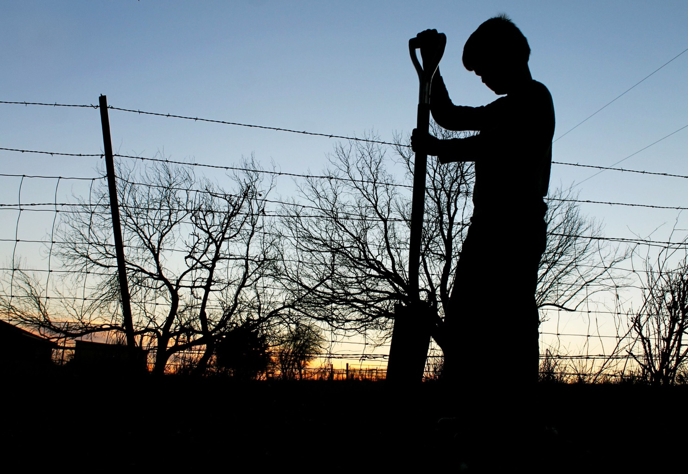

I
must work the works of him that sent me, while it is day: the night cometh, when no man can work. 5 As long as I am in the world, I am the light of the world. (John 9:4-5)

B
ut ye, brethren, are not in darkness, that that day should overtake you as a thief. 5 Ye are all the children of light, and the children of the day: we are not of the night, nor of darkness. 6 Therefore let us not sleep, as do others; but let us watch and be sober. 7 For they that sleep sleep in the night; and they that be drunken are drunken in the night. 8 But let us, who are of the day, be sober, putting on the breastplate of faith and love; and for an helmet, the hope of salvation. (1 Thess 5:3-8)

This hymn will fly in the face of the modern ‘easy believism’ of the modern church which avers that all one need do is call on the name of Jesus, whether they know Him or not; and that once done, God is eager to shower material blessings upon them - (with the stipulation that you place a respectable deposit of ‘Seed Money’ in the offering plate for the preacher’s excessive lifestyle.

This hymn was written by Anna Coghill in 1854 while still only eighteen years old. Music is by Lowell Mason, WORK SONG, in 1864.

Work for the Night is Coming

Work, for the night is coming,
Work through the morning hours;
Work while the dew is sparkling,
Work ’mid springing flowers;
Work when the day grows brighter,
Work in the glowing sun;
Work, for the night is coming,
When man’s work is done.

Work, for the night is coming,
Work through the sunny noon;
Fill brightest hours with labor,
Rest comes sure and soon.
Give every flying minute,
Something to keep in store;
Work, for the night is coming,
When man works no more.

Work, for the night is coming,
Under the sunset skies;
While their bright tints are glowing,
Work, for daylight flies.
Work till the last beam fadeth,
Fadeth to shine no more;
Work, while the night is darkening,
When man’s work is o’er.

Work, for the night is coming, Work through the morning hours; Work while the dew is sparkling, Work ’mid springing flowers; Work when the day grows brighter, Work in the glowing sun; Work, for the night is coming, When man’s work is done. Before there was any work whatsoever, God began His Creation while the earth was without form, and void; and darkness was upon the face of the deep. We would be in darkness today were it not for the work of the sun in sending forth its life-giving beams. Honest work will overcome darkness even when begun in darkness. God began His work of Creation in darkness, but finished in brilliant Light. Our electrical power grid is powered by great generators and solar panels performing work to improve our lives. Good works are evidence of God’s grace both in nature and in the lives of men. The candle uses itself up in providing light where darkness once ruled. We, too, must use our souls to generate light rather than darkness. As Hugh Latimer said to Nicolas Ridley before the burning stake outside Balliol College, Oxford: Play the man, Master Ridley; we shall this day light such a candle, by God's grace, in England, as I trust shall never be put out. Need I remind you that the candle still burns! There are times when work is less appealing than at other times. We would like to stop by the flower garden and linger there in the shade even while souls are perishing, but duty beckons us on. Even in the wee hours of the morning, while the dew is still on the roses, it is time for work and duty. 33 Ye sent unto John, and he bare witness unto the truth. 34 But I receive not testimony from man: but these things I say, that ye might be saved. 35 He was a burning and a shining light: and ye were willing for a season to rejoice in his light. 36 But I have greater witness than that of John: for the works which the Father hath given me to finish, the same works that I do, bear witness of me, that the Father hath sent me. (John 5:32-36)

Salvation, too, results from work, but not OUR work! It is the finished work of Christ in our redemption. If we are to take up our crosses daily and follow Him, we must be ready to do a day’s work as evidence of our salvation. We are saved by GRACE through Faith – TRUE! But our lives beyond the saving Grace must give evidence of that salvation. 18 Yea, a man may say, Thou hast faith, and I have works: shew me thy faith without thy works, and I will shew thee my faith by my works. (James 2:18) Though a stone of stumbling for the great Luther, these words are confirmed throughout Holy Writ.

Work, for the night is coming, Work through the sunny noon; Fill brightest hours with labor, Rest comes sure and soon. Give every flying minute, Something to keep in store; Work, for the night is coming, When man works no more. We must cultivate the fields and sow in the Spring, labor throughout the summer to prevent weeds and draught from overtaking; but we must also finish the job at harvest season. There is a time for everything under the sun as the Preacher (Ecclesiastes) says. God does give His people rest. Our Lord is not only our Passover, but our Sabbath Rest as well. Our good works are His – our bad deeds are our own to claim. 3 For we which have believed do enter into rest, as he said, As I have sworn in my wrath, if they shall enter into my rest: although the works were finished from the foundation of the world. Heb 4:3 (KJV) If the righteous works we do in Christ are not His works, how is it that they were finished from the foundation of the world?

Work, for the night is coming, Under the sunset skies; While their bright tints are glowing, Work, for daylight flies. Work till the last beam fadeth, Fadeth to shine no more; Work, while the night is darkening, When man’s work is o’er. Perhaps this idea of coming night is opposite that of God’s labors since His work always begins in darkness and ends in brilliant light – just as those who are His Elect began a life of darkness ere they heard the clarion call of the Holy Ghost. Once we are believers in that Promise made to Abraham of a Seed, we would be well advised to do the works of righteousness, If ye were Abraham's children, ye would do the works of Abraham. (John 8:39) and, 12 Verily, verily, I say unto you, He that believeth on me, the works that I do shall he do also; and greater works than these shall he do; because I go unto my Father. (John 14:12) We are the Children of Light and, therefore, our labors are performed in the open light of day and not the cover of the darkness of night.

There is a night ahead for all who are the Children of God, but that night is not one of walking in the stupor of drunkenness, but of sleep and dreamy comfort in the bosom of Abraham. Dylan Thomas penned these dark and hopelss words in a poem: Do not go gentle into that good night, Old age should burn and rave at close of day; rage, rage against the dying of the light. Such words of hope forlorn do not belong in the Christian’s dictionary. I am seventy-five years of age and I thank God that He has taken any dread or fear of death from my soul. 51 Behold, I shew you a mystery; We shall not all sleep, but we shall all be changed, 52 In a moment, in the twinkling of an eye, at the last trump: for the trumpet shall sound, and the dead shall be raised incorruptible, and we shall be changed. 53 For this corruptible must put on incorruption, and this mortal must put on immortality. 54 So when this corruptible shall have put on incorruption, and this mortal shall have put on immortality, then shall be brought to pass the saying that is written, Death is swallowed up in victory. 55 O death, where is thy sting? O grave, where is thy victory? 56 The sting of death is sin; and the strength of sin is the law. 57 But thanks beto God, which giveth us the victory through our Lord Jesus Christ. (1 Cor 15:51-57)

