Hymns of the Church (Will the Circle be Unbroken) – 9 September 2014, Anno Domini (In the Year of our Lord)

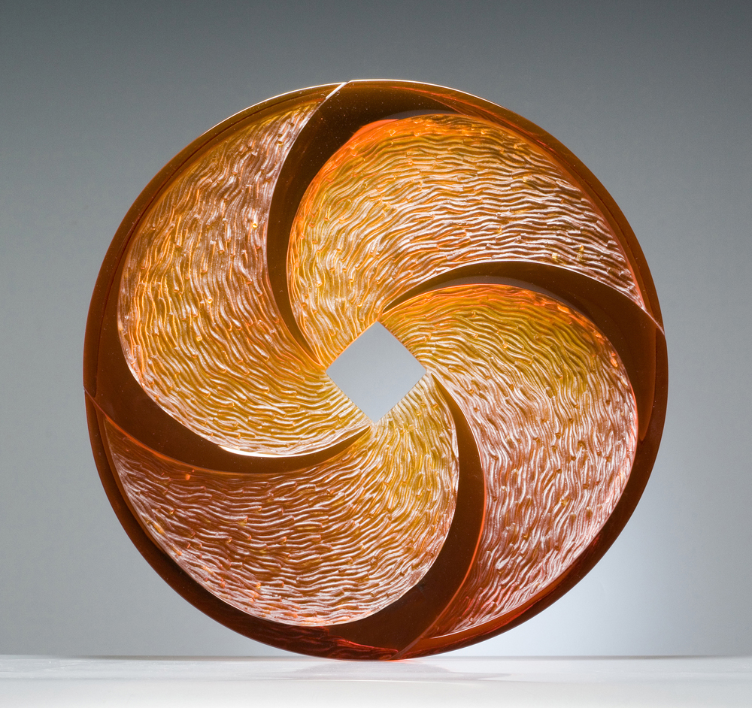

And when Jacob had made an end of commanding his sons, he gathered up his feet into the bed, and yielded up the ghost, and was gathered unto his people. (Gen 49:33)

A rather pressing question is raised in the Old Testament accounts of those saints who died in the Lord: “They were gathered to their people, or slept with their fathers.” Read the last word on King David: “So David slept with his fathers, and was buried in the city of David.” (1 Kings 2:10) This same line is repeated for each of the Patriarchs of Israel. The question is this: Shall we, too, sleep with our fathers and loved ones, and shall we, too, be gathered across Jordan Banks with our people; or shall we go to that Dark Abyss where names are not known or given?

There are two gospel songs by this same title, but today, we will concentrate on the first written by Ada Habershon in 1907. Mrs. Habershon was a member of the inner circle of the Rev. Charles Spurgeon and Dwight L. Moody. She composed many scores of gospels songs, but this seems the most popular. Though often used as a funeral dirge, the song has an application to our present lives and testimony. Having recently attended the funeral of a beloved relative, I heard this song for the first time. It was often sung beautifully by George Beverly Shea during the Billy Graham Crusades. I have fallen in love with the happy, and sad, memories the song evokes. The musical score is composed by Mr. Charles H. Gabriel.

Will the Circle be Unbroken
Author: Ada R. Habershon

There are loved ones in the glory,
Whose dear forms you often miss;
When you close your earthly story,
Will you join them in their bliss?
Refrain
Will the circle be unbroken
By and by, by and by?
In a better home awaiting
In the sky, in the sky?

In the joyous days of childhood,
Oft they told of wondrous love,
Pointed to the dying Savior
Now they dwell with Him above.
Refrain

You remember songs of heaven
Which you sang with childish voice,
Do you love the hymns they taught you,
Or are songs of earth your choice?
Refrain

You can picture happy gatherings
Round the fireside long ago,
And you think of tearful partings,
When they left you here below:
Refrain

One by one their seats were emptied,
One by one they went away;
Here the circle has been broken—
Will it be complete one day?
Refrain

The song posits its fundamental question up front by giving us a setting for the remainder: “There are loved ones in the glory, Whose dear forms you often miss; When you close your earthly story, Will you join them in their bliss? If our entire family has not gone to the devil, we all have loved ones who are in the Glory of Heaven awaiting our own arrival there. We see their smiling faces (we never remember the frowns) in our minds eye, and we long for just one more sight of an ‘old mother rocking away in an old rocking chair’ or a gentle and loving father walking the path to the front door. Would we not love to have just one more moment of solitude with these loved ones? They lived their lives and cared for us as we care now for them, though departed. They marched steadily to their final day on earth from the moment of their birth. Now we continue the march. We all are approaching the last page of the story of our lives. We may not know the number of pages remaining. Some stories are long and filled with many experiences, and some stories are short and sweet as with that of a child who has gone early to see His Father and our Father, His God and our God. Will you be privileged to see them again, or shall you view them from afar as they rest in the bosom of Abraham as your soul famishes in thirst?

The family circle is continually being broken in this life as dear ones depart for eternity. But that same circle can exist in glory if our souls have been owned by the Lord as His Elect. So that circle reforms beyond Jordan Waters. Refrain: “Will the circle be unbroken, By and by, by and by? In a better home awaiting, In the sky, in the sky?” A circle is infinite. It has no beginning or end except in the links that form it. Those links may be removed and joined together again in a new circle in glory. If a link is tragically missing, the circle beyond Jordan will grow smaller.

“In the joyous days of childhood, Oft they told of wondrous love, Pointed to the dying Savior, Now they dwell with Him above.” It was a far more natural thing for our fathers, mothers, and grandparents to know that love of Christ in olden days than in the wicked and evil days in which we now live. The lures that draw us away from reverence and faith are far stronger in our day. There was not the strong lure of drugs, alcohol, promiscuous sex, homosexuality, or abortion to contend with in their day. Society was more mellow, gentle, and welcoming of those who were followers of Christ. As our fathers and mothers grew older, the strong savor of that “old time religion” fortified their memories and their souls. In the sinking sands of their old age, those sweet and precious memories of a Savior who loved them in childhood, also assured them of His love for them in their aged fragility. They had an Anchor and a Hope fixed on high which could not be shaken. Now they have gone on to their promised hope in Christ to the shores of far Jordan, and the glories of Heaven.

“You remember songs of heaven, Which you sang with childish voice, Do you love the hymns they taught you, Or are songs of earth your choice?” Well, do you? Do you remember those sweet, childhood songs we sang at Bible camp or Sunday school. Do you remember with what assurance you sang, and believed, every word? “Jesus loves me, this I know - for the Bible tells me so;” “Jesus loves the little children;” “Oh, the B-I-B-L-E, that’s the Book for me;” and “Joshua fought the battle of Jericho!” There was never a doubt that Jesus loved you then- and there should be no doubt that He loves you now. Yes, Jesus loves the little children, and such are you regardless of age if you love Him. The B-I-B-L-E, I hope is still the Book for you and me. Joshua did fight that battle, and God helped him. He won, but the victory belonged to God. We, too, have battles to fight. Have we accounted the victory as belonging to God in our lives? Or, have we now forgotten the sweet old songs of childhood and opted for the coarse, vapid songs that the world offers? Have our songs changed? “By the rivers of Babylon, there we sat down, yea, we wept, when we remembered Zion. We hanged our harps upon the willows in the midst thereof. For there they that carried us away captive required of us a song; and they that wasted us required of us mirth, saying, Sing us one of the songs of Zion. How shall we sing the LORD'S song in a strange land?” (Psalms 137:1-4) The songs of our childhood are the mark of our soul and character.

“You can picture happy gatherings, Round the fireside long ago, And you think of tearful partings, When they left you here below:” This is truly sad for us, but a cause of rejoicing for them. Why do we always make reference to our loved ones in glory in the past tense? It is wrong and a cause for sorrow to do so. God is the God of Abraham, Isaac, Jacob, Jerry, Don, Scott, Betty, Paulette, Ruth, etc – He is not the God of the dead but of the living. Abraham is in glory, and so will we be someday if our hearts are fixed on God, and that solid Rock of Christ! I can clearly see my mother’s smiling face; and my father in his excited discourse. They are alive today in glory, but they are also alive in my heart of hearts, for a piece of my heart is in Heaven where they have gone. Those happy moments when mother would call me to dinner, and father would drive up into the driveway from work, or some trip, are fresh in my mind though they may have occurred sixty years ago.

“One by one their seats were emptied, One by one they went away; Here the circle has been broken— Will it be complete one day?” The mercy of God is clearly evident in this last verse. Death was never an intention of God, but sin has resulted in that wage. So God takes the souls of His people one-by-one; not suddenly and completely does He take the whole of our relations. This is merciful to us for, if we lost all of our friends and loved ones at once, how miserable we would be alone on earth. Though our circle here on earth starts large and expansive, it slowly shrinks as each link is taken away to a fairer and better land. That circle is being recreated in newness of life just beyond the veil of our understanding and sight. That circle that has been broken here on earth is being forged perfect and whole in the glory of Heaven. Don’t you want to go there and feel your mother’s caress again, and your father’s encouraging and happy words? Do you want to hear your grandmother’s sweet voice singing her favorite hymn in perfect diction and tune? What of our childhood friends whom we swore to remain always in the bond of friendship? It was never possible on earth, but it is in Heaven.

What of the family circle, past and future, of your life. Is it unbroken beyond the Gates of Splendor, or will you find the Lord’s Table with the empty chairs of your favorite and most beloved of friends and family? A line from the Rubaiyyat of Omar Khayyam comes to mind: “The bird of time has but a little way to fly, and lo, the bird is on the wing.” See to the souls of your loved ones while time continues, and seed time and harvest remain.

