Hymns of the Church – We Plough the Field and Scatter– 8 May 2018, Anno Domini

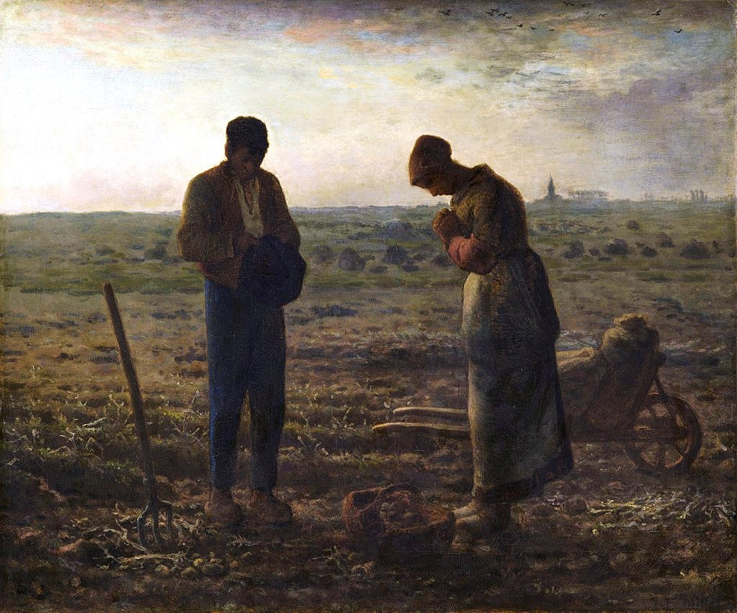

A
nd he said unto them, Take heed what ye hear: with what measure ye mete, it shall be measured to you: and unto you that hear shall more be given. 25 For he that hath, to him shall be given: and he that hath not, from him shall be taken even that which he hath. 26 And he said, So is the kingdom of God, as if a man should cast seed into the ground; 27 And should sleep, and rise night and day, and the seed should spring and grow up, he knoweth not how. 28 For the earth bringeth forth fruit of herself; first the blade, then the ear, after that the full corn in the ear. (Mark 4:24-28)

The Collect for The Fifth Sunday after Easter,
commonly called Rogation Sunday.
The Collect.

O
LORD, from whom all good things do come; Grant to us thy humble servants, that by thy holy inspiration we may think those things that are good, and by thy merciful guiding may perform the same; through our Lord Jesus Christ. Amen.

The Collect
As in all Godly prayers, the focus should be on our need of God in our hearts and thoughts more than for any personal gain of riches. Though appropriate for the farmer to pray for rain, and the Seafarer for following winds, these things should be hoped for only insofar as they might bring us nearer to God in Spirit and Truth. It has been true with many that prosperity has blinded them of their need for God. The object prayed for in the Rogation Collect is most finally that we may possess a thankful heart in worship of those needs provided by the Hand of God. If the prosperity of America could be traded for a return to godliness, would we not opt for the latter? As has been pointed out recently by Godly ministers of the Anglican Orthodox Church, we need to pray in at least three ways: personally, communally, and as a national people. The Collect of Rogation calls us to that prayer attitude always counseled in Scripture.

The Collect for Sunday Past (5th after Easter) fulfills the very need of our hearts to be thankful for ALL that comes our way as from God, and a petition – not for material increase – but that our minds may be conformed to that Mind which is in Christ through the inspiration of God’s Holy Ghost. We further petition that God not only grant us a good and obedient mind, but enable us to perform those good things which the Holy Ghost has led us to embrace in our hearts. Please observe the abject lack of any plea for material enrichment in these words. When America turns her mind away from shining idols and back to the Resplendent Light of Christ, all things needful shall be added to her national treasure.

The Rogation Hymn
When I hear this hymn, my thoughts always go to a common painting displayed in my home when I was a child (of course a cheap copy) – The Angelus by Jean-Francois Millet (1859). A few years later (1865), Millet related his inspiration for the painting. The idea for The Angelus came to me because I remembered that my grandmother, hearing the church bell ringing while we were working in the fields, always made us stop work to say the Angelus prayer for the poor departed very religiously and with cap in hand. This comports fittingly with the spirit of good works symbolized on Rogation Sunday which follow in the lives of those who are the called and chosen of the Lord. The painting depicts two poor peasants who have been laboring in a field of potatoes and are praying over a small yield of harvest. In the distant background is depicted a church steeple from which the church bell rings the Angelus or call to prayer. Labor ceases at the urge of the Spirit. Though our good works are important, our spiritual security in God takes precedence. Our works, too, belong only to Him.

We Plough the Field and Scatter

We plough the fields and scatter
the good seed on the land,
but it is fed and watered
by God's almighty hand:
you send the snow in winter,
the warmth to swell the grain,
the breezes and the sunshine,
and soft refreshing rain.
Refrain:
All good gifts around us
are sent from heaven above;
we thank you, Lord, we thank you, Lord
for all your love.

You only are the Maker
of all things near and far;
you paint the wayside flower,
you light the evening star;
the winds and waves obey you;
by you the birds are fed;
much more to us, your children,
you give our daily bread.
Refrain

We thank you, our provider,
for all things bright and good,
the seedtime and the harvest,
our life, our health, our food.
No gifts have we to offer
for all your love imparts,
but that which you most welcome:
our humble, thankful hearts.
Refrain

We plough the fields and scatter the good seed on the land, but it is fed and watered by God's almighty hand: you send the snow in winter, the warmth to swell the grain, the breezes and the sunshine,and soft refreshing rain. We all plough and scatter seed of some sort, spiritually speaking; however, seed of what nature? We either labor for our father the devil, or for our Father the Lord. We cannot serve BOTH! 24 No man can serve two masters: for either he will hate the one, and love the other; or else he will hold to the one, and despise the other. Ye cannot serve God and mammon. (Matthew 6:24) Clearly, it is not the merits of our own labors that beget good fruit, but rather the germinating influences of the Holy Spirit in the darkness of the good soil of the heart.

You only are the Maker of all things near and far; you paint the wayside flower, you light the evening star; the winds and waves obey you; by you the birds are fed; much more to us, your children, you give our daily bread. No one has provided the gardens of pastureland upon which the wild Zebra feeds but the Lord. The wild creatures of the earth have ample food for their survival without the lifting of a finger by man. It is the Lord who feeds them, and it is the Lord that has placed us in the midst of enormous and prosperous faculties and resources by which we are fed with little effort. 26 Behold the fowls of the air: for they sow not, neither do they reap, nor gather into barns; yet your heavenly Father feedeth them. Are ye not much better than they? 27 Which of you by taking thought can add one cubit unto his stature? 28 And why take ye thought for raiment? Consider the lilies of the field, how they grow; they toil not, neither do they spin: 29 And yet I say unto you, That even Solomon in all his glory was not arrayed like one of these. 30 Wherefore, if God so clothe the grass of the field, which to day is, and to morrow is cast into the oven, shall he not much more clothe you, O ye of little faith? 31 Therefore take no thought, saying, What shall we eat? or, What shall we drink? or, Wherewithal shall we be clothed? 32 (For after all these things do the Gentiles seek:) for your heavenly Father knoweth that ye have need of all these things. 33 But seek ye first the kingdom of God, and his righteousness; and all these things shall be added unto you. 34 Take therefore no thought for the morrow: for the morrow shall take thought for the things of itself. Sufficient unto the day is the evil thereof.
We thank you, our provider, for all things bright and good, the seedtime and the harvest, our life, our health, our food. No gifts have we to offer for all your love imparts, but that which you most welcome: our humble, thankful hearts. It is certain that there is a time for our labors, performed in faith of future blessing, that are delineated by the natural laws instituted by our Maker and Lord – field cultivation and ploughing, seedtime of sowing in our fields, weeding, guarding against vermin and thieves, and, finally, harvesting and gathering of the harvest. Just as our Lord allowed Adam to have a role in maintaining the Garden in Eden, He allows us to have a role in sowing His seed of the Gospel and participating in the harvest of souls; but not according to our merits and labors, but HIS! We must take a like interest in the hedging about, furrowing, planting, guarding against vermin and thieves, and weeding in the field of the Lord – His Church. Presently, the weeds and vermin seem to be gaining an upper hand.

Refrain
All good gifts around us are sent from heaven above; we thank you, Lord, we thank you, Lord for all your love. The glory of a great hymn is its relation to Scriptural truth. The refrain of this hymn reflects just THAT! Every good gift and every perfect gift is from above, and cometh down from the Father of lights, with whom is no variableness, neither shadow of turning. Of his own will begat he us with the word of truth, that we should be a kind of firstfruits of his creatures.. (James 1:17-18) It is His loves which constrains His blessings usward.

