Trusting Jesus – 12 September 2017, Anno Domini

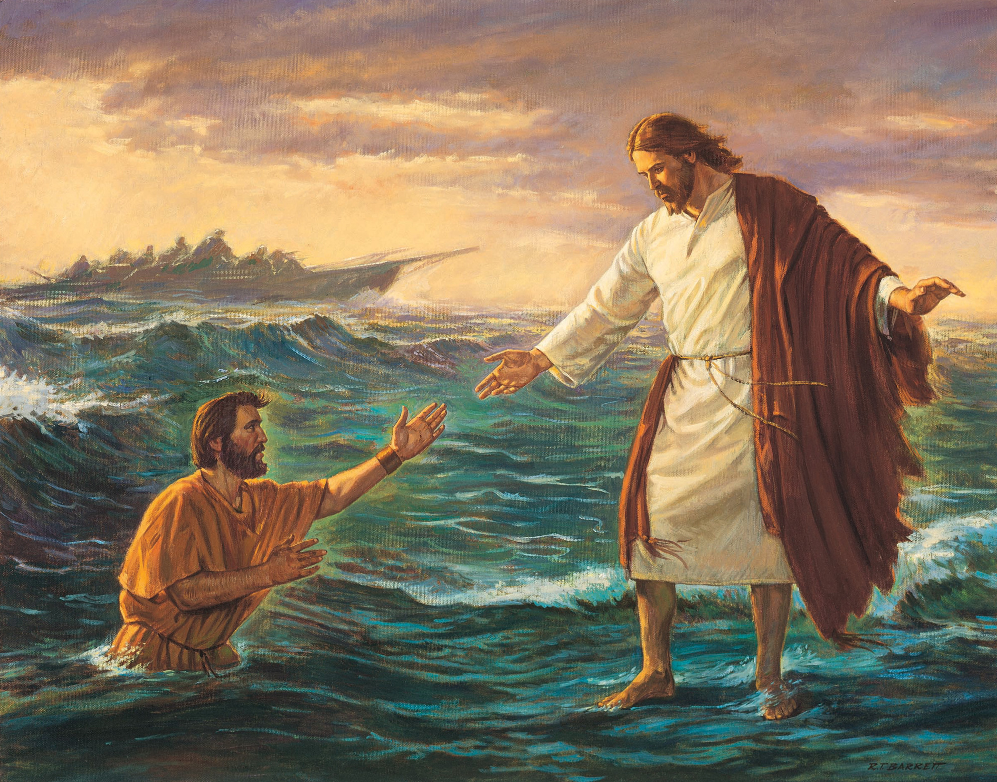

1 Let not your heart be troubled: ye believe in God, believe also in me. (John 14:1)

This hymn was written by Edgar P. Stites in 1876 and first appeared as a poem in a newspaper of that time. When Dwight L. Moody saw the poem, he gave it to Ira Sankey and asked that he put it to music which he did in the present tune we have today

Trusting Jesus
(a favorite Hymn of the Korean Church)

Simply trusting every day,
Trusting through a stormy way;
Even when my faith is small,
Trusting Jesus, that is all.

Refrain
Trusting as the moments fly,
Trusting as the days go by;
Trusting Him whate’er befall,
Trusting Jesus, that is all.

Brightly does His Spirit shine
Into this poor heart of mine;
While He leads I cannot fall;
Trusting Jesus, that is all.
Refrain

Singing if my way is clear,
Praying if the path be drear;
If in danger for Him call;
Trusting Jesus, that is all.
Refrain

Trusting Him while life shall last,
Trusting Him till earth be past;
Till within the jasper wall,
Trusting Jesus, that is all.
Refrain

Simply trusting every day, Trusting through a stormy way; Even when my faith is small, Trusting Jesus, that is all. For those of great faith and much Bible knowledge, trusting Jesus is less difficult than for those who are recent recipients of the saving grace of our Lord. A new recruit to the military service develops marching skills by constant and repetitive practice. Faith, too, requires a modicum of practice. As we are confronted with the challenges of life, seek the Lord’s leading in prayer, and observe amazing responses from Heaven to those prayers, our faith grows exponentially. But even a small sliver of faith is sufficient if it is a pure and undefiled faith. Faith does not stand alone – it must be directed to the right source of strength. We may have faith in a stone image of a saint or angel, but that will avail nothing. Our faith must be focused on God. Many professing Christians place their faith in large congregations, church buildings and institutions, in some charismatic leader; but those are not the substances of availing faith. We are warned in both the Old and New Testaments not to place our trust in any man, king, minister, or potentate; we are to trust God above all. 8 It is better to trust in the Lord than to put confidence in man. 9 It is better to trust in the Lord than to put confidence in princes. (Psalm 118:8-9), and, Then Peter and the other apostles answered and said, We ought to obey God rather than men. (Acts 5:29)

Refrain
Trusting as the moments fly, Trusting as the days go by; Trusting Him whate’er befall, Trusting Jesus, that is all. Trust is really the evidence of faith. Trust is not a fleeting emotion as evidenced in the light and trivial worship of many modern churches – trust is a way of life to the believer. We placed our trust in Christ yesterday, we trust Him today, and we will trust Him tomorrow. The changing fortunes of war or circumstance should not diminish our trust in Christ. Our Lord not only died loving us, but died BECAUSE of that love. The pains of the cross did not deter Him. “A frantic mother called her pastor one day. She had a bad case of "nerves." He thought he heard a child's voice over the phone, so he asked, "Is your child upset and worried as you are?" "Why, of course not," she replied. "But why not?" he asked. "I suppose she puts her trust in me and lets me do the worrying," she answered. "Then make a transference, try to think of yourself as a child of God, and just as your child puts her trust in you, you put your trust in God." — Christian Digest

Brightly does His Spirit shine Into this poor heart of mine; While He leads I cannot fall; Trusting Jesus, that is all. The Light of God’s Holy Spirit shines brightest when our own feeble lamps of our heart grow dim. God be merciful unto us, and bless us; and cause his face to shine upon us; Selah. That thy way may be known upon earth, thy saving health among all nations. (Psalm 67:1-2) In making reference to the prominent preachers of His day (Pharisees and Scribes), Jesus warned the people about following them: 10 And he called the multitude, and said unto them, Hear, and understand: 11 Not that which goeth into the mouth defileth a man; but that which cometh out of the mouth, this defileth a man. 12 Then came his disciples, and said unto him, Knowest thou that the Pharisees were offended, after they heard this saying? 13 But he answered and said, Every plant, which my heavenly Father hath not planted, shall be rooted up. 14 Let them alone: they be blind leaders of the blind. And if the blind lead the blind, both shall fall into the ditch. (Matt 15:10-14) There are many ‘popular’ preachers who are leading thousands into the ditch (i.e.: Osteen and his ilk).

Singing if my way is clear, Praying if the path be drear; If in danger for Him call; Trusting Jesus, that is all. God puts a song in the heart of the believer in both good and bad times. 3 And he hath put a new song in my mouth, even praise unto our God: many shall see it, and fear, and shall trust in the Lord. (Psalm 40:3) O God, my heart is fixed; I will sing and give praise, even with my glory.” (Psalm 108:1) “But none saith, Where is God my maker, who giveth songs in the night. (Job 35:10) I call to remembrance my song in the night: I commune with mine own heart: and my spirit made diligent search, (Psalm 77:6) All songs and music of great beauty come by inspiration of God. All of the classical composers attest to this fact. Singing is a means of expressing joy. There are times when that joy becomes forlorn in the lonely, dark stretches of the long night. But we may still utter songs of praise to God thereby casting away fear and doubt. And then we have the benefit of prayer to bolster our courage and faith.

Trusting Him while life shall last, Trusting Him till earth be past; Till within the jasper wall, Trusting Jesus, that is all. This first clause of the final verse is pregnant with deep meaning. AS our Lord said to Martha without the tomb of her brother, Lazarus: I am the resurrection, and the life: he that believeth in me, though he were dead, yet shall he live: And whosoever LIVETH AND BELIEVETH IN ME SHALL NEVER DIE. Believest thou this? (John 11:25-26) Lazarus is asleep in death, yet he believed in the Lord. He is sleeping and not truly dead. All who believe are forever alive. But look at the capitalized words in the verse! We must believe in this life for there is no faith in the tomb after. We trust in Christ ALL THE WAY – in joys, in sorrows, in prosperity, in poverty, in health and in sickness we trust the Lord.

Do You?

