The Trusting Heart – 19 September 2017, Anno Domini

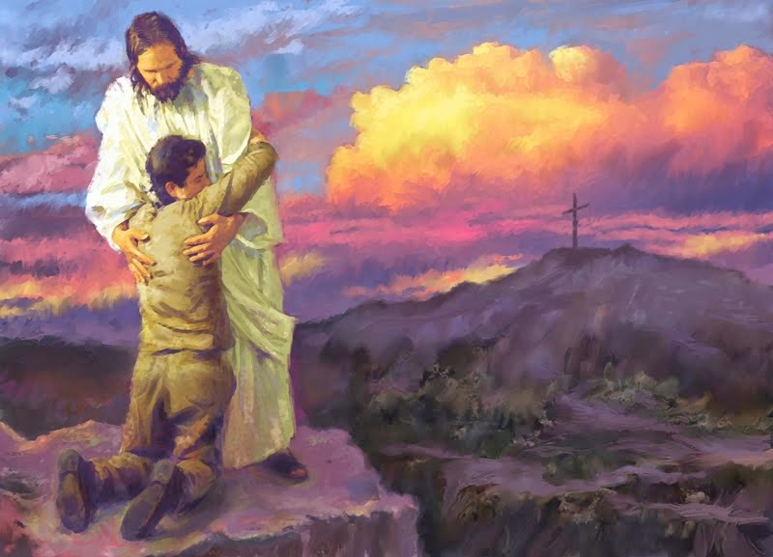

T
hen sang Deborah and Barak the son of Abinoam on that day, saying, 2 Praise ye the Lord for the avenging of Israel, when the people willingly offered themselves. 3 Hear, O ye kings; give ear, O ye princes; I, even I, will sing unto the Lord; I will sing praise to the Lord God of Israel. 4 Lord, when thou wentest out of Seir, when thou marchedst out of the field of Edom, the earth trembled, and the heavens dropped, the clouds also dropped water. 5 The mountains melted from before the Lord, even that Sinai from before the Lord God of Israel. (Judges 5:1-5)

This lovely old hymn is another favorite of the Korean Church, and it is one which, sung in the Korean language, moved me to respond to the call to the ministry many years ago. The lyrics are the work of Eliza E. Hewitt (1898), and the music is the composition of William J, Kirkpatrick. It is a joyful hymn that will lift the most depressed of Christian hearts. It reminds us of our absolute reliance upon our Lord Jesus Christ under every circumstance of life. Not only must we rely upon Him as our Fortress, Mainstay, and Rock of Salvation; but that reliance must be supported by an absolute trusting faith. It has been omitted from the 1940 Hymnal.

The Trusting Heart

The trusting heart to Jesus clings,
Nor any ill forebodes,
But at the cross of Calv’ry, sings,
Praise God for lifted loads!
Refrain
Singing I go along life’s road,
Praising the Lord, praising the Lord,
Singing I go along life’s road,
For Jesus has lifted my load.

The passing days bring many cares,
Fear not, I hear Him say,
And when my fears are turned to prayers,
The burdens slip away.
Refrain

He tells me of my Father’s love,
And never slumb’ring eye,
My everlasting King above
Will all my needs supply.
Refrain

When to the throne of grace I flee,
I find the promise true,
The mighty arms upholding me
Will bear my burdens too.
Refrain

The trusting heart to Jesus clings, Nor any ill forebodes, But at the cross of Calv’ry, sings, Praise God for lifted loads! If the heart does not trust and cling to our Lord, then it stands alone; and apart from our Lord Jesus Christ, there is only darkness and death. There is great sorrow depicted in the suffering of our Lord on Calvary Mount; but please consider the joy engendered at the Garden Tomb three days later! These worn and tired bodies will likewise lie in a borrowed tomb at the time of the Lord’s own choosing; but what joy comes on the morning of resurrection. Mary sought, while it was yet dark, to find a dead body of her Lord at the Garden Tomb; but her tears were turned from tears of deep morning into tears of inexpressible joy when she recognized the Voice of her Lord through her profuse tears – a LIVE BODY! The suffering of Christ bore the marks of many burdens which we have laid upon His able shoulders. The cross was also illustrative of that fact.

The passing days bring many cares, Fear not, I hear Him say, And when my fears are turned to prayers, The burdens slip away. The key to the beginning words of this verse is ‘passing days’. Every day has an end – including the day of sadness and sorrow. The sun always rises again in splendor. Our days under the sun are always mixed with goodness and wickedness. We can only make effort to allay the wickedness of the day, and foster the goodness thereof. Take therefore no thought for the morrow: for the morrow shall take thought for the things of itself. Sufficient unto the day is the evil thereof. (Matt 6:34)

He tells me of my Father’s love, And never slumb’ring eye, My everlasting King above Will all my needs supply. Our Lord has spoken His Father’s Love to us by His very life and Being. He is the personification of love. And He never slumbers or sleeps. For the eyes of the Lord run to and fro throughout the whole earth, to shew himself strong in the behalf of them whose heart is perfect toward him. (2 Chron 16:9) 1 I will lift up mine eyes unto the hills, from whence cometh my help. 2 My help cometh from the Lord, which made heaven and earth. 3 He will not suffer thy foot to be moved: he that keepeth thee will not slumber. 4 Behold, he that keepeth Israel shall neither slumber nor sleep. 5 The Lord is thy keeper: the Lord is thy shade upon thy right hand. 6 The sun shall not smite thee by day, nor the moon by night. 7 The Lord shall preserve thee from all evil: he shall preserve thy soul. 8 The Lord shall preserve thy going out and thy coming in from this time forth, and even for evermore. (Psalm 121:1-8) Yea, God will supply all of the needs of His Elect people, but not all of their foolish desires which can lead to ruin.

When to the throne of grace I flee, I find the promise true, The mighty arms upholding me Will bear my burdens too. The Mercy Seat is no longer behind the Curtain of the Holiest of Holies – that curtain was ripped from top to bottom at the final breath of Christ on the cross. Man could not remove it by ripping it from bottom to top; so God ripped it from TOP to BOTTOM! So now we need no high priest to make intercession for us. We may approach the Throne of Grace by way of our Eternal High Priest which is Christ! Christ can, and will, bear our burdens if we place our full trust in Him. Come unto me, all ye that labour and are heavy laden, and I will give you rest. Take my yoke upon you, and learn of me; for I am meek and lowly in heart: and ye shall find rest unto your souls. For my yoke is easy, and my burden is light. (Matt 11:28-30) He gives us complete rest since He is not only our Passover, but our Sabbath (rest) as well. If we do the Lord’s will, it is He who is working in us and not our own works of righteousness.

Refrain
Singing I go along life’s road, Praising the Lord, praising the Lord, Singing I go along life’s road, For Jesus has lifted my load. Bob Hope tells the story about driving down Sunset Boulevard in Hollywood one sunny afternoon. He had his top down on his convertible and felt very happy. He began to sing a popular song of the time and, when stopped at a traffic light, noticed some burly fellows in a truck next to him staring at him curiously. It was then he realized he was singing, I enjoy being a girl! The same is true when we travel life’s rocky road with a song on our lips. The world will believe we have lost our wits; but, in actuality, the world has never had its wits to lose. When we are very joyous under desperate circumstances, the world will consider us a peculiar people. Hopefully, we are just that. Looking for that blessed hope, and the glorious appearing of the great God and our Saviour Jesus Christ; Who gave himself for us, that he might redeem us from all iniquity, and purify unto himself a peculiar people, zealous of good works. (Titus 2:13-14) We are able to walk life’s road with a glad heart and a light foot, for Jesus has lifted our load.

