Hymns of the Church – Thy Word is like a Garden, Lord – 18 June 2019, Anno Domini (In the Year of our Lord)

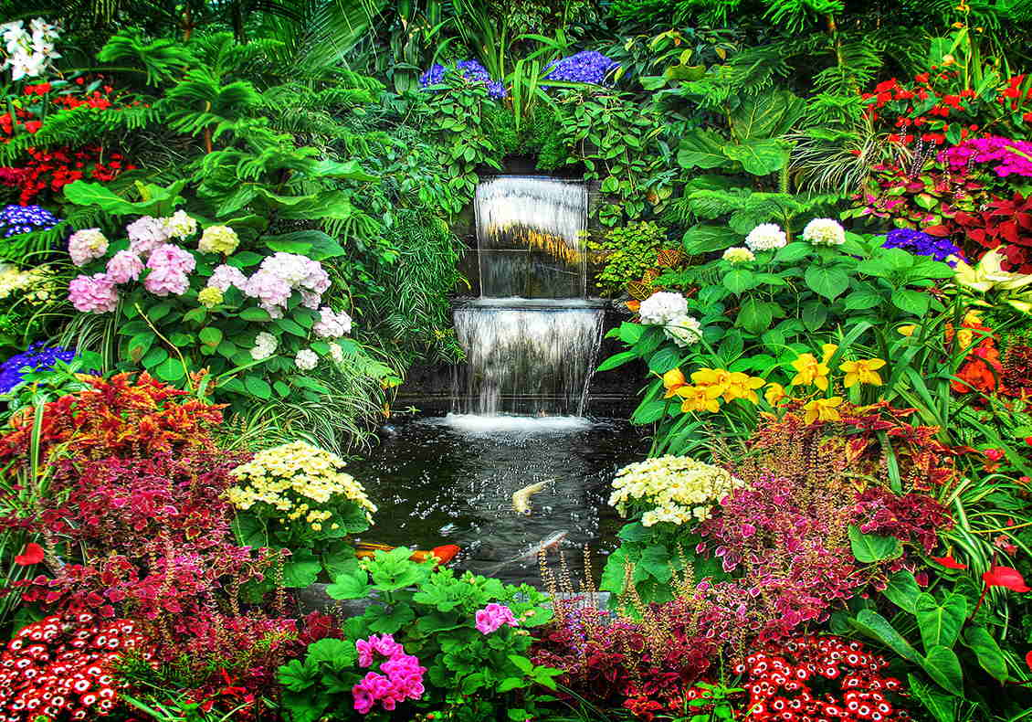

F
OR the LORD shall comfort Zion: he will comfort all her waste places; and he will make her wilderness like Eden, and her desert like the garden of the LORD; joy and gladness shall be found therein, thanksgiving, and the voice of melody. (Isaiah 51:3)

A garden is a place of living things – a place for nurturing the child and producing good fruit for man. Our hymn today is about God’s Word compared to the Garden. It is written by Edwin Hodder (1837-1904) who wrote hymns and devotions most often for children. He traveled to New Zealand at the age of nineteen to conduct sociological studies on the lives of the Maori people. He remained there for five years before returning to his home in England. Being young, impressionable, and still able to see beauty in every aspect of God’s Creation, Hodder was overwhelmed at the beauty of flowers and foliage of New Zealand. It seemed to young Hodder to perfectly fit the description given in Scripture of the Garden at Eden. On his return to England, he wrote this hymn (1863) to describe his impression of the Garden and God’s Word. The tune most often employed is entitled, BETHLEHEM, by Gottfried Wilhelm Fink (8 March 1783 – 27 August 1846) a German composer, music theorist, poet, and Protestant clergyman.

Thy word is like a Garden, Lord

Your Word is like a garden, Lord,
with flowers bright and fair;
and everyone who seeks may pluck
a lovely cluster there.
Your Word is like a deep, deep mine;
and jewels rich and rare
are hidden in its mighty depths
for every searcher there.

Your Word is like a starry host;
a thousand rays of light
are seen to guide the traveler,
and make his pathway bright.
Your Word is like an armory,
where soldiers may repair,
and find, for life's long battle day,
all needful weapons there.

O may I love your precious Word,
may I explore the mine,
may I its fragrant flowers glean,
may light upon me shine.
O may I find my armor there,
your Word my trusty sword;
I'll learn to fight with every foe
the battle of the Lord.

Your Word is like a garden, Lord, with flowers bright and fair; and everyone who seeks may pluck a lovely cluster there. Your Word is like a deep, deep mine; and jewels rich and rare are hidden in its mighty depths for every searcher there.” Our Lord Jesus Christ said, “The hour is come, that the Son of man should be glorified. Verily, verily, I say unto you, Except a corn of wheat fall into the ground and die, it abideth alone: but if it die, it bringeth forth much fruit. He that loveth his life shall lose it; and he that hateth his life in this world shall keep it unto life eternal.” (John 12:23-25) It is no coincidence our Lord was buried in a Garden Tomb and rose from the dead in the same Garden at which the blessed Mary Magdalene first saw the risen Savior without that Garden Tomb. He died that we might live. The same is true of each of us as believers – we must die to self and live for Christ if we will enjoy life eternal. God’s Word is, indeed, like a garden filled with all manner of flowers and fruits. The fragrance is delightful, and the flavors delectable and succulent. The Garden is well maintained and hedged in on all sides to keep the weeds and tares of the world from invading. Not only are the flowers vibrant and beautiful, but the ground from which they spring is rich is the rubies, diamonds, and gold of that great land. The flowers may represent the outward leisure of the Christian life; but the gems and jewels under the sod are those deeper truths and works that require time and study to unearth. God’s Word is immeasurable for value. We will never fathom the full depth in this world; but we must be mining every gem and jewel of it our spiritual spades can turn up. It will not be a laborious work for those who love those gems and jewels, but a joy and excitement to discover such spiritual wealth deep under the surface.

Your Word is like a starry host; a thousand rays of light are seen to guide the traveler, and make his pathway bright. Your Word is like an armory, where soldiers may repair, and find, for life's long battle day, all needful weapons there.” The young author of this hymn had never seen such natural beauty in England as he found in colonial New Zealand. But more than the beauty of the earth’s provision was also the beauty of the stars and moon at night as viewed through the pristine air of that land. To be sure, every star is a flaming sun if one could draw near to it. But even at such a great distance as light years, the beam of light travels straight and pure to impact the pathway of the soul on his earthly walk. Those stars, too, have fixed orbits across the heavens to guide the ship and the coach on its way. Such are true heavenly bodies who are not merely wanderers in space. There are heavenly bodies (meteors) who, like the sinner, are not guided by the Law of God or His natural force fields. Such are referred to in the Book of Jude: “Raging waves of the sea, foaming out their own shame; wandering stars, to whom is reserved the blackness of darkness for ever.” (Jude 1:13) This describes the shooting, or falling, star perfectly. It yields a bright and glowing light in the night sky as it falls toward earth burning itself out in the atmosphere. This, too, is like the sinner. He may make a bright flash as he is drawn by the gravitational field of sin toward the things of this world; but he will burn out long before reaching those mirages of dreams.

The Word of God is also an arsenal of weaponry to be used against satanic attack. The weapons are spiritual and require a higher caliber of courage to wield. “Put on the whole armour of God, that ye may be able to stand against the wiles of the devil. For we wrestle not against flesh and blood, but against principalities, against powers, against the rulers of the darkness of this world, against spiritual wickedness in high places. Wherefore take unto you the whole armour of God, that ye may be able to withstand in the evil day, and having done all, to stand. Stand therefore, having your loins girt about with truth, and having on the breastplate of righteousness; And your feet shod with the preparation of the gospel of peace; Above all, taking the shield of faith, wherewith ye shall be able to quench all the fiery darts of the wicked. And take the helmet of salvation, and the sword of the Spirit, which is the word of God: Praying always with all prayer and supplication in the Spirit, and watching thereunto with all perseverance and supplication for all saints” (Eph 6:10-18) There is no greater weapon than the Sword of the Lord to cut asunder every false premise.

O may I love your precious Word, may I explore the mine, may I its fragrant flowers glean, may light upon me shine. O may I find my armor there, your Word my trusty sword; I'll learn to fight with every foe the battle of the Lord.” Unless we love the Word of God, we cannot truly KNOW it, or the Person who is the full manifestation of the WORD – our Lord Jesus Christ! We are gardeners and miners of the Word of God, and we must be mining and caring for the fruits of the garden. He is returning to His Vineyard ere many moons pass over the heavens. How shall He find the husbandmen of His Garden performing. If we have sold the fruit cheaply or allowed the weeds to over-grow the rows of flowers and fruits; or have killed those whom the Lord has sent to reckon the fruit of our labors, we shall be shamefully poor and naked before Him and His discriminating Counsel. A Garden requires Light and Love. The Light of God prospers the growth of fruit, and Love is the fertilizer that causes the flowers to blossom. The weapons of war are those which heal and do not hurt or destroy.

This hymn is perfectly suited for the young and innocent mind to grasp truths too bright for the dim eyes of the unsaved to appreciate, but the purpose of hymns is to cause the Garden to flourish with young plants that grow old and become the seed which are planted for the new.

