Hymns of the Church – The Rock that is Higher than I – 24 January 2017, Anno Domini

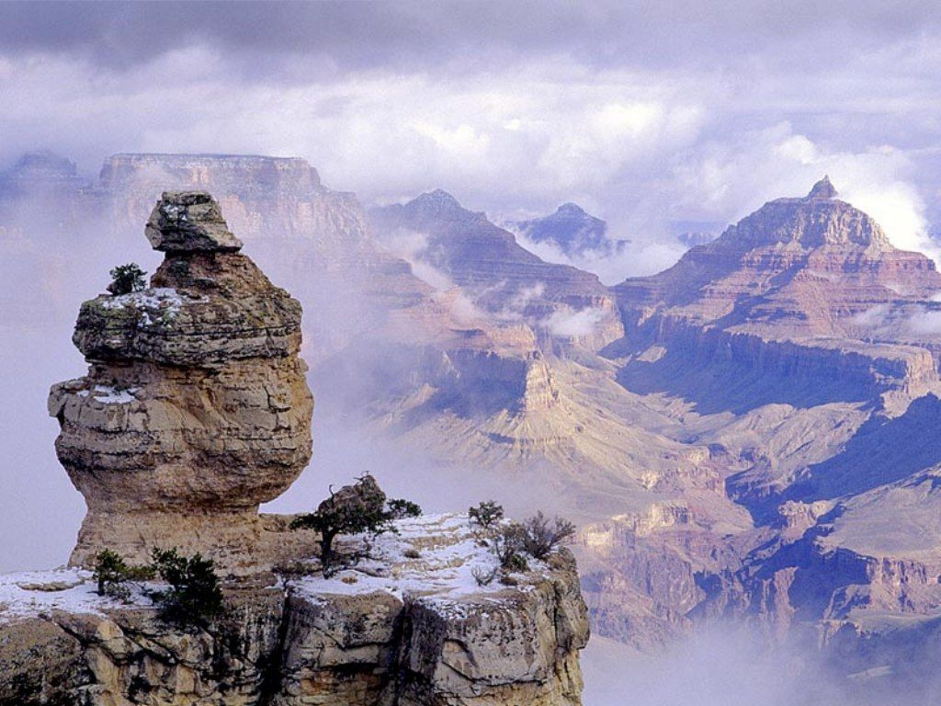

1 Hear my cry, O God; attend unto my prayer. 2 From the end of the earth will I cry unto thee, when my heart is overwhelmed: lead me to the rock that is higher than I. 3 For thou hast been a shelter for me, and a strong tower from the enemy. 4 I will abide in thy tabernacle for ever: I will trust in the covert of thy wings. Selah. (Psalm 61:1-4)
Here is a Gospel song which closely resembles a prayer of praise to our God. The lyrics are by William O. Cushing in 1876, and the music by the renowned Ira D. Sankey (1877). It should serve to remind us of the Solid Rock which is Christ – the Foundation and Fountainhead of all of our faith. As regards the circumstances of its composition, I share the comments of the Cyberhymnal Website:
‘Hiding in Thee’ was written in Moravia, New York, in 1876,” writes Mr. Cushing. “It must be said of this hymn that it was the outgrowth of many tears, many heart-conflicts and soul-yearnings, of which the world can know nothing. The history of many battles is behind it. But the occasion which gave it being was the call of Mr. Sankey. He said, ‘Send me something new to help me in my Gospel work.’ A call from such a source, and for such a purpose, seemed a call from God. I so regarded it, and prayed: ‘Lord, give me something that may glorify Thee.’ It was while thus waiting that ‘Hiding in Thee’ pressed to make itself known. Mr. Sankey called forth the tune, and by his genius gave the hymn wings, making it useful in the Master’s work. Sankey, p. 149

The Rock that is Higher than I

O safe to the Rock that is higher than I,
My soul in its conflicts and sorrows would fly;
So sinful, so weary, Thine, Thine, would I be;
Thou blest “Rock of Ages”, I’m hiding in Thee.

Refrain
Hiding in Thee, hiding in Thee,
Thou blest “Rock of Ages”,
I’m hiding in Thee.

In the calm of the noontide, in sorrow’s lone hour,
In times when temptation casts o’er me its power;
In the tempests of life, on its wide, heaving sea,
Thou blest “Rock of Ages,” I’m hiding in Thee.
Refrain

How oft in the conflict, when pressed by the foe,
I have fled to my refuge and breathed out my woe;
How often, when trials like sea billows roll,
Have I hidden in Thee, O Thou Rock of my soul.
Refrain

O safe to the Rock that is higher than I, My soul in its conflicts and sorrows would fly; So sinful, so weary, Thine, Thine, would I be; Thou blest “Rock of Ages,” I’m hiding in Thee. There is abundant protection and security in the presence of a great Rock. The Rock of Gibraltar broods in majesty above the straits of the same name. My father used to tell me stories of the old west that were factual and unusual. One such story was of the Great White Rock of Acoma (pronounced Ah-ko ma). The Acoma Pueblo is located about 80 miles west of Albuquerque, New Mexico, atop a 360 ft. mesa. The Acoma tribe of Indians is made up of about 5,000 souls as of the 2010 U.S. census. The only access to the high city pueblo atop Acoma Rock was by means of near vertical steps cut into the stone face of the Rock. It was a safe haven for centuries to the Acoma Indians – perhaps the oldest continuously inhabited communities in the United States (since the 13th century and most likely long before).

The Acoma Indians were protected for those many centuries by their safe refuge atop the mesa. But with the coming of Spanish missionaries, they were also blessed with another Great Rock – that of Jesus Christ! The first Spanish friar gave them a large portrait of Saint Joseph during the 16th century – a portrait which they revered as a thing that brought them good fortune. In simple terms, this portrait became an idol. The Mesa of Acoma always produced a bountiful supply of food and vegetables – the rains always came on time. The Acoma Indians carried this portrait to stand guard over them while they worked the fields of the mesa. They believed it gave them ‘good luck.’ Finally, the great portrait was stolen by a nearby tribe of Indians from the Laguna Pueblo. This tribe had experienced draught and want while the Acomas enjoyed plenty. They wanted the portrait to bless them as it had the Acomas.

Suddenly, the Laguna Pueblo began to flourish under the watchful eyes of the portrait of Saint Joseph and the Acomas, on the contrary, lost hope and suffered failures in their crops. Brought to the brink of war between the two pueblos, an old Spanish friar interceded. He told the people that it was not the portrait of Saint Joseph which caused the prosperity of the pueblos in its presence, but the faith in the One who was greater than Saint Joseph. It was God who gave them hope and inspiration to work more heartily and energetically that resulted in the greater harvests. They broke the arrow and peace was restored. This is the provision of the Rock that is higher than us. Faith in Him blesses all who place their trust in His name – and not some Roman superstition.

In the calm of the noontide, in sorrow’s lone hour, In times when temptation casts o’er me its power; In the tempests of life, on its wide, heaving sea, Thou blest “Rock of Ages,” I’m hiding in Thee. There is no cooler place in all of the desert wilderness than the refuge of a great stone. The desert traveler can rest safely under that great stone until the evening shadows lengthen and travel is again possible. So, in our lives, troubles and the heat of life grow intense, and we seek the shelter of the Great Rock of Christ in the shadow of the noon-day sun. Loneliness is not always a detriment – it is often a blessed time to stop our worldly pursuits and attune our hearts to the Voice of God. To the wandering ship, aimlessly drifting on the stormy seas, a great rock will break her apart and all aboard perish; but the ship, well mastered and navigated, seeks the shelter of the great rocky coast to hide from such stormy blasts. The greatest Rock we can know is that of Christ. He offers blessings of rain, sun, and shelter. And He offers a sure Foundation upon which to build our lives.

How oft in the conflict, when pressed by the foe, I have fled to my refuge and breathed out my woe; How often, when trials like sea billows roll, Have I hidden in Thee, O Thou Rock of my soul. During the Battle of Fredericksburg during the War Between the States, the Confederate Army found shelter behind a great stone wall at the base of Marye’s Heights and were thereby enabled to hold off the relentless waves of a far greater force of the Union army. The stone wall was their advantage and protection, and so is Christ a far greater protection from our enemies in the battles of life. There is relief in finding solid and sound protection in the Lord. The billows of the sea have beaten for centuries against the craggy stones of the New England coastline, yet the stones remain as evidence that the mighty sea is no match for the stones. Christ is the Rock of the Christian’s soul, and when our anchors are fastened on that Rock at the Sea bottom, we shall not drift – our souls are anchored on that Rock! . . . . we might have a strong consolation, who have fled for refuge to lay hold upon the hope set before us: Which hope we have as an anchor of the soul, both sure and stedfast, and which entereth into that within the veil. (Heb 6:18-19)

Refrain
Hiding in Thee, hiding in Thee,
Thou blest “Rock of Ages,”
I’m hiding in Thee.

This very proper refrain summarizes, as all refrains should, the context of the entire hymn. If we are hiding in the Rock of Ages which is Christ, we are invisible to the things of the world. Our works are those of Christ and not our own. We are small to the world, but large in the eyes of the Lord. In fact, we are the “Apple of His Eye.”

