Hymns of the Church – The Abyss of Many a Former Sin – 31 January 2017, Anno Domini

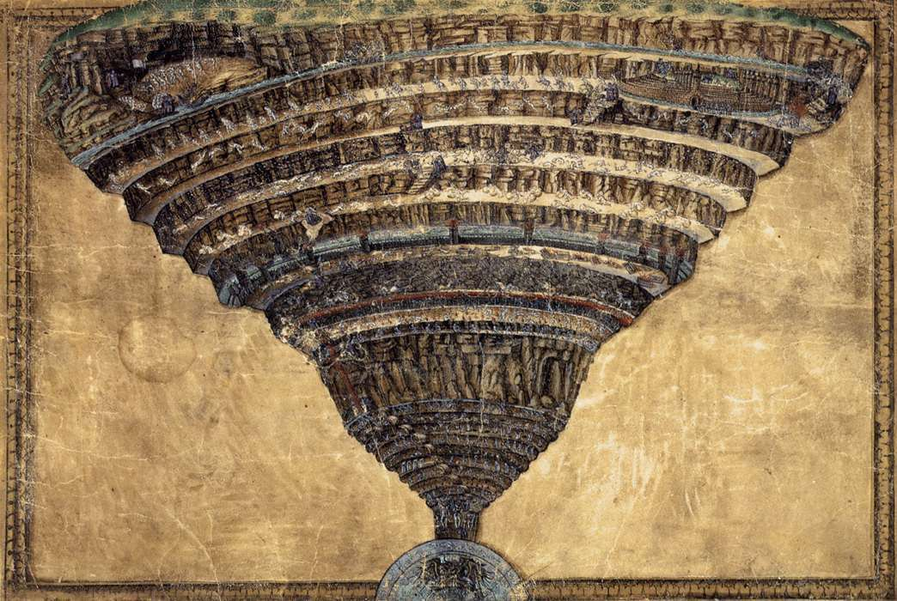

Father, I have sinned against heaven, and before thee, (Luke 15:18)

Son, remember that thou in thy lifetime receivedst thy good things, and likewise Lazarus evil things: but now he is comforted, and thou art tormented. And beside all this, between us and you there is a great gulf fixed: so that they which would pass from hence to you cannot; neither can they pass to us, that would come from thence. (Luke 16:25-26)

This is a hymn of the Eastern Church written by Joseph of the Studium. Its English translation is by John M. Neal. “This is a portion from the Triodion of the Canon at Lauds for the Sunday of the Prodigal Son.” Cyberhymnal (http://www.cyberhymnal.org/htm/t/a/tabysmfs.htm). The harmony of Vater Unser is by J.S. Bach. (1726).

The Abyss of Many a Former Sin

The abyss of many a former sin
Encloses me and bars me in;
Like billows my transgressions roll:
Be Thou the Pilot of my soul,
And to salvation’s harbot bring
Thou Savior and thou Glorious King.

My Father’s heritage abused,
Wasted by lust, by sin misused;
To shame and want and misery brought,
The slave to many a fruitless thought,
I cry to Thee, who lovest men,
O pity and receive again!

In hunger now, no more possessed,
Of that my portion bright and blest,
The exile and the alien see,
Who yet would fain return to Thee,
And save me, Lord, who seek to raise
To Thy dear love the hymn of praise!

With that blest thief my prayer I make,
“Remember” for Thy mercy’s sake!
With that poor publican I cry,
“Be merciful, ” O God most high!
With that lost prodigal I fain
Back to my home would turn again!

Mourn, mourn, my soul, with earnest care,
And raise to Christ the contrite prayer;
“O Thou, who freely wast made poor,
My sorrows and my sins to cure,
Me, poor of all good works, embrace,
Enriching with Thy boundless grace!

“Abyss” is a term fallen from popular use in our day, perhaps owing to the awful prospects of its implication. It defines a pit of such great depth there is no escape. It perfectly describes the Hell of the Rich man who looked up and saw Lazarus in the bosom of Abraham. Death is an abyss that locks the jaw of man, hobbles his feet and hands, and removes him from all that he considers precious; but there remains the same escape for man from that sorrowful fate as existed for the Beggar Lazarus and the Penitent Thief on the Cross.

The abyss of many a former sin Encloses me and bars me in; Like billows my transgressions roll: Be Thou the Pilot of my soul, And to salvation’s harbor bring Thou Savior and thou Glorious King. The freedoms of mind, soul and body can only be enjoyed by a people under Authority of God Almighty. Liberty requires reliance upon the mercies of God and the freedom He only can offer. Any people that turn away from that Authority will always be under some other authority of the world (which leads to enslavement). The wages of sin is death as the Apostle declares. It is what every man, woman and child has coming to them as a matter of justice based on their sinful natures. Even if we could be so righteous as to harbor only one sin in life, that one sin condemns us to death. Of course, each of us is born with the nature of Adam to sin without limits. In fact, we cannot even remember all of the sins the commit in a week, or a day, or often an hour. Our sins are as the billows of the sea breaking upon the rocks of the shoreline. Ships at sea need an experienced and qualified pilot to bring the ship to safe harbor, and that Pilot for the sinner is the Lord Jesus Christ.

My Father’s heritage abused, Wasted by lust, by sin misused; To shame and want and misery brought, The slave to many a fruitless thought, I cry to Thee, who lovest men, O pity and receive again! The celestial ambience of the Garden was shattered by Adam’s Fall. The living Creatures – all of them – including birds and animals – were the outward expression of God’s masterful art and loving heart; but all suffered loss because of the man and woman who failed in their dominion over Creation. Paradise had to be withdrawn from the access of man since he had failed as its husbandman. Reduced to the shame of nakedness, the Lord had to take the life of one of His beloved and innocent creatures to cover Adam’s nakedness. We are not changed in our natures from that of Adam. There is only One who ever loved you without limits, and that is the Lord. He is full of pity for those who love Him and hear His Voice Calling.

In hunger now, no more possessed, Of that my portion bright and blest, The exile and the alien see, Who yet would fain return to Thee, And save me, Lord, who seek to raise To Thy dear love the hymn of praise! Do we hunger and thirst for the Lord? I do not refer to the affected interest that expresses itself only on Sunday’s or at cardinal points of the calendar; but rather a SOUL hunger and Thirst for God that drives you to the Source of Water and the House of Bread – the kind of hunger and thirst that awakens you each day with a resort to prayer and Scripture study. We are unable to return the ‘legal tender in kind’ that God has proferred to us in the coinage and currency of abundant love; but we can at least return a shallow echo of that love and be received by Him by grace and mercy. In so doing, our hearts are lifted in joyous praise to our Maker and Redeemer.
v
With that blest thief my prayer I make, “Remember” for Thy mercy’s sake! With that poor publican I cry, “Be merciful,” O God most high! With that lost prodigal I fain Back to my home would turn again! What differentiates the Elect of God from the lost? Is it a life of righteousness that earns them the distinction? Certainly not! It is the unmerited grace of God that acts externally to the outward expressions of life. God ordains, and God elects. We have not chosen Him – He has chosen us! 15 Henceforth I call you not servants; for the servant knoweth not what his lord doeth: but I have called you friends; for all things that I have heard of my Father I have made known unto you. 16 Ye have not chosen me, but I have chosen you, and ordained you, that ye should go and bring forth fruit, and that your fruit should remain: that whatsoever ye shall ask of the Father in my name, he may give it you. 17 These things I command you, that ye love one another. (John 15:15-17) Reject the commandment of Verse 17 to your own spiritual detriment! We are not different from that thief on the cross – hands and feet affixed to the cross – who called upon the Lord for mercy. He could do nothing except express the desire of his heart, and THAT was enough. None who reject the Lord are in their right mind just as the Prodigal was not; but “when he came to himself” he resolved to return to the favor of his father and to repent there. He then followed up on that resolution and was received with honors.

Mourn, mourn, my soul, with earnest care, And raise to Christ the contrite prayer; “O Thou, who freely wast made poor, My sorrows and my sins to cure, Me, poor of all good works, embrace, Enriching with Thy boundless grace!v We are so very poor that we can offer NOTHING to God of worth – except a contrite heart. The sacrifices of God are a broken spirit: a broken and a contrite heart, O God, thou wilt not despise. (Psalms 51:17) There is a hymn whose first lines of each stanza sum up the means of salvation. Those first lines are these:

- Weeping will not save me.
- Working will not save me.
- Waiting will not save me.
- Faith in Christ will save you.

Are you waiting, working, or weeping for salvation? Simply attune your heart’s ears to His voice and respond in faith and belief.

