Hymns of the Church – Te Deum Laudamus – 7 January 2020, Anno Domini (In the Year of our Lord)

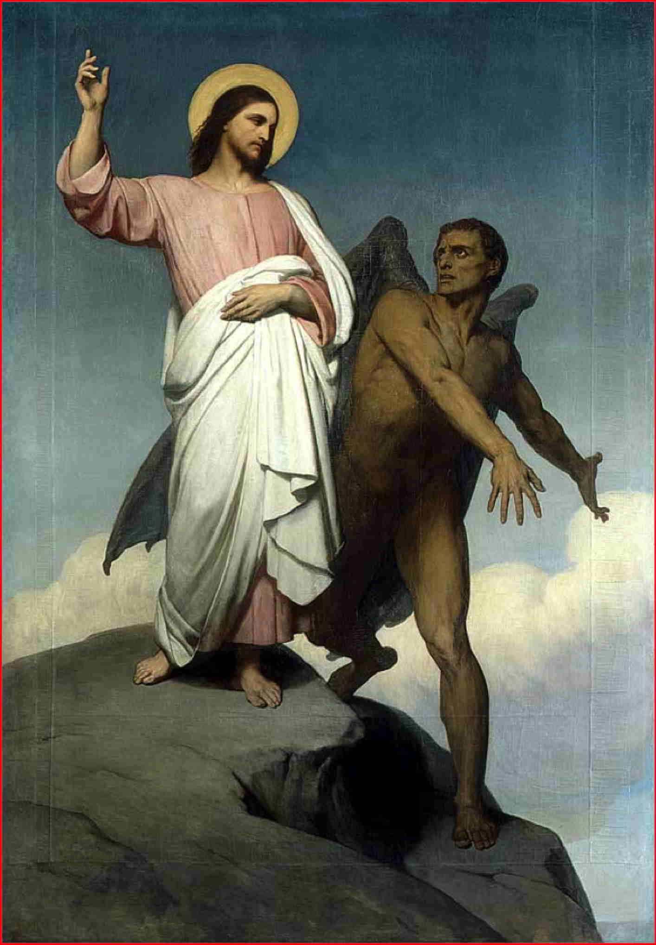

T
HEN was Jesus led up of the Spirit into the wilderness to be tempted of the devil. ² And when he had fasted forty days and forty nights, he was afterward an hungred. ³ And when the tempter came to him, he said, If thou be the Son of God, command that these stones be made bread. ⁴ But he answered and said, It is written, Man shall not live by bread alone, but by every word that proceedeth out of the mouth of God. (Matthew 4:1-4 (KJV)

T
HEN the devil taketh him up into the holy city, and setteth him on a pinnacle of the temple, ⁶ And saith unto him, If thou be the Son of God, cast thyself down: for it is written, He shall give his angels charge concerning thee: and in their hands they shall bear thee up, lest at any time thou dash thy foot against a stone. ⁷ Jesus said unto him, It is written again, Thou shalt not tempt the Lord thy God. (Matthew 4:5-7)

A
GAIN, the devil taketh him up into an exceeding high mountain, and sheweth him all the kingdoms of the world, and the glory of them; ⁹ And saith unto him, All these things will I give thee, if thou wilt fall down and worship me. ¹⁰ Then saith Jesus unto him, Get thee hence, Satan: for it is written, Thou shalt worship the Lord thy God, and him only shalt thou serve. (Matthew 4:7-10)

NOTE: With each temptation, note the response of the Lord – “IT IS WRITTEN!”

Of uncertain origin in the form found in the Book of Common Prayer, the Te Deum Laudamus (God, we Praise Thee) in both Word and Spirit are derived directly from Holy Scripture. It is a summary of the Faith in God’s Words, not man’s. The Te Deum is a part of Morning Prayer in all traditional books of Common Prayer and represents a perfect description of our faith and worship.

It may be a bit too formal for the average church today, but formality is an expression of sober and serious worship. In many churches today, the Bible itself is too serious and sober for their worship, so they accent their worship with frivolous and worldly songs, emotional outbursts, and claims of spiritual powers not granted by the Holy Spirit. The Ted Deum places the honor and glory where it belongs – with God. The hymn is said to have been first sung by St. Ambrose at the baptism of St. Augustin in the 4th century. It might be said by the modern church that Bishop Ambrose was not duly consecrated. There would be great consternation on the validity of his succession since he never held an ecclesiastical office until he was made Bishop of Milan by popular acclamation! If he was missing the proper paperwork, he was not missing the proper doctrinal succession which trumps any act of man every time. This devotion cannot cover all 29 verses of this hymn, so we will address its impact and testimony.

Te Deum Laudamus

WE praise thee, O God; we acknowledge thee to be the Lord.
All the earth doth worship thee, the Father everlasting.
To thee all Angels cry aloud; the Heavens, and all the Powers therein;
To thee Cherubim and Seraphim continually do cry,
Holy, Holy, Holy, Lord God of Sabaoth;
Heaven and earth are full of the Majesty of thy glory.
The glorious company of the Apostles praise thee.
The goodly fellowship of the Prophets praise thee.
The noble army of Martyrs praise thee.
The holy Church throughout all the world doth acknowledge thee;
The Father, of an infinite Majesty;
Thine adorable, true, and only Son;
Also the Holy Ghost, the Comforter.
THOU art the King of Glory, O Christ.
Thou art the everlasting Son of the Father.
When thou tookest upon thee to deliver man, thou didst humble thyself to be born of a Virgin.
When thou hadst overcome the sharpness of death, thou didst open the Kingdom of Heaven to all believers.
Thou sittest at the right hand of God, in the glory of the Father.
We believe that thou shalt come to be our Judge.
We therefore pray thee, help thy servants, whom thou hast redeemed with thy precious blood.
Make them to be numbered with thy Saints, in glory everlasting.
O LORD, save thy people, and bless thine heritage.
Govern them, and lift them up for ever.
Day by day we magnify thee;
And we worship thy Name ever, world without end.
Vouchsafe, O Lord, to keep us this day without sin.
O Lord, have mercy upon us, have mercy upon us.
O Lord, let thy mercy be upon us, as our trust is in thee.
O Lord, in thee have I trusted; let me never be confounded.

The late Rev. Dr. William Reed Huntington, Rector of Grace Church, New York, says: "Other hymns may surpass The Te Deum in the exhibition of this or that phase of feeling, but there is none that combines as this combines, all the elements that enter into a Christian's conception of religion. The Te Deum is an orchestra in which no single instrument is lacking; first or last, every chord is struck, every note sounded. The soul listens and is satisfied; not one of her large demands has been dishonored." Smith, Colonel Nicholas, 1901, Hymns Historically Famous, pg 1.

This hymn has a broader application of biblical truth than any other hymn though many may have specific revelations of certain beauty, no other covers such a broad swath of those truths as the Te Deum.

It seems altogether proper that this hymn should constitute a reading from Morning Prayer. It is a wonderful way in which to begin the day acknowledging the beauty of holiness in God. It may be sung or chanted either antiphonally, congregationally, chorally, or by the priest alone. It might be classified as the King of hymns for its beauty, scope and veracity in Holy Scripture. Deep wells of praise, faith, and Godly governance is extolled in this hymn, and it glorifies the King of Love and Glory – our Lord Jesus Christ.

Since this hymn is sung at the beginning of each day in Morning Prayer, why not make it also the beginning hymn for the new year just turning, and continue every day of this new year? Too serious and somber? Not at all! – nothing can be more serious, formal and sober than the worship due the King of Kings and Lord of Lords.

As stated earlier, I have not commented on the beauty of individual verses of this hymn. Why not? Because each verse is so simple, so beautiful, and so self-explanatory. How can I expand on the meaning of such verses as, “When thou tookest upon thee to deliver man, thou didst humble thyself to be born of a Virgin?” This is a matter of biblical fact and history. What meaning can be added by further exposition? All of the verses ae likewise havens of simplicity and transparency.

Like all prayers and hymns, we may sing this one out of sheer abandonment and rote memory. If we do so, are we not taking the name of the Lord in vain by doing so? Every line, being pregnant with biblical and Holy Truth, is worthy of serious thought and consideration as we sing. If we observe that characteristic of our hymns, prayers, and Bible readings, we shall be benefitted with blessings far above the vulgar worship we observe in most churches of our day.

Let’s make this Morning Prayer Canticle not only the beginning of our day in the Lord, but of our year, our decade, and all days left us under the sun.

