Hymns of the Church – Taps – 21 April 2020, Anno Domini

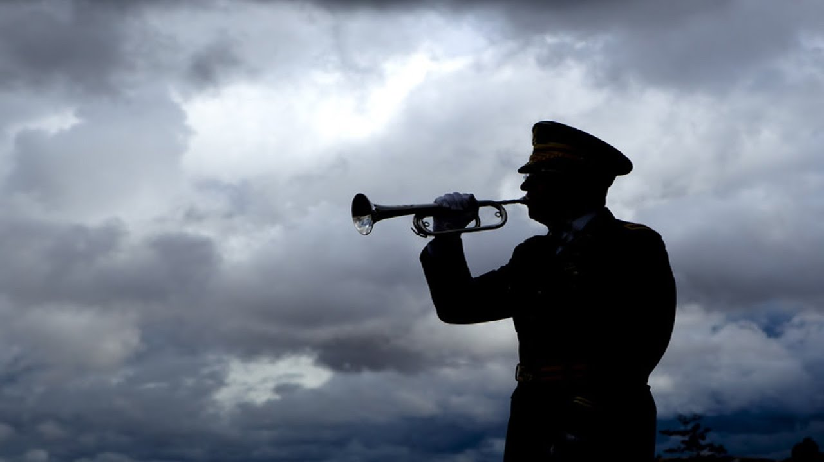

Y
E are all the children of light, and the children of the day: we are not of the night, nor of darkness. 6 Therefore let us not sleep, as do others; but let us watch and be sober. 7 For they that sleep sleep in the night; and they that be drunken are drunken in the night. 8 But let us, who are of the day, be sober, putting on the breastplate of faith and love; and for an helmet, the hope of salvation. 9 For God hath not appointed us to wrath, but to obtain salvation by our Lord Jesus Christ, 10 Who died for us, that, whether we wake or sleep, we should live together with him.
(1 Thessalonians 5:5-10)

I
WILL lift up mine eyes unto the hills, from whence cometh my help. 2 My help cometh from the LORD, which made heaven and earth. 3 He will not suffer thy foot to be moved: he that keepeth thee will not slumber. 4 Behold, he that keepeth Israel shall neither slumber nor sleep. 5 The LORD is thy keeper: the LORD is thy shade upon thy right hand.6 The sun shall not smite thee by day, nor the moon by night. (Psalms 121:1-6)

Though you may not recognize it as a hymn, this hymn is probably heard more often than any other – TAPS. There are few who have not heard this plaintive hymn played at close of day, or at a military funeral, and there are no soldier, sailor, or airman who is not intimately familiar with its every note if not its lyrics. The name of the original author is lost in obscurity, however, Brigadier General Daniel A. Butterfield of the Union Army of the Potomac is credited with the lyrics we have today as revised by him. I have written a history of this tune before, but will now do so as a hymn. There are conflicting reports as to the author of the tune and original notes, but this version that we have today was first played following the Wilderness Campaign (1862) in which the Union Army was badly mangled by the Confederate forces under General Robert E. Lee. The tune wafted across the battle lines and was taken up by both sides (North & South) as the second and final Tattoo of the day.

Every day of my life at the Military Academy, I heard this piece played as the last bugle notes of the day. There are five major calls played in the evening in the military – Retreat, To the Color, Call to Quarters, Tattoo, and, finally, Taps (lights out). TAPS (sometimes referred to as the 2nd Tattoo or last tattoo) may bode well to a nation that needs to silently consider and meditate upon the engagements of our day and resolve to awaken after the dark night of her soul to a new heart and a new direction under God. According to Jari Vilanueva of the Arlington Bugle Exhibit, the lyrics are as follows:

Taps

Day is done, gone the sun,
From the hills, from the lake,
From the sky.
All is well, safely rest,
God is nigh.

Go to sleep, peaceful sleep,
May the soldier or sailor,
God keep.
On the land or the deep,
Safe in sleep.

Love, good night, Must thou go,
When the day, And the night
Need thee so?
All is well. Speedeth all
To their rest.

Fades the light; And afar
Goeth day, And the stars
Shineth bright,
Fare thee well; Day has gone,
Night is on.

Thanks and praise, For our days,
'Neath the sun, Neath the stars,
'Neath the sky,
As we go, This we know,
God is nigh.

Day is done, gone the sun, From the hills, from the lake, From the sky. All is well, safely rest, God is nigh.There is a chilling memory I have of a cold day of 21st February 1967 when our family we gathered on a hillside cemetery overlooking Dug Gap Valley. The occasion was the burial of my younger brother, Spec4 Kenneth Ogles who was KIA in the Ia Drang Valley of Vietnam on 16 February 1967 with the 1st Cavalry Division. The funeral service had earlier included the hymn, Jesus Loves Me, This I know, which seemed a bit out of place in the presence of a military Honor Guard; but it was not. Ken was still a child at the age of 19 when he died; moreover, that hymn was written and first sung at the United States Military Academy at West Point. At the conclusion of the burial and the gun salute came the notes of the bugler playing Taps. It is both sad and also inspiring to hear. For the warrior, whether of mortal combat, or in the service of the Lord, the day is finished and the light fades with the sun. The sharp, piercing notes of Taps echoed and re-echoed from the mountains and ridges surrounding that cemetery. It was the final salute, yet it was so memorial that all present will never forget the event. The soldier was finally home and the attending his last bivouac. God is always nigh the heart of the believer in Him, and my brother was certainly a believer from the early days of his childhood.

Go to sleep, peaceful sleep, May the soldier or sailor, God keep. On the land or the deep, Safe in sleep. Whether the bed be made on land or at sea, the meaning is the same. Sailors go to the swirling deep with the same notes as the infantryman. The honors paid are particularly meaningful for those who died in defense of liberty and freedom. The peace they could not enjoy on the battlefield is grant ed finally in the bosom of Abraham. No more cannon artillery fire, mortar bursts, or muffled screams and rifle fire will be heard by the sleeper. That day will come as if by a blinking of the eye when the deep shall surrender her dead, and the ground will give up those who have slept in silent rest. “﻿13 And the sea gave up the dead which were in it; and death and hell delivered up the dead which were in them: and they were judged every man according to their works.” (Revelations 20:13) The largest cemetery in the earth is the sea bearing her untold millions.

Love, good night, Must thou go, When the day, And the night Need thee so? All is well. Speedeth all To their rest. No love can beckon more strongly than the loved of God to His own.. The midnight hour comes for every child of dod as well as those of the world. The appointment cannot be broken. Our love for the departing soldier-soul cannot delay his posting to his new duty station with God. Taps is a way of saying goodbye to a gallant soldier. It is a final goodbye this side of Jordan Waters. Soldiers must always obey orders, and there are no orders from a Higher Headquarters than Heaven. So, we bid Godspeed in the final bivouac of the soldier.

Fades the light; And afar Goeth day, And the stars Shineth bright, Fare thee well; Day has gone, Night is on. Suffering from either the bloody wounds of battle or else the sudden blast of the cannon, the soldier sees his vision began to fail and fade. He has never seen it so, but the time has come for his posting Beyond.. Though the mortal lights fade, the heavenly lights gleam more brilliantly than ever before the soldier’s failing vision. The soldier has gone to his narrow home in the heart of the earth, and his soul to his Maker on High.

Thanks and praise, For our days, 'Neath the sun, Neath the stars, 'Neath the sky, As we go, This we know, God is nigh. The nation owes a debt of gratitude and honor to her soldiers who have given the last full measure of devotion to its defense and preservation. Rightly so, the American flags line the boulevards of our cities on Memorial Day. We must go thankful to our Lord for those wonderful past days “'Neath the sun, Neath the stars, 'Neath the sky.” We have no regrets, for every second of our days were gifts from God. AS the final notes of Taps fade away on the hills and valleys, the Christian soldier awakes to a different Bugler playing Reveille!

