Hymns of the Church – Take Time to be Holy – 21 February 2017, Anno Domini (In the Year of our Lord)

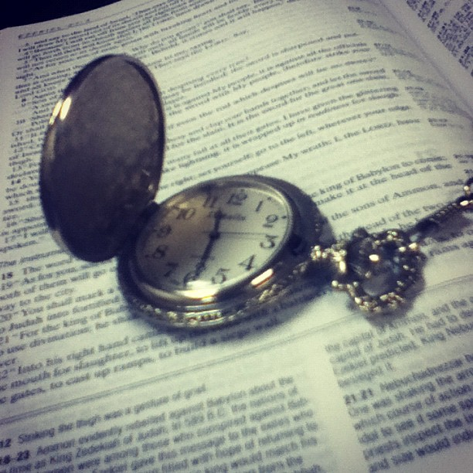

1 And the LORD spake unto Moses, saying, 2 Speak unto all the congregation of the children of Israel, and say unto them, Ye shall be holy: for I the LORD your God am holy. 3 Ye shall fear every man his mother, and his father, and keep my sabbaths: I am the LORD your God. 4 Turn ye not unto idols, nor make to yourselves molten gods: I am the LORD your God. 5 And if ye offer a sacrifice of peace offerings unto the LORD, ye shall offer it at your own will. (Lev 19:1-5)

The hymn for today addresses the practice most wanting in the modern church and the issue upon which many other displeasing (to our Lord) modern practices have devolved. God is Holy in His Person and so is His Word Holy in every jot and tittle. When man takes a light view of Holy Scripture, he is taking a light view of its Author as well. It is unfortunate that this hymn was excluded from the 1940 Hymnal.

The lyrics of Take Time to be Holy were composed by William D. Longstaff of north east England in 1882 after hearing a sermon preached by a missionary to China on the subject taken from the First Epistle of Saint Peter, 16 Because it is written, Be ye holy; for I am holy. 17 And if ye call on the Father, who without respect of persons judgeth according to every man's work, pass the time of your sojourning here in fear: (1 Peter 1:16-17) The music is written by the renowned George C. Stebbins in 1890.

Take Time to be Holy

Take time to be holy, speak oft with thy Lord;
Abide in Him always, and feed on His Word.
Make friends of God’s children, help those who are weak,
Forgetting in nothing His blessing to seek.

Take time to be holy, the world rushes on;
Spend much time in secret, with Jesus alone.
By looking to Jesus, like Him thou shalt be;
Thy friends in thy conduct His likeness shall see.

Take time to be holy, let Him be thy Guide;
And run not before Him, whatever betide.
In joy or in sorrow, still follow the Lord,
And, looking to Jesus, still trust in His Word.

Take time to be holy, be calm in thy soul,
Each thought and each motive beneath His control.
Thus led by His Spirit to fountains of love,
Thou soon shalt be fitted for service above.

Take time to be holy, speak oft with thy Lord; Abide in Him always, and feed on His Word. Make friends of God’s children, help those who are weak, Forgetting in nothing His blessing to seek. Holy affairs should be treated with a high degree of reverence. That is the purpose of the Prayer Book in guiding our worship and preventing the errors of manmade worship from infiltrating that worship. But even a solemn and punctilious worship can be irreverent if the heart is not aligned with the holiness of the occasion. If those Christians of 1882 needed to take time from their daily schedules to consider things Holy, how much more is such a practice needed in our busy day? In many homes of that period, there was a family altar and prayer room which did not want for use every day. Those spoke oft of thy Lord. Even in the days of my childhood, men and women of the rural South carried on daily communications with God’s Word woven throughout. We should seek God’s blessing on every endeavor that we undertake. We should care for those who are wanting the material necessities within the church, and then beyond.

Take time to be holy, the world rushes on; Spend much time in secret, with Jesus alone. By looking to Jesus, like Him thou shalt be; Thy friends in thy conduct His likeness shall see. There is no more sincere and meaningful prayer than that which is offered up in the privacy of one’s prayer closet. There does not even need the facility of words for the Holy Spirit knows our wants and desires before we express them. Prayer and meditation are closely joined in private prayer. Some may say, I simply do not have time to pray. Really! You are badly mistaken! You do not have time NOT to pray. All time belongs to God since He is the Author of the time scale. Like Peter walking on the sea, we must keep our eyes fixed on the Savior, else, like Peter, we will sink into the turbid waters when we take counsel of our fears and avoid His face. The more we gaze into that wonderful Glass (which is God’s Word) the more we come to know our own total depravity and recognize the perfection and holiness of His Person. We become more alike the object of our admiration.

Take time to be holy, let Him be thy Guide; And run not before Him, whatever betide. In joy or in sorrow, still follow the Lord, And, looking to Jesus, still trust in His Word. The Lord Jesus Christ is our Good shepherd who laid down His life for His Sheep. He knows the Way, and IS the Way, that leads to green pastures and still waters. The errant lamb that runs ahead will lose its way and be lost. We trust in the Lord under every circumstance, even when we may feel doubtful. Unquestioning obedience to His Word is always the best policy. To the committed Christian, there can even be joy in sorrow. Remember the first five words in each stanza of this hymn – Take time to be Holy. Holiness requires a conscious effort to be obedient to God in every avenue of life. Many have perished on the high slopes of the mountain for failure to look up instead of staring at the very dirt of the next step, or to the threatening crevasses below. Our whole lives should be dedicated to looking up to Heaven instead of down to the penurious provisions of the world. Take Time! Important endeavors require time to plan and execute. So, do the matters of one’s soul. When we enter church, do we make light of the occasion, or do we prepare our hearts in prayer for the worship hour? Remember the words of Christ: 2 The kingdom of heaven is like unto a certain king, which made a marriage for his son, 3 And sent forth his servants to call them that were bidden to the wedding: and they would not come. 4 Again, he sent forth other servants, saying, Tell them which are bidden, Behold, I have prepared my dinner: my oxen and my fatlings arekilled, and all things are ready: come unto the marriage. 5 But they made light of it, and went their ways, one to his farm, another to his merchandise. (Matt 22:2-5) Do not make light of the calling and worship of the Lord.

Take time to be holy, be calm in thy soul, Each thought and each motive beneath His control. Thus led by His Spirit to fountains of love, Thou soon shalt be fitted for service above. Pray tell, how can our hearts be prepared for worship when our tongues are wagging on mundane subjects and gossiping just before the moment of worship! When we enter the church, we must remember that we tread upon Holy ground. If we fail to remove our shoes, then at least let us remove the concerns of the world. Our hearts need to be calmed and our spiritual ears tuned to hear the gurgling flow of the waters of the Holy Ghost. When our thoughts, motives, and desires are congruent with His, then do we kneel in reverence before the very throne of God. When our wills are made to conform perfectly to His Will, every utterance of prayer will be answered according to His good pleasure. The Good Shepherd will lead us to the Fountain of Living Waters that is over-flowing with love. Our hearts can little contain the profusion of those waters. They overflow and our love is spread abroad without a single drop lacking replenishment. (see Jeremiah 17:13) It is by looking constantly in the Glass of God’s Word that we become more like Him, and are fitted for that service to which we go when God awakens us from our borrowed tombs. 22 But be ye doers of the word, and not hearers only, deceiving your own selves. 23 For if any be a hearer of the word, and not a doer, he is like unto a man beholding his natural face in a glass: 24 For he beholdeth himself, and goeth his way, and straightway forgetteth what manner of man he was. 25 But whoso looketh into the perfect law of liberty, and continueth therein, he being not a forgetful hearer, but a doer of the work, this man shall be blessed in his deed. (James 1:22-25)

When we are conformed to the will of God, then we are free indeed since the things that we desire to see and do are precisely those things that the Father wills, and it shall be granted to us.

I admonish each of us in the coming week to take time to be holy. If we do so, we will all recognize a delightful improvement in our dispositions, characters, and joys.

