Hymns of the Church – Stranger of Galilee – 2 February 2016, Anno Domini (In the Year of our Lord)

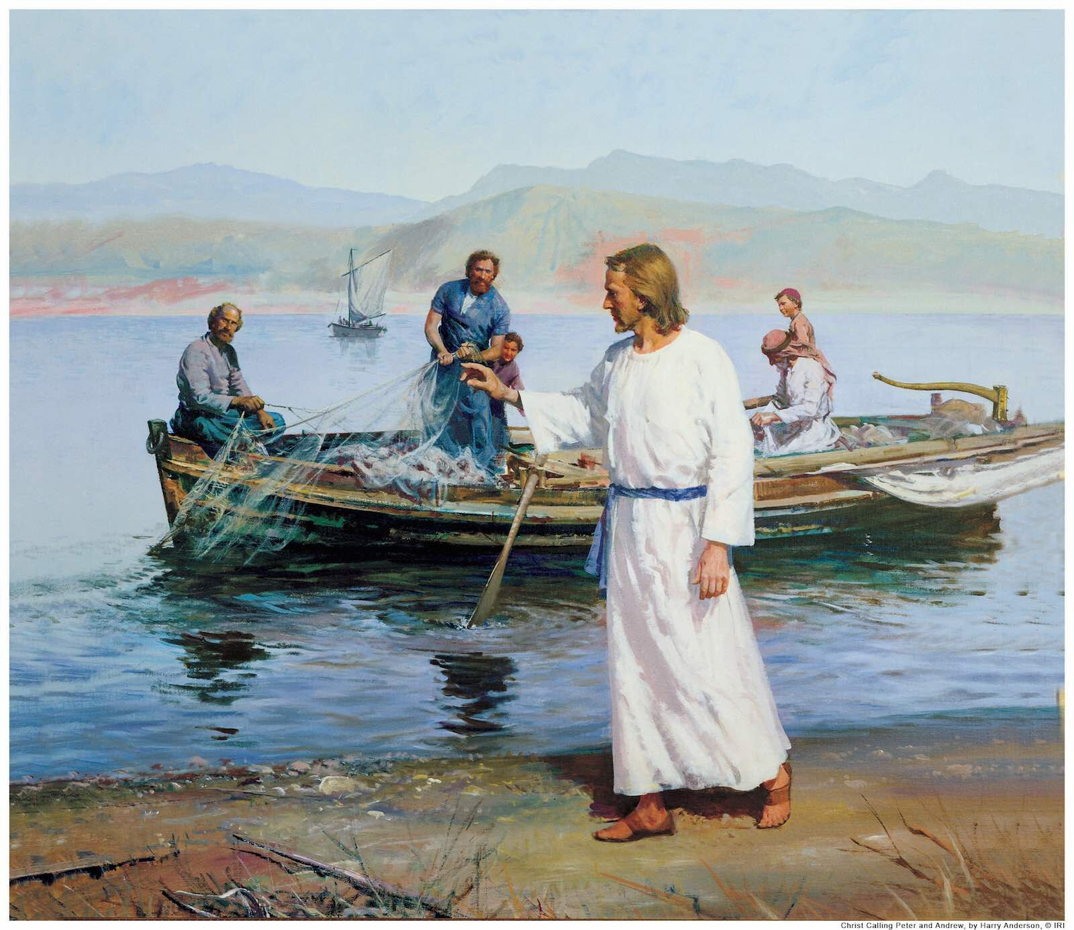

Jesus walked in Galilee.
John 7:1

This beautiful hymn of reflective solitude was composed in 1893 by Mrs. Lelia C. Morris (1862-1929) of Pennsville, Ohio. Mrs. Morris is the author of more than 1,000 hymns, many of which she wrote after going blind at the age of 52. She and her husband were active in the Methodist Episcopal Church.

We are taken back by the lyrics to the placid and peaceful shores of the Sea of Galilee and its verdant and sloping surrounding country. This is the land in which Jesus was raised, and its strikes a sharp contrast to that tumultuous and violent Hill outside the gates of Jerusalem at which He was crucified. Those blue waters, teeming with life, remind us of the Giver of Life Himself - our Lord and Savior! There are two refrains included in this hymn - the first for the first three stanzas; and the second for the last stanza.

The Stranger of Galilee

In fancy I stood by the shore, one day,
Of the beautiful murm’ring sea;
I saw the great crowds as they thronged the way
Of the Stranger of Galilee;
I saw how the man who was blind from birth,
In a moment was made to see;
The lame was made whole by the matchless skill
Of the Stranger of Galilee.

Refrain 1-3:
And I felt I could love Him forever,
So gracious and tender was He!
I claimed Him that day as my Savior,
This Stranger of Galilee.

His look of compassion, His words of love,
They shall never forgotten be;
When sin-sick and helpless He saw me there,
This Stranger of Galilee;
He showed me His hand and His riven side,
And He whispered, It was for thee!
My burden fell off at the pierced feet
Of the Stranger from Galilee.
[Refrain]

I heard Him speak peace to the angry waves,
Of that turbulent, raging sea;
And lo! at His word are the waters stilled,
This Stranger of Galilee;
A peaceful, a quiet, and holy calm,
Now and ever abides with me;
He holdeth my life in His mighty hands,
This Stranger of Galilee.
[Refrain]

Come, ye who are driven and tempest-tossed,
And His gracious salvation see;
He’ll quiet life’s storms with His Peace, be still!
This Stranger of Galilee;
He bids me to go and the story tell—
What He ever to you will be,
If only you let Him with you abide,
This Stranger of Galilee.

Refrain 4:
Oh, my friend, won’t you love Him forever?
So gracious and tender is He! Accept Him today as your Savior,
This Stranger of Galilee.

1 In fancy I stood by the shore, one day, Of the beautiful murm’ring sea; I saw the great crowds as they thronged the way Of the Stranger of Galilee; I saw how the man who was blind from birth, In a moment was made to see; The lame was made whole by the matchless skill Of the Stranger of Galilee. Imagine the experience of standing on those semi-arid shores of Galilee and looking across the waters knowing that Jesus Himself had most likely stood on that very strand. Look to the misty sea waters that separate us from the far shore and remember that Jesus had walked on these very waters. Remember the day that Jesus taught the multitudes seated in a small ship pushed back only a few feet from the shore on which you now stand. Jesus spoke there the parables of the Kingdom of Matthew 13 - beginning with that of the Sower. See, too, the foamy brine near the makeshift docks where fishers tied their small craft. It was here that Jesus first called Peter and Andrew as they were casting their nets. Jesus calls men and women who are doers, not idlers. And a bit further along the shore, Jesus saw James and John mending their nets, and He called them to follow on - and all did so without hesitation! Think of those whose lives have been made joyful through the healing touch of Christ - not just at Galilee - but everywhere He went .... and everywhere He works His miracles today.

Jesus was a Stranger to many who received His healing mercies at Galilee. He is a Stranger to many today who either reject His Kingship and Redemption, or whose consciences are so soiled and dirtied that their consciences have been seared to the point of senselessness. He came a Stranger to a woman at Jacob's Well, and left as the most important Man she had ever known. He was a Stranger to the two disciples on the Road to Damascus until their eyes were opened at the taking of Bread from His nail-scarred hands. If He is not your Savior, then He is a total Stranger to you.

2 His look of compassion, His words of love, They shall never forgotten be; When sin-sick and helpless He saw me there, This Stranger of Galilee; He showed me His hand and His riven side, And He whispered, It was for thee! My burden fell off at the pierced feet Of the Stranger from Galilee. He did, indeed, see you and me there. He saw us as the Woman at the Well, the Woman taken in Adultery, the Woman with an Issue of Blood, in Nicodemus at the midnight hour, and in the tragic person of Pontius Pilate sitting in the judgment seat. We have often been sinners and lost to God. We have been, at some point, Pharisees of the worst kind, and adulterers, too. Yet this Stranger saw through our wicked persona and touched our heart with a Golden Voice - and we were strangers no more. Our Lord is our Burden-Bearer - we bear no burdens for Him. Come unto me, all ye that labour and are heavy laden, and I will give you rest. (Matt 11:28) How can the pot bear a profitable burden for the Potter who made it? Perhaps we may mistake what we consider a burden to be merely our bounden duty to God and man. Even so, we can do no good works. If they are good works, they belong to Christ who works in, and through, us. If they are evil works, we may lay claim to those without dispute. Jesus bore the shame and humiliation of the cross for you and me. He was virtuous without stain of sin and modest, yet He allowed Himself to be stripped naked in public, abused, tortured and, finally, nailed to the cross - and it was all for those who would know and believe according to the power of the Holy Ghost.

3 I heard Him speak peace to the angry waves, Of that turbulent, raging sea; And lo! at His word are the waters stilled, This Stranger of Galilee; A peaceful, a quiet, and holy calm, Now and ever abides with me;
He holdeth my life in His mighty hands, This Stranger of Galilee. Why should we be amazed that the Voice of Jesus stilled the waves and billows of the sea? The same Voice spoke the worlds and galaxies into being at the dawn of Creation morning! His disciples were affrighted at the boisterous sea while their Lord slept peacefully in the hull of the ship - why? If the One who commands the stars in their orbits sleeps during the storm on a small sea, all must be well. Yet, we are fearful when the sea of life is restless and dark. Our Lord is right beside, and it is He that leadeth us beside the still waters. Peace is not a value of external conditions, but rather the INTERNAL condition of the heart. And, yes, He holds our lives, moment by moment, in the palm of His loving Hand.

Refrain 1-3: And I felt I could love Him forever, So gracious and tender was He! I claimed Him that day as my Savior, This Stranger of Galilee. If we have come to love Christ forever, it is merely because He has first loved us. There is no other way to love Christ than FOREVER! Once we have come to know Christ as our Lord and Savior, He immediately ceases to be a Stranger and becomes a Friend that sticketh closer than a brother. (Proverbs 18:24) Our eyes are instantly opened at the proffer of the Bread of Life at the close of our Damascus Road journey.

4 Come, ye who are driven and tempest-tossed, And His gracious salvation see; He’ll quiet life’s storms with His Peace, be still! This Stranger of Galilee; He bids me to go and the story tell— What He ever to you will be, If only you let Him with you abide, This Stranger of Galilee. All are driven and tempest tossed if they know not the Lord of Life. There is no storm as violent as that which rages on the Sea of the Heart of man without Christ, and, without Him, there is no hope of abatement of the storm. And he arose, and rebuked the wind, and said unto the sea, Peace, be still. And the wind ceased, and there was a great calm. (Mark 4:39)

Observe that there was not a simple calm that followed on the command of Christ, but a GREAT calm! Note, too, that Jesus did not shout or scream at the sea, but simply spoke the words, and the sea was calmed. He abides in the hearts of His elect and chosen - He is no casual visitor, but a permanent Resident of the heart of the believer. He bids us go forth and tell the world that once we were blind, but now we see; once we were lepers, but now we are cleansed; once we were afflicted with diverse maladies, but now we are healed; and once we were sin-laden and hopeless, but now we are washed clean and made righteous with His IMPUTED righteousness.

Refrain for 4th stanza: Oh, my friend, won’t you love Him forever? So gracious and tender is He! Accept Him today as your Savior, This Stranger of Galilee. If there were no FOREVER, we could not love Him so. But He is the Alpha and Omega, the Beginning and End - and in Him, we have life abundantly and eternally. There are no assurances that another day will dawn in your mortal days, so today is the day of salvation - procrastinate not about so mighty a matter.

For he saith, I have heard thee in a time accepted, and in the day of salvation have I succoured thee: behold, now is the accepted time; behold, now is the day of salvation. (2 Cor 6:2)

