Hymns of the Church – Still, Still, Still – 9 December 2014, Anno Domini (In the Year of our Lord)

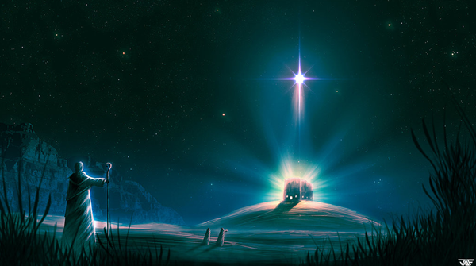

I shall see him, but not now: I shall behold him, but not nigh: there shall come a Star out of Jacob, and a Sceptre shall rise out of Israel. (Num 24:17)

Christmas is such a sweet and peaceful season. The attitudes and dispositions of people – both Christian and un-Christian – seem to assume a glow and warmth that is sadly lacking throughout the rest of the year. From Tokyo to Johannesburg, and Moscow to the Falkland Islands, Christmas decorations of beauty and color mark the landscape. Warm greetings are exchanged on the streets, and an uncommon compassion is demonstrated everywhere. For a very brief moment at Christmas, time seems to stand still. All eyes and hearts are attuned to an event of 2,000 years past when a beautiful and innocent baby boy – literally the only Begotten Son of God - was laid in a manger by his mother after giving Him birth in a stable.

The hymn under discussion today seems to relate that spirit of peace and love in a unique way for the season. It originates Salzburg, Austria in 1819 (same country that gave us Silent Night) and its author is anonymous. One can imagine the falling snows of the Austrian Alps as the unknown scribe penned the words to this lovely carol.

Still, Still, Still
“Salzburger Volkslieder"
Salzburg, 1819 Ausrian Carol (anonymous)

Still, still, still,
One can hear the falling snow.
For all is hushed,
The world is sleeping,
Holy Star its vigil keeping.
Still, still, still,
One can hear the falling snow.

Sleep, sleep, sleep,
'Tis the eve of our Saviour's birth.
The night is peaceful all around you,
Close your eyes,
Let sleep surround you.
Sleep, sleep, sleep,
'Tis the eve of our Saviour's birth.

Dream, dream, dream,
Of the joyous day to come.
While guardian angels without number,
Watch you as you sweetly slumber.
Dream, dream, dream,
Of the joyous day to come.

It is true we may fondly remember Good King Wenceslas (of Bohemia) at this season gathering wood for the widows and poor in the snow of St. Stephens; or (Bishop) St. Nicholas of Asia Minor who was known throughout the land for his generosity to those in need and his love for children. We may even be drawn to the hearth and fireside for ‘chestnuts roasting on an open fire.’ A sleigh ride might warm our hearts as Christmas day approaches; but the purpose and reason for the season is not centered upon these pleasing experiences and memorials. The reason for the season is not X-mas, but CHRIST-mas – the Advent of the Lord Jesus Christ. And it is not the season only centered upon that event, but all of time and eternity.

“Still, still, still, One can hear the falling snow. For all is hushed, The world is sleeping, Holy Star its vigil keeping. Still, still, still, One can hear the falling snow.” Truly that first Christmas awaited the miracle is stillness and peace. No one, especially in sleepy little Bethlehem, expected such a wonderful event to occur within its humble boundaries. Having lived in that environment for a while, I can say with authority that it is likely that the night sky was decorated with thousands of stars whose light penetrated the pristine air. The semi=desert regions of the Holy Land cool to very low temperatures at night and, particularly so in winter. Just as the snow falls from a region far removed from the dirt and grime of the earth, and from a very high point, so would a gift be given from a pure and undefiled Heaven on this very night. He would come in a like stillness with the falling snows of our carol. It is true, even snow can be heard falling in a hushed and quiet night. The Star of Bethlehem also gleamed far more brightly on such a night. If one’s heart is acutely attuned to the Word of God, he can hear His Voice in the stillness of the night. It may not be heard in the boisterous gathering places of a fallen world.

“Sleep, sleep, sleep, 'Tis the eve of our Saviour's birth. The night is peaceful all around you, Close your eyes, Let sleep surround you. Sleep, sleep, sleep, 'Tis the eve of our Saviour's birth.” Christmas Eve leads to one of the longest nights of the year – a time perfect for sleeping well. Men slept while the greatest gift of God was given. The works of man could not have effected the time, means, or nature of God’s gift. It was entirely a work of God the Father. So it is appropriate that men slept during an event over which they had no control to effect or amend. There may come a time in your life that you fall into a very sound sleep unlike any other. It will be so sound that you will feel as if you only blinked your eyes before you awaken to the glorious return of Christ. Men slept a physical sleep during the first Advent of Christ; and may likely sleep a spiritual sleep before His next Advent. Though we may all fall asleep in the same way, our awakening will be quite a contrast – depending on the condition of our hearts when the Angel of Death comes calling.

“Dream, dream, dream, Of the joyous day to come. While guardian angels without number, Watch you as you sweetly slumber. Dream, dream, dream, Of the joyous day to come.” Abraham, Isaac, and Jacob fell asleep in death and “slept with their fathers.” Yet, these were not dead, for God is not the God of the dead but of the living. Moses fell asleep in Christ on Mt. Nebal, yet he was not dead to God. He appeared on the Mt. of Transfiguration about 1200 years later. What kind of sleep do they experience? What dreams may come as the dead in Christ sleep quietly in the dust? What dream may Lazarus have experienced while resting in the bosom of Abraham where he had been carried by the angels? Frankly, we do not know for the Bible does not say; but one thing is sure – the dead in Christ sleep in a blissful paradise awaiting the reunion of their spirits with their glorified bodies. God has never lost a single atom, or a single soul. His Angels surely keep watch over all souls, living and dead, until the consummation of all time. And, if we dream, it is likely that those dreams will consist of the beauty of the joy that is to soon come with the return of our Lord in the clouds.

This sweet little carol reminds us of the watch we are keeping for the first Advent of the Lord Jesus Christ. But it also quietly reminds us that we must bear watch for the second Advent which shall come upon the earth as a thief in the night, or the softly falling snows from heaven.

