Hymns of the Church – Shepherd of Souls – 24 April 24, 2018, Anno Domini (In the Year of our Lord)

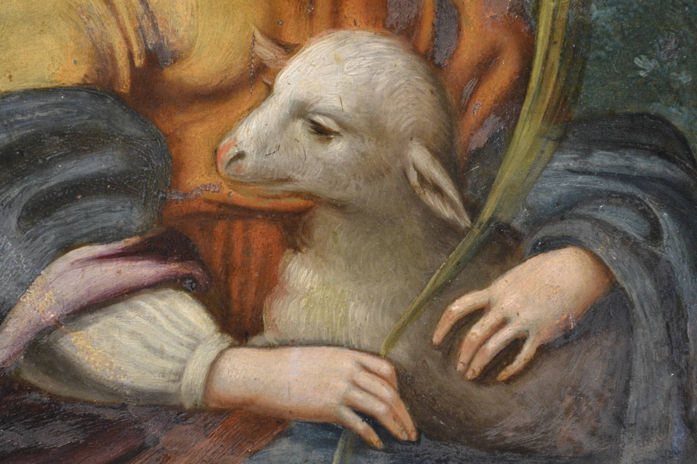

I
t is written, That man shall not live by bread alone, but by every word of God.
(Luke 4:4 (KJV)

I
am that bread of life. 49 Your fathers did eat manna in the wilderness, and are dead. 50 This is the bread which cometh down from heaven, that a man may eat thereof, and not die. 51 I am the living bread which came down from heaven: if any man eat of this bread, he shall live for ever: and the bread that I will give is my flesh, which I will give for the life of the world. (John 6:48-51)

The name of the tune for this hymn is noteworthy – Saint Agnes. Agnes is depicted in art with a lamb, from the Latin word for lamb, agnus. However, the name Agnes is actually derived from the feminine Greek adjective hagnē (ἁγνή) meaning chaste, pure, sacred. She is also shown with a martyr's palm. This young virgin girl of fourteen years was martyred for her absolute devotion to Christ and the moral character required of His followers. It is said she was a beautiful young girl of aristocracy who was reported to authorities for her Christian faith after being reported by would be suitors who felt slighted by her refusal to succumb to their seductions. She was sentenced to be dragged through the streets of Rome to a brothel naked. (304 AD) Owing to several unusual cases of her persecutors being struck blind, she was later tied to a stake and beheaded. The tune is composed by John B. Dykes to go with another hymn, Jesus the very Thought of Thee in 1866.

It seems Christian virtue was much more fervent in the days of the cruel Diocletion than in our own time. The author of the lyrics to the hymn is anonymous though Charles Wesley wrote a hymn with almost the same wording and claimed it as his own. This hymn is my favorite Communion hymn next to Panis Angelicus.

Shepherd of Souls

Shepherd of souls, refresh and bless
Thy chosen pilgrim flock
With manna in the wilderness,
With water from the rock.

We would not live by bread alone,
But by that Word of grace,
In strength of which we travel on
To our abiding place.

Be known to us in breaking bread,
But do not then depart;
Saviour, abide with us, and spread
Thy table in our heart.

There sup with us in love Divine;
Thy body and thy blood,
That living bread, that heav'nly wine,
Be our immortal food.

Shepherd of souls, refresh and bless Thy chosen pilgrim flock With manna in the wilderness, With water from the rock. The words to this hymn borrow heavily from the types and metaphors of Exodus. As you see in this verse, we see three major representations of the Exodus in the pilgrim flock (Children of Israel), Manna in the Wilderness, and the Water from the Rock. These beautiful terms should not seem odd to us since we experience the very same nature of God’s works in our lives today perhaps under different forms. The Christian adherent will immediately confess that the Lord Jesus Christ is the true Shepherd and Bishop of his soul. For ye were as sheep going astray; but are now returned unto the Shepherd and Bishop of your souls. (1 Peter 2:25)

We would not live by bread alone, But by that Word of grace, In strength of which we travel on To our abiding place. We are pilgrims and vagabonds in this world. We are a people who seek to find a Holy City. . . . . they were strangers and pilgrims on the earth. For they that say such things declare plainly that they seek a country. And truly, if they had been mindful of that country from whence they came out, they might have had opportunity to have returned. But now they desire a better country, that is, an heavenly: wherefore God is not ashamed to be called their God: for he hath prepared for them a city. (Heb 11:13-16) A long and arduous journey demands sustenance for the way. Our sustenance is, of course, bread for our bodies, but more importantly, the Bread of Heaven for our souls. How tragic to travel such a distance with a healthy body and arrive with a famished soul at the last. Our abiding place is that place at which we abide together with the One who abides in our hearts.

Be known to us in breaking bread, But do not then depart; Saviour, abide with us, and spread Thy table in our heart. We have an excellent counsel on the breaking of that bread by Paul: 23 For I have received of the Lord that which also I delivered unto you, That the Lord Jesus the same night in which he was betrayed took bread: 24 And when he had given thanks, he brake it, and said, Take, eat: this is my body, which is broken for you: this do in remembrance of me. 25 After the same manner also he took the cup, when he had supped, saying, This cup is the new testament in my blood: this do ye, as oft as ye drink it, in remembrance of me. 26 For as often as ye eat this bread, and drink this cup, ye do shew the Lord's death till he come. 27 Wherefore whosoever shall eat this bread, and drink this cup of the Lord, unworthily, shall be guilty of the body and blood of the Lord. 28 But let a man examine himself, and so let him eat of that bread, and drink of that cup. 29 For he that eateth and drinketh unworthily, eateth and drinketh damnation to himself, not discerning the Lord's body. (1 Cor 11:23-29) The breaking of bread in the Holy Communion is the best reminder that where two or three are gathered together in His Name, He is there among them. His presence is real, though spiritual, at the Lord’s Table. It is His Bread that is Broken (Body) and His Cup (Blood) of which we partake. Just as a family sups together (or should), so does the family of God gather, with one mind, around the Lord’s Table to sup with Him and with each other. The Sacrament of Holy Communion is ‘an outward and visible expression of an inward and spiritual grace.’ The Table of the Lord from which we are served the Bread and Wine must mirror that same table in our hearts at which we dine daily on Bread and Wine of Heaven with the Lord.

There sup with us in love Divine; Thy body and thy blood, That living bread, that heav'nly wine, Be our immortal food. The Cup from which Christ drank was a Cup of horrendous proportion. He would have preferred to allow that Cup to pass from Him; yet, He came to do His Father’s will and He received the Cup with an obedient heart. We, too, have that Common Cup from which to drink. It is for that reason that we observe the Communion with the one Cup for all: Ye shall indeed drink of the cup that I drink of; and with the baptism that I am baptized withal shall ye be baptized. (Mark 10:39) Besides the Blood and Body of Christ, what one word might summarize his terrible suffering and sacrifice for us? Is it not the word, LOVE? Love is able to sacrifice all for the object of its affection. It can perform miracles on its own behalf. Christ represents the truest form of LOVE in its virgin state. He loved us while we were yet enemies. He loved us first before we ever could love Him. That kind of love survives death and is not subject to death. He feeds us with His Word. We feed on Him because He IS the Word.

At times of reflection on my life, my memories often go back to the glimmering dreams of childhood when, engaged in outdoor games with my little friends, I would hear my mother call my name. She called it in a special way and with a peculiar accent reserved only for the occasion of supper. Jereee! Come to supper. I knew to drop all other interest and head for the table to be fed on the choice foods of my heart – my mother could prepare a table fit for a king! But God calls us now to a Table PREPARED BY A KING, and fit for His sons and daughters! The call should immediately cause us to forfeit all other interest to be drawn into that Communion of Holy Bread and Wine of the Holy Spirit – and without delay.

Our hearts must be staid on Him alone – ALWAYS!

