Hymns of the Church – That Sheep may safely Graze –14 August 2018, Anno Domini (In the Year of our Lord)

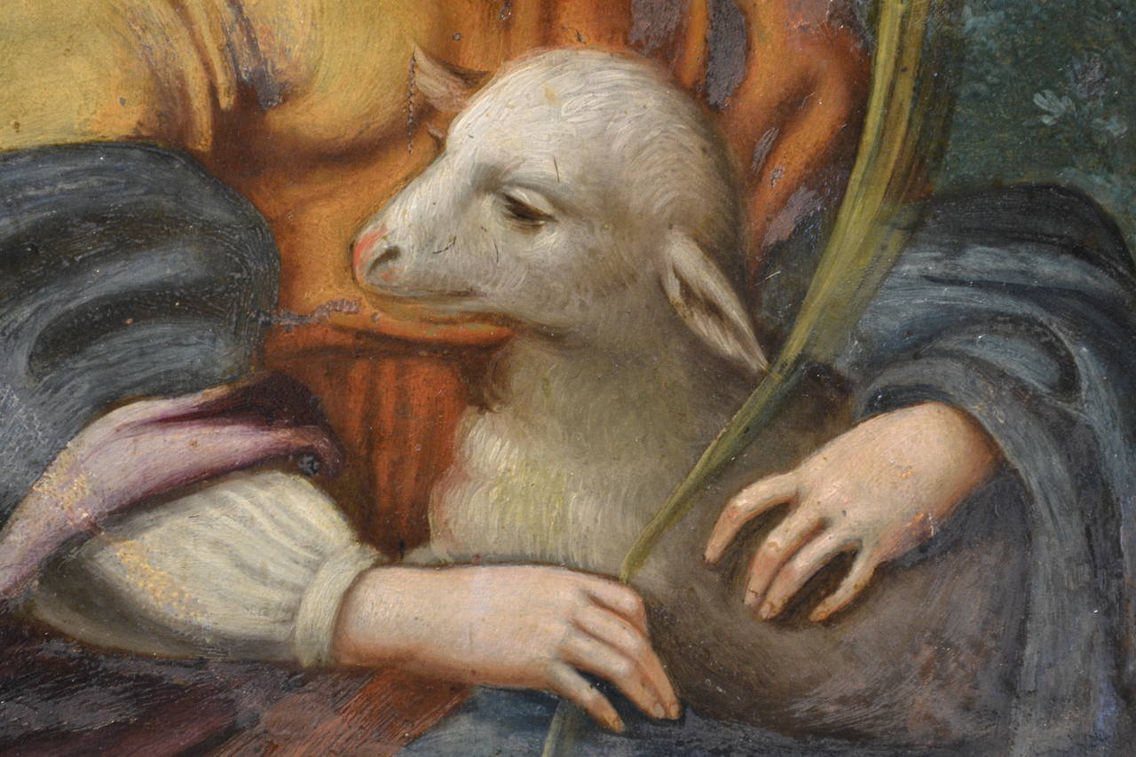

T
he LORD is my shepherd; I shall not want. 2 He maketh me to lie down in green pastures: he leadeth me beside the still waters. 3 He restoreth my soul: he leadeth me in the paths of righteousness for his name's sake. 4 Yea, though I walk through the valley of the shadow of death, I will fear no evil: for thou art with me; thy rod and thy staff they comfort me. 5 Thou preparest a table before me in the presence of mine enemies: thou anointest my head with oil; my cup runneth over. 6 Surely goodness and mercy shall follow me all the days of my life: and I will dwell in the house of the LORD for ever. (Psalm 23:1-6)

It would not be possible to discuss the beauty and Godly merits of this hymn, short in lyrics but long in musical component, without discussing its under-shepherd of the score (for the under-shepherd considered all of his musical works to be the product of the inspiration of the Master Shepherd of Glory.) His name is known around the world and respected highly by all who love the reverence and majesty of music that lifts the soul to the seventh heaven – Johann Sebastian Bach. (31 March 1685 to 28 July 1750).

With the passing of Bach, the great Baroque Period in musical composition ended. All that he ever wrote in music, he wrote solely to the glory and edification of a Holy God. He always offered up a short prayer before beginning any new creation. The prayer? Simply, “Help me, Jesus.” He entered that prayer on the first line of each new manuscript in Latin: “Jesu Juve” and he ended every score with the phrase, Soli Deo Gloria” – Solely to the Glory of God. Whether therefore ye eat, or drink, or whatsoever ye do, do all to the glory of God. (1 Cor 10:31) He apparently took the same principle in parenting since he fathered 20 children!

He encoded his melodies with a mathematical and melodious technique of spelling out Bible verses from the liturgy encrypted in his music. In a sense, Bach made the music of heaven flesh by bringing those glorious and beautiful peels of Heaven down to those who dwell upon the earth.

We, too, should perform all our works solely to the Glory of God – Our Lord Jesus Christ being our helper. The Invisible Hand in all of Bach’s works was extended an infinite distance from Heaven’s Gate. 11 For other foundation can no man lay than that is laid, which is Jesus Christ. 12 Now if any man build upon this foundation gold, silver, precious stones, wood, hay, stubble; 13 Every man's work shall be made manifest: for the day shall declare it, because it shall be revealed by fire; and the fire shall try every man's work of what sort it is. 14 If any man's work abide which he hath built thereupon, he shall receive a reward. 15 If any man's work shall be burned, he shall suffer loss: but he himself shall be saved; yet so as by fire. (1 Cor 3:11-15) Bach had a firm Foundation, indeed.

There are many beloved quotes to be discovered in researching the life of Bach. One such quote reads: Like all music, the figured bass should have no other end and aim than the glory of God and the recreation of the soul; where this is not kept in mind there is no true music, but only an infernal clamour and ranting.

Would it not be a great movement to have this principle re-established in the “entertainment centers of today” which we erroneously refer to as churches?

One of Bach’s most enduring compositions (and all are classical wonders) is Cantata # 208, or better known by the tune, “That Sheep May Safely Graze” composed in 1713. It has been used as a funeral hymn, and even a wedding song, but it is more properly directed to the Spirit-filled heart of the devoted worshipper. Over the centuries, a number of lyrics have been added to this majestic work, but five lines of the original stand out conveying a sense of deep devotion. They appear in the ninth movement as a beacon aria:

That Sheep may safely Graze

Sheep may safely graze and pasture
In a watchful Shepherd's sight.
Those who rule with wisdom guiding
Bring to hearts a peace abiding
Bless a land with joy made bright.

Sheep may safely graze and pasture In a watchful Shepherd's sight. In order to enjoy the blessings of having a good and watchful Shepherd, the lambs must remain close enough to the Shepherd for Him to see their grazing. If the lamb disregards the Shepherd, he may get into the lost ravines and wilderness of sin. But, like the old father of the Prodigal, the Good Shepherd is forever keeping a watchful eye over the flock. The Shepherd promised to “lay down his life for the sheep” – and He did! What security we have in knowing that the Shepherd is near to us, and we are near to Him. There can come no conniving wolf among the flock to hurt the sheep that remain near the Shepherd and follow His every command. It is a lack of zeal and a morbid ignorance that causes men to fall for the deceptive voices of false prophets in our day.

Bach made this principle a reality with his exquisitely composed music of deep devotion. He said, “Where there is devotional music, God is always at hand with His gracious presence.” Devotional music is selfless music devoted, in all its parts, to God alone – not evincing some imagined talent of man. It is never man-centered, or even desire-centered; but rather always God-centered to praise and worship Him alone.

Those who rule with wisdom guiding Bring to hearts a peace abiding Bless a land with joy made bright. God’s elect people are the guiding lights of civilization because they are the reflected Light of the Sun of Righteousness, and it is His Light which they reveal to a darkened world. A Christian people will always have righteous rulers. If they forget the Lord, they must suffer growing oppression and cruel injustice. Bach has here placed the truth voiced by God’s Word into his composition: When the righteous are in authority, the people rejoice: but when the wicked beareth rule, the people mourn. (Prov 29:2) We need not look further than an island away to see this wicked rule which has oppressed the people and taken, not only their treasure, but their souls, hostage with dictatorial socialism which steals the possessions of every citizen; and the pride of those who receive a meager benefit.

I dimly remember a day in my early life when America was ruled by men of more righteous character – a time when, as a Constitutional Republic, the laws applied equally to every citizen. There were no special provisions for certain classes and political persuasions; but just look at the mess we have gotten ourselves into. We murder the most innocent of life in the sanctuary of its mother’s womb, and then sell those body parts for fantastic profit. What unimaginable wickedness! WE have granted official acceptance and a false dignity to marriages of sinful homosexuals and lesbians. We have placed the idol of indoctrination of lies at the head of our schools and have exiled the greater truth. So we need again those rulers to whom Bach makes reference who are wise in the eyes of God to bring abiding peace to our hearts and the Joy of effulgent and resplendent LIGHT to our spiritual eyes. But we shall not have them until we become wise and discerning citizens as well.

I hope each reader of this devotion will make a serious appraisal of his heart’s treasures to see if he, too, does all for the Glory of God alone!

