Hymns of the Church (Shall we Gather at the River) – 30 September 2014, Anno Domini (In the Year of our Lord)

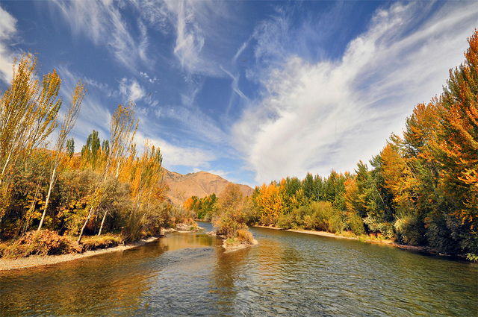

And out of the ground made the LORD God to grow every tree that is pleasant to the sight, and good for food; the tree of life also in the midst of the garden, and the tree of knowledge of good and evil. And a river went out of Eden to water the garden; (Gen 2:9-10)

And he shewed me a pure river of water of life, clear as crystal, proceeding out of the throne of God and of the Lamb. In the midst of the street of it, and on either side of the river, was there the tree of life, which bare twelve manner of fruits, and yielded her fruit every month: and the leaves of the tree were for the healing of the nations. (Rev 22:1-2)

It is an awesome observation to view the Tree of Life and the River of Life in both the beginning of the Creation of God (Genesis 2:9-10) and those two Beauties of God at the last in the end of Revelations (22:1-2) It is as if God has completed a perfect circle of Eternal proportion. Rivers have always excited my imagination and fascinated my concept of Life itself. That fascination was brought into acute focus while I lived on the high desert of Iran (old Persia). There was a cold stream river that flowed through the city of Esfahan where I lived named Zayanderud (Giver of Life). This river had its origin from the melting snows on the heights of the Zagros Mountains to the west. This mountain range overlooked the Province of Elam which was the center of Power of the Medes and Persians, and the capital city of Susa from which Daniel made prophecies.

What made the Zayanderud such a marvelous river? It was only about 105 miles long from beginning to end. It was not very wide, either. Its great beauty and meaning resided in the contrast its life-giving waters created across the barren desert along its course. Flying across the parched sands east of Esfahan, one need never doubt the course of that gentle river. A wide belt of verdant, green vegetation was seen bordering the river in its course across the desert. Small villages could be seen there along with flocks of sheep and goats attended by shepherds. It gave life wherever it went, just as Christ does. It had its death in a salt sea across the desert interestingly called Gav-Khuni (Blood of an Ox). It was so called because the water appeared blood red when viewed from the shore of that dead sea. The life of Christ, too, was short, and it ended in a wilderness dead sea of our sins.

This old Gospel hymn has plenty of testimony to recommend it as one of the finest of the common folk of Christendom, and those who might consider it of too little sophistication might be wise to lower their heads and lift their hearts to the heights of its yearning acclamations. That river mentioned in the hymn is not some desert stream such as the Zayanderud, but the River of Life that watered, and still waters, the Paradise of God.

The hymn was composed by Robert Lowery (1826-1899) at the height of the War Between the States in1864. Just a year earlier, a great Christian general of that war, Stonewall Jackson, uttered the immortal words at the moment of his death, "Let us cross over the river and rest under the shade of the trees." (Sunday, May 10, 1863). Here, in his own words, is Lowery’s feelings at the time of writing: “One afternoon in July, 1864, when I was pastor at Hanson Place Baptist Church, Brooklyn, the weather was oppressively hot, and I was lying on a lounge in a state of physical exhaustion…My imagination began to take itself wings. Visions of the future passed before me with startling vividness. The imagery of the apocalypse took the form of a tableau. Brightest of all were the throne, the heavenly river, and the gathering of the saints…I began to wonder why the hymn writers had said so much about the “river of death” and so little about the “pure water of life, clear as crystal, proceeding out of the throne of God and the Lamb.” As I mused, the words began to construct themselves. They came first as a question of Christian inquiry, “Shall we gather?” Then they broke in chorus, “Yes, we’ll gather.” On this question and answer the hymn developed itself. The music came with the hymn.”

The words stir up fond memories of home and the mountains of Tennessee in my mind, for it was a favorite of the mountain people of that day. Humorously, too, was the fact that it was a favorite among the women of the Prohibition movement who broke up “dens of iniquity” (Bars and saloons) to this hymn.

Shall we gather at the river,

Shall we gather at the river,
Where bright angel feet have trod,
With its crystal tide forever
Flowing by the throne of God?
Refrain
Yes, we’ll gather at the river,
The beautiful, the beautiful river;
Gather with the saints at the river
That flows by the throne of God.

On the margin of the river,
Washing up its silver spray,
We will talk and worship ever,
All the happy golden day.
Refrain

Ere we reach the shining river,
Lay we every burden down;
Grace our spirits will deliver,
And provide a robe and crown.
Refrain

At the smiling of the river,
Mirror of the Savior’s face,
Saints, whom death will never sever,
Lift their songs of saving grace.
Refrain

Soon we’ll reach the silver river,
Soon our pilgrimage will cease;
Soon our happy hearts will quiver
With the melody of peace.
Refrain

“Shall we gather at the river, Where bright angel feet have trod, With its crystal tide forever Flowing by the throne of God?” Observe how pleasantly this verse corresponds to that description given of the River of Life in Revelations 22:1-2. Though this may not comport with the near Banks of Jordan Waters, it may very favorably resemble the Far Banks at our crossing. The River is divine and representative of our own Giver of Life – the Lord Jesus Christ.

“On the margin of the river, Washing up its silver spray, We will talk and worship ever, All the happy golden day.” The strokes and colors of these word pictures conjure up glimmering arrays that far outstrip those of Van Gogh or Raphael. Even at the very margin of the river, we experience a glorious foretaste of that “glory divine’ that is the blessing of every saint who approaches the River at the moment of eternal rest. “All the Happy Golden Day” is a description of that unending day in which no storm clouds arise, and no shadows will dim.

“Ere we reach the shining river, Lay we every burden down; Grace our spirits will deliver, And provide a robe and crown.” In this life, even our mortal bodies, in addition to our sins, are a burden to us; but we shall lay down our ‘sword and shield,’ our old worn-out coils of pain and hurt, along with our war books, down by that riverside. Then, light as the Wind of the Holy Spirit, we shall float with the ease and grace of a swan across that crystal sea. The Father waits across the way with a robe and crown for every returning prodigal and faithful son.

“At the smiling of the river, Mirror of the Savior’s face, Saints, whom death will never sever, Lift their songs of saving grace.” I love the metaphor of this line. Yes, the face of our Lord is mirrored in the Waters of Life for these waters are His essence. “For I am persuaded, that neither death, nor life, nor angels, nor principalities, nor powers, nor things present, nor things to come, Nor height, nor depth, nor any other creature, shall be able to separate us from the love of God, which is in Christ Jesus our Lord.” (Romans 8:38-39) Shakespeare describes death with eerie insight in Hamlet: “Thou know'st 'tis common; all that lives must die, Passing through nature to eternity.” (Act I, scene 2, line 72); but not with the beauty and clarity of God’s Word: “We shall not all sleep, but we shall all be changed, In a moment, in the twinkling of an eye, at the last trump: for the trumpet shall sound, and the dead shall be raised incorruptible, and we shall be changed. For this corruptible must put on incorruption, and this mortal must put on immortality. So when this corruptible shall have put on incorruption, and this mortal shall have put on immortality, then shall be brought to pass the saying that is written, Death is swallowed up in victory. O death, where is thy sting? O grave, where is thy victory? The sting of death is sin; and the strength of sin is the law. But thanks be to God, which giveth us the victory through our Lord Jesus Christ.” (1 Cor 15:51-57)

“Soon we’ll reach the silver river, Soon our pilgrimage will cease; Soon our happy hearts will quiver With the melody of peace.” Yes, we shall reach that silver strand sooner than many who are reading this devotion may imagine. Death is a thief who comes at awkward hours of the night, but sometimes even in the high noon day. Though we are strangers and pilgrims here in this life, we shall not be so in that land of hope and promise to come. Every citizen of that land shall be blood-bought and redeemed – full citizens of the Kingdom. Our hearts have quivered here on earth when our spirits are lifted in praise and song to heaven. But in God’s Paradise, it will be a constant quiver of joy.

If you will be an accomplished literary analyst, master the Word of God. It will open windows on the perfect peace of verdant, green pastures, and the beauty of cloudless, pristine skies. We cannot find the ultimate beauty while simply sitting Sunday after Sunday in church and feeding only on the nutrients of a single sermon. We had to be weaned off our mother’s milk, did we not? So must we grow beyond the spoon-feeding of the Word, and learn to mine its precious veins of ore ourselves. Only then can we call it truly OURS.

