Hymns of the Church – Savior, like a Shepherd Lead Us – 6 June 2017, Anno Domini

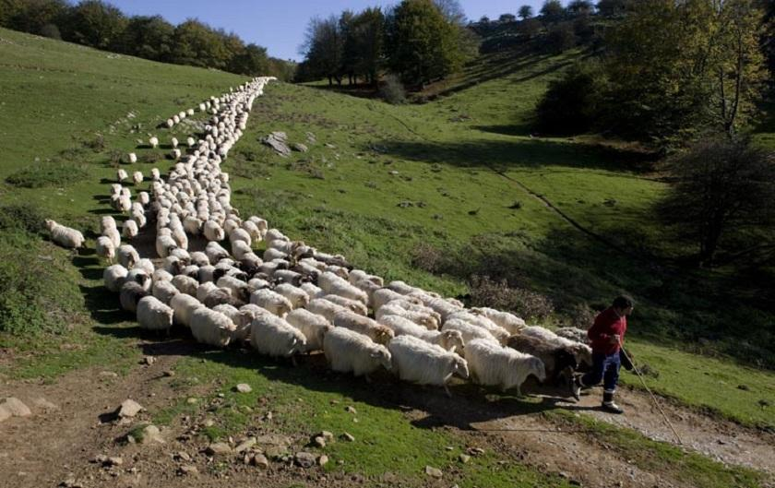

T
hen said Jesus unto them again, Verily, verily, I say unto you, I am the door of the sheep. All that ever came before me are thieves and robbers: but the sheep did not hear them. I am the door: by me if any man enter in, he shall be saved, and shall go in and out, and find pasture. The thief cometh not, but for to steal, and to kill, and to destroy: I am come that they might have life, and that they might have it more abundantly. I am the good shepherd: the good shepherd giveth his life for the sheep. But he that is an hireling, and not the shepherd, whose own the sheep are not, seeth the wolf coming, and leaveth the sheep, and fleeth: and the wolf catcheth them, and scattereth the sheep. The hireling fleeth, because he is an hireling, and careth not for the sheep. I am the good shepherd, and know my sheep, and am known of mine. As the Father knoweth me, even so know I the Father: and I lay down my life for the sheep. (John 10:7-15)

Like every classical hymn, this hymn reveals deeply hidden spiritual truths that the vulgar man cannot grasp – or will not! It is so fully explanatory of the truth of John 10 (the Shepherd Chapter) that the words almost sound like Scripture arranged in a wonderful melodic pattern. The lyrics were written and published by Dorothy Thrupp in 1836; and the music, BRADBURY, is by none other than William Bradbury (1859). There are alternate tunes of lesser appeal (in my view). They are, PLEASANT PASTURES, (1901); and, WALHEAD, (1879) BY Thomas Walhead. We all have a shepherd of some nature. It is best to be prayed that our Shepherd is Jesus Christ and not that wicked one who will lead us into eternal ruin.

Savior, like a Shepherd Lead Us

Savior, like a shepherd lead us, much we need Thy tender care;
In Thy pleasant pastures feed us, for our use Thy folds prepare.
Blessèd Jesus, blessèd Jesus! Thou hast bought us, Thine we are.
Blessèd Jesus, blessèd Jesus! Thou hast bought us, Thine we are.

We are Thine, Thou dost befriend us, be the guardian of our way;
Keep Thy flock, from sin defend us, seek us when we go astray.
Blessèd Jesus, blessèd Jesus! Hear, O hear us when we pray.
Blessèd Jesus, blessèd Jesus! Hear, O hear us when we pray.

Thou hast promised to receive us, poor and sinful though we be;
Thou hast mercy to relieve us, grace to cleanse and power to free.
Blessèd Jesus, blessèd Jesus! We will early turn to Thee.
Blessèd Jesus, blessèd Jesus! We will early turn to Thee.

Early let us seek Thy favor, early let us do Thy will;
Blessèd Lord and only Savior, with Thy love our bosoms fill.
Blessèd Jesus, blessèd Jesus! Thou hast loved us, love us still.
Blessèd Jesus, blessèd Jesus! Thou hast loved us, love us still.

Savior, like a shepherd lead us, much we need Thy tender care; In Thy pleasant pastures feed us, for our use Thy folds prepare. Blessèd Jesus, blessèd Jesus! Thou hast bought us, Thine we are. Blessèd Jesus, blessèd Jesus! Thou hast bought us, Thine we are. As the Good Shepherd Himself proclaims in our leading Scripture text, He is like a shepherd in His manner of leading us always into fertile pastures and fountains of still waters. The fact that we NEED His tender care is evidence of its being granted for He cares for us. If an infant cries for milk, his mother, knowing the need will provide it just as our Lord satisfies our every need. He not only feeds us in peaceful pastures, but protects us in His FOLD of security. Even in the face of an encircling enemy, the Lord will feed and feast His people: ⁵ Thou preparest a table before me in the presence of mine enemies: thou anointest my head with oil; my cup runneth over. Psalm 23:5) Having become One with the Church of God, our purchase price has been immeasurable. We BELONG to Christ. ²⁸ Take heed therefore unto yourselves, and to all the flock, over the which the Holy Ghost hath made you overseers, to feed the church of God, which he hath purchased with his own blood. (Acts 20:28)

We are Thine, Thou dost befriend us, be the guardian of our way; Keep Thy flock, from sin defend us, seek us when we go astray. Blessèd Jesus, blessèd Jesus! Hear, O hear us when we pray. Blessèd Jesus, blessèd Jesus! Hear, O hear us when we pray. Jesus is a Friend unlike any other. What a privilege to be accounted His friend! 15 Henceforth I call you not servants; for the servant knoweth not what his lord doeth: but I have called you friends; for all things that I have heard of my Father I have made known unto you. (John 15:15) We are not only afforded the privilege to be His friend but, more importantly, He is OUR Friend. A man that hath friends must shew himself friendly: and there is a friend that sticketh closer than a brother. (Prov 18:24) There is in this Proverb a small catch phrase: A man that hath friends must shew himself friendly. Christ first showed Himself to be our friend, but now we must reciprocate only by the empowering will of the Holy Ghost. Ye have not chosen me, but I have chosen you, and ordained you, that ye should go and bring forth fruit, and that your fruit should remain: that whatsoever ye shall ask of the Father in my name, he may give it you. (John 15:16) There is no way that you came to Christ by some virtue or merit of your own – you were drawn to Him by the Holy Spirit.

Lambs, especially little ones, may wander from the trail of the sheep and their Shepherd. Newly baptized Christians, too, may wander away. A lamb is very short-sighted and can see only a few feet ahead. When his focus ventures to the side and fixes on a clump of delectable grass, he may wander off to that grass, and wander again, and again, until he looks up and finds himself lost. What does he do on such an occasion? He will begin to bleat, over and over. This bleating enables the shepherd to find his lost sheep; just as when a baby Christian finds himself separated from the Shepherd, he will pray and pray until the Lord comes to fetch him.

Thou hast promised to receive us, poor and sinful though we be; Thou hast mercy to relieve us, grace to cleanse and power to free. Blessèd Jesus, blessèd Jesus! We will early turn to Thee. Blessèd Jesus, blessèd Jesus! We will early turn to Thee. Christ will receive all whom the Father has placed in His hands. If we ‘earned our salvation’ and were able to decide without the intercession of the Holy Spirit, we would not need mercy and grace; but we all do need mercy and grace because we are all alike unworthy sinners. Though depraved as we were, we could not resist His IRRESISTABLE grace at our calling. He has cleansed us of our sins by His life’s blood. He has made us worthy by the imputed righteousness (which is His) that He offers to us. Those who seek Him early, will find Him. Seek ye the LORD while he may be found, call ye upon him while he is near: (Isaiah 55:6)

Early let us seek Thy favor, early let us do Thy will; Blessèd Lord and only Savior, with Thy love our bosoms fill. Blessèd Jesus, blessèd Jesus! Thou hast loved us, love us still. Blessèd Jesus, blessèd Jesus! Thou hast loved us, love us still. No man or woman has a free will unless that will has been surrendered to the will of God. Only then are we free. In our old man, we were in bondage to sin. How can a person in bondage have a will that is free? The bill collector of sin will place liens on our souls and bodies so that freedom is only a dream. In the Lord’s Prayer, we pray only that His will (not ours) be done. If we are One with Christ, our wills will be identical to God’s will for us. The greatest evidence of our being part and parcel of the true Church is the abundance of love that fills our breasts. This is my commandment, That ye love one another, as I have loved you. Greater love hath no man than this, that a man lay down his life for his friends. Ye are my friends, if ye do whatsoever I command you. (John 15:12-14) Love is not an option, but a Commandment! The measure of our love is qualified by the extent of our willingness to sacrifice for others. Do you want to be a true friend of the Lord Jesus Christ? Then do whatsoever He commands – including sacrificial love toward one another. Ye are my friends, if ye do whatsoever I command you. The love of Christ is immutable and unchanging. Once He has claimed us as His own, His love will keep us always.

