Hymns of the Church – Rejoice, Rejoice, Believers – 6 December 2016, Anno Domini

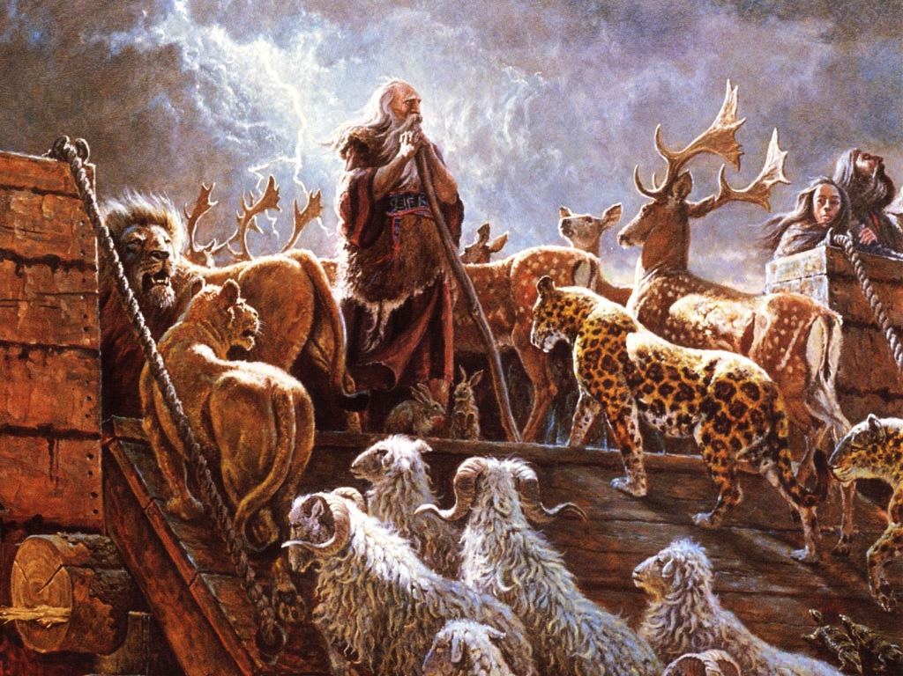

13 In the selfsame day entered Noah, and Shem, and Ham, and Japheth, the sons of Noah, and Noah's wife, and the three wives of his sons with them, into the ark; 14 They, and every beast after his kind, and all the cattle after their kind, and every creeping thing that creepeth upon the earth after his kind, and every fowl after his kind, every bird of every sort. 15 And they went in unto Noah into the ark, two and two of all flesh, wherein is the breath of life. 16 And they that went in, went in male and female of all flesh, as God had commanded him: and the LORD shut him in. (Gen 7:13-16)

10 And while they went to buy, the bridegroom came; and they that were ready went in with him to the marriage: and the door was shut. (Matt 25:10)

From the first light of Creation men and women of faith have observed the Advent Season. Though the Church has set a specific time for its observance, its practical and constant observance has been from that moment Adam sinned until today, and far into the future. His coming was promised through the promise God made to Eve, and by the slaying of an innocent animal to cover their nakedness until that first Christmas night in Bethlehem. But it also is in effect until our Lord’s coming again. The Gates of Splendor are locked to all who are not of faith, but the One who has the Key is coming soon.

Can you imagine the sore distress, horror and despondency of those who had heard and rejected the 100 years of preaching of Noah before the Deluge who, seeing the rising waters gushing from the fountains of the deep and the bottomless skies, found the door of the Ark closed and barred. They doubtless fled to the hills and mountains to share the last spots of dry ground with snakes, lions, and every creeping thing. But those of us who have placed our hope and faith in the Anchor of God’s Word need not worry about the door being shut to the Marriage Supper of the Lord.

The author of this Lutheran hymn is Laurentius Laurenti in 1700. My favorite tune for this hymn is Greenland – a composition of Johann Haydn around 1760. Other tune selections are Lancashire (Henry Smart 1835) and a Welsh tune entitled, Llangloffan, by D. Evans (1865)

Rejoice, Rejoice, Believers

Rejoice, rejoice, believers,
and let your lights appear;
the evening is advancing,
and darker night is near.
The Bridegroom is arising,
and soon he draweth nigh;
up, pray, and watch, and wrestle:
at midnight comes the cry.

See that your lamps are burning;
replenish them with oil;
and wait for your salvation,
the end of earthly toil.
The watchers on the mountain
proclaim the Bridegroom near;
go meet him as he cometh,
with alleluias clear.

O wise and holy virgins,
now raise your voices higher,
until in songs of triumph
ye meet the angel choir.
The marriage feast is waiting,
the gates wide open stand;
rise up, ye heirs of glory,
the Bridegroom is at hand.

Our hope and expectation,
O Jesus, now appear!
Arise, thou Sun so longed for,
over this benighted sphere!
With hearts and hands uplifted,
we plead, O Lord
that brings us unto thee., to see
the day of earth's redemption

Rejoice, rejoice, believers, and let your lights appear; the evening is advancing, and darker night is near. The Bridegroom is arising, and soon he draweth nigh; up, pray, and watch, and wrestle: at midnight comes the cry. We are the burning, lower lights of God. We must be lights to those around us until the midnight moment, and then the lights are for our use and only those who have them, individually, alone. 35 Let your loins be girded about, and your lights burning; 36 And ye yourselves like unto men that wait for their lord, when he will return from the wedding; that when he cometh and knocketh, they may open unto him immediately. (Luke 12:35-36) It is altogether true that the darkest and coldest moment of the night is just before the resplendent rays of sunrise burst across the horizon. To many, the Midnight Cry will be a horrifying sound; but to those who know and believe, it will be the serene of happy welcome. The Bridegroom comes for His Bride the Church; but to judge and condemn those who have rejected the Light.

See that your lamps are burning; replenish them with oil; and wait for your salvation, the end of earthly toil. The watchers on the mountain proclaim the Bridegroom near; go meet him as he cometh, with alleluias clear. Our Lord preached a short but famous sermon at Capernaum from the Book of Isaiah (61:1-2): 1 The Spirit of the Lord GOD is upon me; because the LORD hath anointed me to preach good tidings unto the meek; he hath sent me to bind up the brokenhearted, to proclaim liberty to the captives, and the opening of the prison to them that are bound; 2 To proclaim the acceptable year of the LORD. (Isaiah 61:1-2) This sermon our Lord concluded with, This day is this scripture fulfilled in your ears. (Luke 4:21) We are watchers on the mountains of our modern day, but we may not send out the urgent call if we have no lights with which to lighten the dark hearts of men: 6 I the LORD have called thee in righteousness, and will hold thine hand, and will keep thee, and give thee for a covenant of the people, for a light of the Gentiles. (Isaiah 42:6) If we are not lights to the unbelievers, we are all darkness within and without. But as our lights are continually burning, 6 But ye shall be named the Priests of the LORD: men shall call you the Ministers of our God. (Isaiah 61:5-6)

O wise and holy virgins, now raise your voices higher, until in songs of triumph ye meet the angel choir. The marriage feast is waiting, the gates wide open stand; rise up, ye heirs of glory, the Bridegroom is at hand. It is possible to be morally upright, yet unholy. The five foolish virgins were of this latter sort. They dressed modestly and were pure in their living; yet, they were not Holy, and none can please God with good works – rather by grace through faith. To the holy people of God, the Gates are opened widely already to receive you; but to those who have lived the outward appearance of chastity and righteousness while the inside of their hearts are full of illicit desires will find the gates shut and barred.

Our hope and expectation, O Jesus, now appear! Arise, thou Sun so longed for, over this benighted sphere! With hearts and hands uplifted, we plead, O Lord that brings us unto thee., to see the day of earth's redemption. When we pray the Lord’s Prayer, do we pray the words with believing faith, Thy Kingdom come; they Will be done? This must be the Christians earnest desire! The latter Creation will be made new. The old will have passed away with its corrupt politics, dishonest society, vanity and pomp. I will lift up my hands in thy name. (Psalm 63:4) The whole world is sick! Sin has disfigured and marred the beauty of God’s Creation. But this will not persist in the end. The Man with the Key and the Burning Sword is Coming: 2 But unto you that fear my name shall the Sun of righteousness arise with healing in his wings; and ye shall go forth, and grow up as calves of the stall. (Mal 4:2)

Even so, come Lord Jesus. (Revelations 22:20b)

