Hymns of the Church – Open My Eyes – 21 April 2015, Anno Domini (In the Year of our Lord)

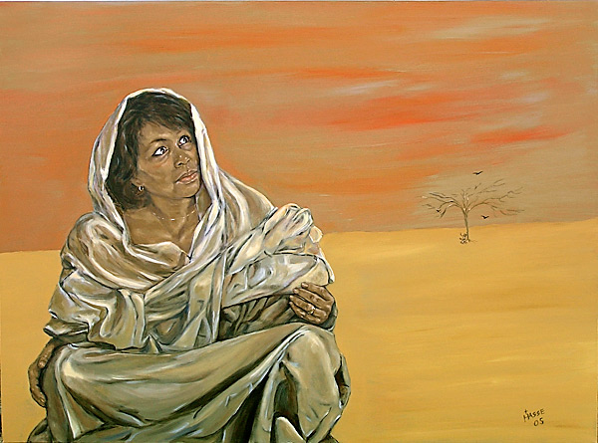

18 Open thou mine eyes, that I may behold wondrous things out of thy law.
(Psalms 119:18)

It is possible to have perfect eyesight but, at the same time to be blind to the most pressing matters around us. There is one kind of blindness that is physical, but another more tragic blindness of the soul. Today’s hymn devotion touches on that soul-blindness, and its cure.

Hagar was a servant girl who had experienced much hardship and abuse from her owner Sarah. As a result of Sarah’s and Abraham’s sin of trying to satisfy the promises of God by their own hands (Gen 21), Hagar found herself driven out of house and home and into the Wilderness of Beersheba with only the provision of a morsel of bread and a bottle of water. In the midst of the wilderness, Hagar found herself stranded there with the water expended and no hope of survival for herself or her son, Ishmael. She placed the son under a shrub and went the distance of a bow-shot away so that she would not see the death of her beloved son. The agony of a mother’s heart under such circumstances must have been unimaginable! The scripture says of Hagar that she said, Let me not see the death of the child. And she sat over against him, and lift up her voice, and wept. (Gen 21:16-17) This feature of the Asian in grief and mourning is called ‘wailing’ and it is still common in the Middle East. The grief-stricken mother of a dead child will often wail and throw dust up over their heads to express a spiritual and emotional pain that cannot be expressed in words. This is the grief of poor Hagar.

Like Mary Magdalene at the Garden Tomb, Hagar’s tears were profuse and constant. There was no water for her son. She cared not for her own want, but only for that of her dear son! Her tears were enough to blind her to the very thing that she needed the most. “And God opened her eyes, and she saw a well of water; and she went, and filled the bottle with water, and gave the lad drink.” (Gen 21:19) The well of water was there all along, but Hagar was blinded by her tears, her fears, and her lack of understanding, so the Lord opened her eyes and she saw the blessed answer to her want. It is a human trait to weep so much that the object of our desires cannot be seen even when the Lord supplies the need.

Open my eyes, that I may see
Words & Music: Clara H. Scott, 1895

Open my eyes, that I may see
Glimpses of truth Thou hast for me;
Place in my hands the wonderful key
That shall unclasp and set me free.
Refrain
Silently now I wait for Thee,
Ready my God, Thy will to see,
Open my eyes, illumine me,
Spirit divine!

Open my ears, that I may hear
Voices of truth Thou sendest clear;
And while the wave notes fall on my ear,
Everything false will disappear.
Refrain

Open my mouth, and let me bear,
Gladly the warm truth everywhere;
Open my heart and let me prepare
Love with Thy children thus to share.
Refrain

Open my eyes, that I may see Glimpses of truth Thou hast for me; Place in my hands the wonderful key That shall unclasp and set me free.

It is sometimes true that God must open our eyes by first opening our ears, just as the Lord did with Mary Magdalene when she did not recognize Him at the Garden Tomb. When He called her name, her eyes, too, were open in addition to her ears. Our spiritual eyes are opened at every leaf and page of the Holy Scriptures as we read verses in which we find new and hidden truths that we have often overlooked. The scriptures hold the key to Eternal Life, and the Key for opening those mysteries is the Holy Ghost. The chains of bondage in which sin has held us fast are broken by the simple beauty of the Gospel of our Lord Jesus Christ.

Refrain
Silently now I wait for Thee, Ready my God, Thy will to see, Open my eyes, illumine me, Spirit divine!

Doubtless, the most difficult part of prayer is not in our expressing our wants and petitions to God, but in the silent solitude in waiting to hear His response. In fact, this part is often omitted entirely as we make our prayers to God as if transmitting a laundry list of our desires. Our DESIRES count for nothing unless they coincide with His. Even eyes that are open are unable to see without the Light of Illumination. That Light of understanding and wisdom comes from the Holy Spirit. Without spiritual light, our hearts cannot find the way in love and faith.

Open my ears, that I may hear Voices of truth Thou sendest clear; And while the wave notes fall on my ear, Everything false will disappear.

Though our eyes are important, they are not the primary means of discovery God. So then faith cometh by hearing, and hearing by the word of God. (Romans 10:17) It is important that our ears are attuned to the voices of Truth and not “another Gospel.” But I fear, lest by any means, as the serpent beguiled Eve through his subtilty, so your minds should be corrupted from the simplicity that is in Christ. For if he that cometh preacheth another Jesus, whom we have not preached, or if ye receive another spirit, which ye have not received, or another gospel, which ye have not accepted, ye might well bear with him. (2 Cor 11:3-4) Bank tellers are very gifted at detecting counterfeit currency, but they acquire that gift by studying and handling the REAL currency, not the counterfeit. The true Federal Reserve Note becomes so very familiar that anything else is immediately exposed to their recognition. If we study diligently and regularly the Word of God, no false preacher or professor can ever deceive us.

Open my mouth, and let me bear, Gladly the warm truth everywhere; Open my heart and let me prepare Love with Thy children thus to share.

It is the eyes and ears that give voice to the mouth. If the Gospel truth has been heard and seen, the mouth is the outlet by which the Fountain of the Heart is proclaimed and shared abroad. “That if thou shalt confess with thy mouth the Lord Jesus, and shalt believe in thine heart that God hath raised him from the dead, thou shalt be saved. 10 For with the heart man believeth unto righteousness; and with the mouth confession is made unto salvation.” (Romans 10:9-10) The heart is the fountain of our beings. If it is full of bitterness and hate, its spring waters will be vile and putrid. If, on the other hand, the heart is filled with Christ and His Love, it will become a Fountain of Living Waters, for the Fountain is not ours, but becomes His own! We share love with our brothers and sisters of this world; how much more the brothers and sisters of our Heavenly Father. I tell the blood relationship between the Children of God is far stronger than that of the carnal blood relationship of this world; for the Blood which binds us together in Christian Love we share with other Christians, and the fealty we bare for the Savior who died for us, is that which lasts beyond the grave – it is His Blood that binds us together with each other and to Him.

I hope that we are all Friends with Him “who sticketh closer than a brother.”

