Hymns of the Church – O God of Love, O King of Peace – 12 November 2019, Anno Domini (In the Year of our Lord)

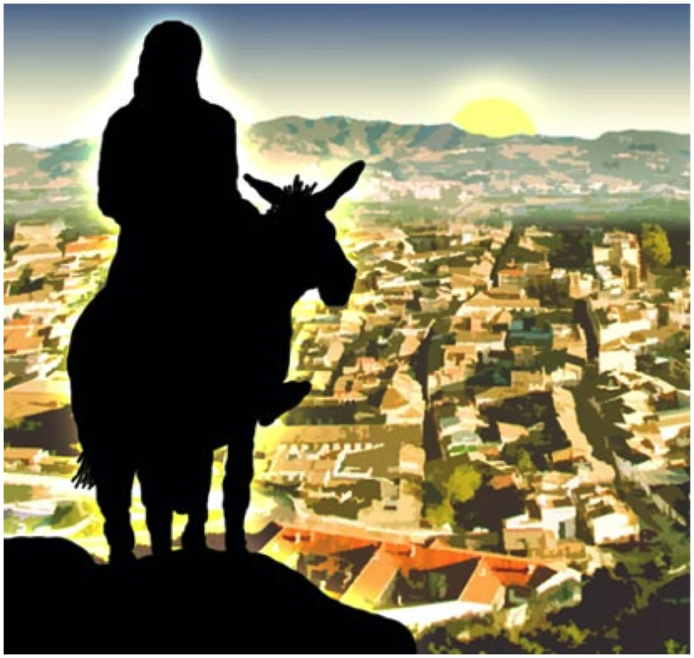

B
ELOVED, let us love one another: for love is of God; and every one that loveth is born of God, and knoweth God. ⁸ He that loveth not knoweth not God; for God is love. ⁹ In this was manifested the love of God toward us, because that God sent his only begotten Son into the world, that we might live through him. ¹⁰ Herein is love, not that we loved God, but that he loved us, and sent his Son to be the propitiation for our sins. ¹¹ Beloved, if God so loved us, we ought also to love one another. ¹² No man hath seen God at any time. If we love one another, God dwelleth in us, and his love is perfected in us. ¹³ Hereby know we that we dwell in him, and he in us, because he hath given us of his Spirit. (1 John 4:7-13)

S
AYING, Go ye into the village over against you; in the which at your entering ye shall find a colt tied, whereon yet never man sat: loose him, and bring him hither. ³¹ And if any man ask you, Why do ye loose him? thus shall ye say unto him, Because the Lord hath need of him. ³² And they that were sent went their way, and found even as he had said unto them. ³³ And as they were loosing the colt, the owners thereof said unto them, Why loose ye the colt? ³⁴ And they said, The Lord hath need of him. ³⁵ And they brought him to Jesus: and they cast their garments upon the colt, and they set Jesus thereon. ³⁶ And as he went, they spread their clothes in the way. ³⁷ And when he was come nigh, even now at the descent of the mount of Olives, the whole multitude of the disciples began to rejoice and praise God with a loud voice for all the mighty works that they had seen; ³⁸ Saying, Blessed be the King that cometh in the name of the Lord: peace in heaven, and glory in the highest. (Luke 19:30-38)

This hymn bears the coincidence of both lyrics and music being the work of Henry Baker – but different unrelated men by that same name. The music is a beautiful work entitled, HESPERUS, composed by young Henry Baker while a student at Exeter College, Oxford, in 1854. The lyrics were written by another Henry W. Baker (1860), made baron in 1851, and well known in circles of hymnody in England. The tone and meaning are reverent and majestic, and it is a hymn-prayer for greater expressions of love for others and a sovereign Peace from the Author of Peace and Love.

O God of Love, O King of Peace
O God of love, O King of peace,
Make wars throughout the world to cease;
Violent acts, O God, restrain;
Give peace, O God, give peace again!

Remember, Lord, your works of old,
The wonders that to us were told;
Remember not our sins' dark stain;
Give peace, O God, give peace again!

Whom shall we trust but you, O Lord?
Where rest but on your faithful word?
None ever called on you in vain;
Give peace, O God, give peace again!

Where saints and angels dwell above,
All hearts are knit in holy love;
O bind us in that heav'nly chain;
Give peace, O God, give peace again

1 O God of love, O King of peace, Make wars throughout the world to cease; Violent acts, O God, restrain; Give peace, O God, give peace again! From the Fall of our ancient parents until now, war and its causes have evaded resolution by nations of the earth. War, in fact, began at Eden with the murder of righteous Abel. War is an extension of arguments that are not subject to settlement by negotiation. As Karl von Clauswitz has written, War is the extension of diplomacy by other means. At the heart of every war is greed generated by false pride and envy. All participants are not necessarily motivated by these sins of aggression, but at least one side will be. National defense is an undertaking granted by God. Just as it is imperative that one must defend his home from invasion and mayhem, so do nations have that responsibility to defend her borders and her citizens. The only solution that would eliminate wars is the only solution that the world will not receive – faith in Almighty God. If every nation adhered to the Summary of the Law given by our Lord, wars would fade from our collective memories: Jesus said unto him, Thou shalt love the Lord thy God with all thy heart, and with all thy soul, and with all thy mind. This is the first and great commandment. And the second is like unto it, Thou shalt love thy neighbour as thyself. On these two commandments hang all the law and the prophets. (Matthew 22:37-40)

2 Remember, Lord, your works of old, The wonders that to us were told; Remember not our sins' dark stain; Give peace, O God, give peace again! God reiterates, more than once, the importance of remembrance. Since learning is enhanced by repetition, God’s Word employs repetition to foster remembrance. In our youth, most of us have heard often the Gospel lessons taught at church, home, and perhaps even in social circles; however, as we grow older in stature – and pride – we tend to forget many of those Gospel principles which cry from the dust of the earth from our forefathers. Remember now thy Creator in the days of thy youth, while the evil days come not, nor the years draw nigh, when thou shalt say, I have no pleasure in them; While the sun, or the light, or the moon, or the stars, be not darkened, nor the clouds return after the rain: Ecclesiastes 12:1-2 (KJV) There is a subtle difference between forgetfulness and failing to remember. Forgetfulness is often unconsciously effected by a lack of care or focus. Remembrance, or not remembering, is most often intentional. We must strive to REMEMBER the important points in life including the Gospel.

3 Whom shall we trust but you, O Lord? Where rest but on your faithful word? None ever called on you in vain; Give peace, O God, give peace again! We must not place our trust in men – in princess, in kings, in magistrates, or even in ministers. All things, even from trusted ministers, must be confirmed by a resort to the Word of God, especially during this apostate generation. It is better to trust in the LORD than to put confidence in man. It is better to trust in the LORD than to put confidence in princes. (Psalm 118:8-9) Then Peter and the other apostles answered and said, We ought to obey God rather than men. (Acts 5:29) We can place full trust in the Lord, and the peace of God will always accompany that trust regardless the external circumstances in our lives. Christ is our REST (Sabbath) in the same sense He is our PASSOVER. Come unto me, all ye that labour and are heavy laden, and I will give you rest. Take my yoke upon you, and learn of me; for I am meek and lowly in heart: and ye shall find rest unto your souls. For my yoke is easy, and my burden is light. The only prayer God does not hear is that uttered from a heart filled with iniquity. If I regard iniquity in my heart, the Lord will not hear me: (Psalm 66:18)

4 Where saints and angels dwell above, All hearts are knit in holy love; O bind us in that heav'nly chain; Give peace, O God, give peace again. Regardless the number of links in a chain, it is still one chain. Each link is part of that oneness. If we are One with Christ, and He One with the Father, there is Oneness with God all around and particularly among the people of His Church. There has not been, nor will ever be, war in Heaven since that Old Deceiver was cast down with his angels. Love is the union that glues the saints and angels into Oneness with God the Father, God the Son, and God the Holy Ghost – and with each other. The last link in a chain is just as important as the first since it must hold the same weight and stress. If the last link breaks, the whole chain fails its purpose. If you wonder why there is so much division in churches today, consider the fact that the Word is not exalted above all else. If brothers and sisters in Christ allowed themselves to be united in the Truth and Love of the Gospel, there could be no argument about color of carpets or budgetary expenditures. When all are One in Christ, all will be One with each other.

