Hymns of the Church – My Savior First of All – 28 January 2020, Anno Domini

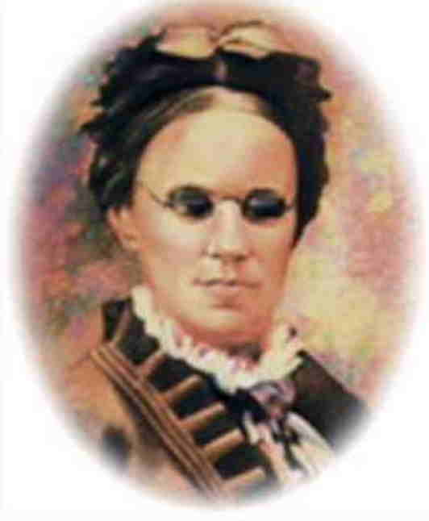

A
ND it came to pass, as he sat at food with them, he took bread, and blessed it, and brake, and gave to them. And their eyes were opened, and they knew him; and he vanished out of their sight. (Luke 24:30-31)

B
EHOLD my hands and my feet, that it is I myself: handle me, and see; for a spirit (o. pneuma) has not flesh and bones, as all of you see me have. And when he had thus spoken, he showed them his hands and his feet. (Luke 24:39-40)

Here is another hymn by the greatest of all American hymnists, Fanny Crosby. In spite of my well-stocked library of hymnary, I could find no references to this beautiful hymn. As in all of her hymns, Mrs. Crosby adds the strength of her own testimony in the lyrics. Blind from infancy, Fanny learned to see the unseen and hear the unspoken things of God. Her vision of God was enhanced by her blindness to man and the world about her. Fanny always included in her hymns a description of her personal submission and exaltation of the Lord and His Holy Word. A line from one of her favorite poems reads:

I think that life is not too long and therefore I determine,
That many will read a song who will not read a sermon.

In keeping with that proposition, each of Fanny’s hymns are sermons touched by the beautiful colors of God’s rainbow. This hymn was written in 1894.

My Savior First of All

When my life work is ended, and I cross the swelling tide,
When the bright and glorious morning I shall see;
I shall know my Redeemer when I reach the other side,
And His smile will be the first to welcome me.
Refrain
I shall know Him, I shall know Him,
And redeemed by His side I shall stand,
I shall know Him, I shall know Him,
By the print of the nails in His hand.

Oh, the soul thrilling rapture when I view His blessèd face,
And the luster of His kindly beaming eye;
How my full heart will praise Him for the mercy, love and grace,
That prepare for me a mansion in the sky.
Refrain

Oh, the dear ones in glory, how they beckon me to come,
And our parting at the river I recall;
To the sweet vales of Eden they will sing my welcome home;
But I long to meet my Savior first of all.
Refrain

Through the gates to the city in a robe of spotless white,
He will lead me where no tears will ever fall;
In the glad song of ages I shall mingle with delight;
But I long to meet my Savior first of all.
Refrain

My Savior First of All
The title of this hymn is worth noting. As every educator will admit, repetition aids recall. This is a salient principle of learning. The Master Educator – the Word of God – frequently employs this principle. 9 Whom shall he teach knowledge? and whom shall he make to understand doctrine? them that are weaned from the milk, and drawn from the breasts. 10 For precept must be upon precept, precept upon precept; line upon line, line upon line; here a little, and there a little: 11 For with stammering lips and another tongue will he speak to this people. 12 To whom he said, This is the rest wherewith ye may cause the weary to rest; and this is the refreshing: yet they would not hear. 13 But the word of the LORD was unto them precept upon precept, precept upon precept; line upon line, line upon line; here a little, and there a little; that they might go, and fall backward, and be broken, and snared, and taken. I(Isaiah 28:9-13) And so the repetition of I Shall Know Him. It is something that was peculiarly characteristic of Fanny Crosby. She did KNOW Him!

When my life work is ended, and I cross the swelling tide, When the bright and glorious morning I shall see; I shall know my Redeemer when I reach the other side, And His smile will be the first to welcome me. It is astonishing to my mind that Fanny could SEE the coming GLORY better than anyone I know though she was, in this life, blind. She has phenomenal spiritual vision, but do not fail to consider her unusual ability to hear and listen. When . . . . I cross the swelling tide. Fanny had never witnessed the rolling of the tides of the sea, yet she could see them clearly in her hearing the tide swell and break on the New England coast as she meditated there – and she considered all to be the very Voice of God in nature. When a child, my parents used to make outings to the mountain streams of North Georgia and Tennessee. In those days, these streams were not frequented by the crowds of tourist of today. As you walked along those streams, you would know that you were approaching the white water rapids downstream by the crashing sounds of the cascading waters. That is what Fanny heard in the swelling tides ere they broke upon the rocks. She sees, with her mind’s eye, the bright and glorious morning when her eyes will behold her Redeemer without any impediment of vision. It is that face that Fanny repeatedly longed to see in her letters and talks with others. That face of Christ will be a smiling and welcoming face to such as Fanny who could never have seen a smiling and welcoming face before.

Refrain
I shall know Him, I shall know Him, And redeemed by His side I shall stand, I shall know Him, I shall know Him, By the print of the nails in His hand. Yes, Fanny shall know Him by more ways than one. She will know Him on sight for His grace and mercy; and she will know Him by the print of the nails in His hand. Perhaps the formerly blind Fanny will know Him better than anyone else on that glorious resurrection morning. At that moment, the most deeply felt yearnings of poor, blind Fanny Crosby will be realized.

Oh, the soul thrilling rapture when I view His blessèd face, And the luster of His kindly beaming eye; How my full heart will praise Him for the mercy, love and grace, That prepare for me a mansion in the sky. It is obvious from this line that Fanny has given much thought to the appearing Savior. An elderly Fanny Crosby died in 1915 blind and waning; but her resurrected and glorified body will see the blessed face of her Lord. She will see the love beams of kindness glistening from His eyes of mercy and grace. The praise of God for which Fanny lived and wrote will not be diminished, but rather increased a hundred-fold, at the sight of her Lord. His Mercy, Love, and Grace were the Anchor and Cable that drew her to that union with Christ, and was the oil that burned in her heart in praise that is now even more abundant. Even a godly Fanny Crosby needed preparation to be able to receive such a glorious mansion as the Lord has prepared for her and all who believe.

Oh, the dear ones in glory, how they beckon me to come, And our parting at the river I recall; To the sweet vales of Eden they will sing my welcome home; But I long to meet my Savior first of all. Remember our long past separation from mothers, fathers, brothers, sisters, and other loved ones by the Banks of Jordan Waters? We may have cried aloud, or shed silent, warm tears at the parting. It would seem an interminable time before our reunion on the far shores of the Jordan. But now, as our curtain descends, and we close our eyes on that precious gift of life on earth that was the grant of Heaven, there awaits the most wonderful of glorious events. We shall see our loved ones again beyond Jordan’s stormy banks; but the One that makes all of that possible will be the more glorious face to behold – our Lord and Savior.

Through the gates to the city in a robe of spotless white, He will lead me where no tears will ever fall; In the glad song of ages I shall mingle with delight; But I long to meet my Savior first of all. Those Gates of Splendor are never closed to the elect of God. They swing wide open in welcome to those who have lived for Christ. There is a Banquet planned which will require a proper attire – the White Robe of Righteousness purchased by the life-blood of our dear Savior. 1 And I saw a new heaven and a new earth: for the first heaven and the first earth were passed away; and there was no more sea. 2 And I John saw the holy city, new Jerusalem, coming down from God out of heaven, prepared as a bride adorned for her husband. 3 And I heard a great voice out of heaven saying, Behold, the tabernacle of God is with men, and he will dwell with them, and they shall be his people, and God himself shall be with them, and be their God. 4 And God shall wipe away all tears from their eyes; and there shall be no more death, neither sorrow, nor crying, neither shall there be any more pain: for the former things are passed away. (Rev 21:1-4) Nonetheless, Fanny long’s to meet her Savior first of all as must we all who are bound for that City in the Sky.

