Hymns of the Church – My God, Now I from Sleep Awake – 16 June 2020, Anno Domini

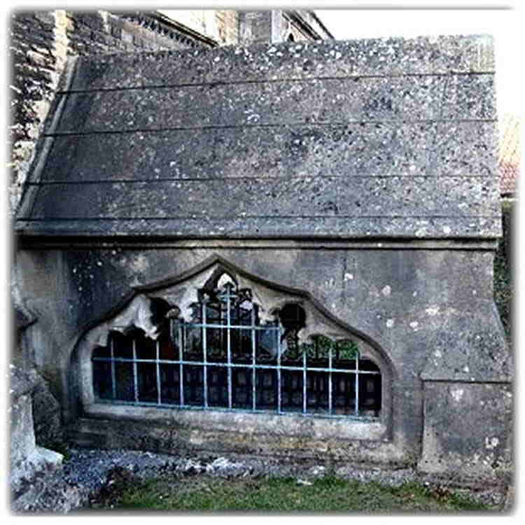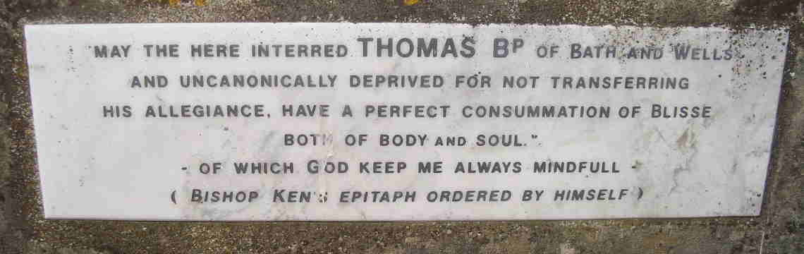

A
N evil and adulterous generation seeketh after a sign; and there shall no sign be given to it, but the sign of the prophet Jonas: For as Jonas was three days and three nights in the whale’s belly; so shall the Son of man be three days and three nights in the heart of the earth. The men of Nineveh shall rise in judgment with this generation, and shall condemn it: because they repented at the preaching of Jonas; and, behold, a greater than Jonas is here. (Matthew 12:39-41)

Today’s hymn devotion is more about the author than about the specific hymns he wrote. Bishop Thomas Ken was the most prominent of the seven non-juror bishops having fallen out with King James II over his ‘Declaration of Indulgence’ which Bishop Ken felt gave too much episcopal recognition to Roman Catholicism for which he harbored a strong aversion. He also believed publishing such an edict would compromise the spiritual freedom of the Church. For this refusal, he was committed to the Tower pending trial, but later acquitted. Feeling that taking an oath of allegiance to William of Orange subsequent to his taking the same oath to King James II, Bishop Ken felt that was a compromise of principle. As a result, he was superseded in his office by Richard Kidder, Dean of Peterborough. He lived out the remainder of his life in a devotional retirement.

One of the reasons I believe Bishop Thomas Ken merits some special recognition is due to his unswerving faith in the Church of the English Reformation. Another is his rejection of anything Romish. Moreover, Bishop Thomas Ken is considered one of the fathers of English church hymnody. Much of his hymnal contributions are centered on morning and evening prayer. In 1685, he published his Exposition on the Church Catechism, perhaps better known by its sub-title, The Practice of Divine Love.

Ken died in retirement in 1711 at Longleat in Wiltshire. Not possessing any active title, he requested to be buried beneath the eastern window of the Church of St. John’s at Frome. "I am dying," Ken had written, "in the Holy, Catholic and Apostolic Faith professed by the whole Church before the disunion of East and West; and, more particularly, in the Communion of the Church of England, as it stands distinguished from both Papal and Protestant innovation, and adheres to the Doctrine of the Cross." The dawn following his death, his friends gathered to sing, “Awake my soul, and with the Sun,” as Bishop Thomas Ken was laid to rest there under that east window.

The subject hymn today is taken from Ken’s Midnight Hymn of worship. It is a wonderful description of Ken’s view of coming glory in Christ:

My God, Now I From Sleep Awake

My God, now I from sleep awake.
The sole possession of me take ;
From midnight terrors me secure,
And guard my heart from thoughts impure.

Bless'd angels, while we silent lie,
Your Hallelujahs sing on high,
Your joyful hymn the ever-blessed,
Before the throne, and never rest.

My God, now I from sleep awake. The sole possession of me take; From midnight terrors me secure, And guard my heart from thoughts impure. Ken requested burial under the east window of the Church of St. John because he desired to have an immediate and unobstructed view of the eastern sky at our Lord’s return. Standing upon the infirm soil of an open grave, he desired to waste not a minute before being drawn by the Great Heavenly Magnet of the Lord skyward to join Him. When we awake from death, we, like Ken, have only ourselves (our borrowed souls) for which we pray our Lord to take possession. Otherwise that soul is doomed to wonder in outer darkness for Eternity future. But the Lord knows His own, and not a hair of the head of His beloved will be lost in time or eternity. The midnight terrors are the terrors of death which occur at the physical midnight of life. The Lord is able to safeguard our hearts from impure thoughts when those hearts have been surrendered to Him.

Bless'd angels, while we silent lie, Your Hallelujahs sing on high, Your joyful hymn the ever-blessed, Before the throne, and never rest. If there is joy in Heaven over the salvation of a single soul, imagine the joy at the death of a saint. The anthem swirls ceaselessly about the Throne of God. The time element is as the twinkling of an eye from sunset to sunrise!

Conclusion
There is no memorial marker to designate the tomb of Christ. Why is that so? It is because Christ actually had no tomb. He was laid in a borrowed tomb just as every saint since has been laid (including our friend and brother, Lazarus the Beggar) in a borrowed tomb. Christ needs no memorial statue or marker to commemorate His life. There is a far greater memorial of our Lord Jesus Christ that abides in the hearts of His elect people. He, unlike the men and women memorialized on monuments and statues, is alive. In the leading text, our Lord said: An evil and adulterous generation seeketh after a sign; and there shall no sign be given to it, but the sign of the prophet Jonas: For as Jonas was three days and three nights in the whale’s belly; so shall the Son of man be three days and three nights in the heart of the earth. The men of Nineveh shall rise in judgment with this generation, and shall condemn it: because they repented at the preaching of Jonas; and, behold, a greater than Jonas is here. We need no statue to remember Christ. It is enough to know that He was dead and buried for three days and three nights, and He rose from the tomb on the third day. Dead men have memorials, but not the LIVING!.

Good Bishop Thomas Ken had a modest burial with little pomp and circumstance other than the simple singing of one of his favorite hymns save the simple words committed to his epitaph (words very similar to those of Thomas Gray’s Elegy in a Country Churchyard):

To him is raised no marble tomb,
Within the dim cathedral fane,
But some faint flowers of summer bloom,
And silent falls the winter's rain.

No village monumental stone
Records a verse, a date, a name.
What boots it? When thy task is done,
Christian, how vain the sound of fame.

Oh, far more grateful to thy God,
The voices of poor children rise,
Who hasten o'er the dewy sod
To pay their morning sacrifice.

