Hymns of the Church – Marvelous Grace of our loving Lord – 26 February 2019, Anno Domini (In the Year of our Lord)

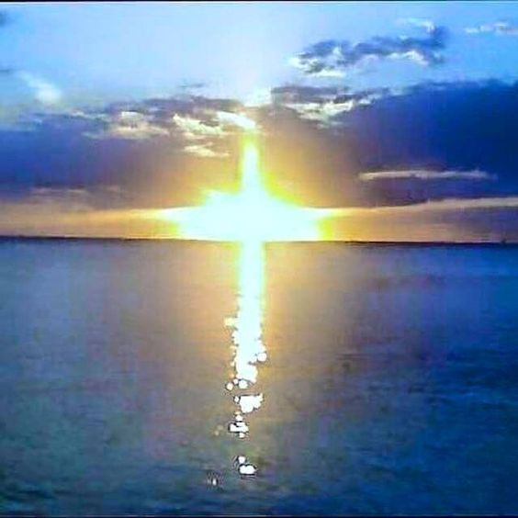

B
EING justified freely by his grace through the redemption that is in Christ Jesus: 25 Whom God hath set forth to be a propitiation through faith in his blood, to declare his righteousness for the remission of sins that are past, through the forbearance of God; 26 To declare, I say, at this time his righteousness: that he might be just, and the justifier of him which believeth in Jesus. (Romans 3:24-26)

A
ND not as it was by one that sinned, so is the gift: for the judgment was by one to condemnation, but the free gift is of many offences unto justification. 17 For if by one man's offence death reigned by one; much more they which receive abundance of grace and of the gift of righteousness shall reign in life by one, Jesus Christ. (Romans 5:16-17)

This is a hymn intended to teach us to believe the greater weight of grace in God’s economy over the terror of our sins which, unforgiven, would lead to our damnation. The author, Julia H. Johnston, wrote this hymn in 1911. Though she authored over 500 hymns, this is the one that has been included in most major hymnals. Mrs. Johnston taught Sunday School at her church (Presbyterian) for more than forty years and died in 1919. The soothing tune is MOODY composed by Daniel B. Towner in 1911 and who also died in the same year as the author, Johnston, in 1919.

Marvelous Grace of our loving Lord

Marvelous grace of our loving Lord,
grace that exceeds our sin and our guilt!
Yonder on Calvary's mount outpoured,
there where the blood of the Lamb was spilt.
Refrain:
Grace, grace, God's grace,
grace that will pardon and cleanse within;
grace, grace, God's grace,
grace that is greater than all our sin!

Sin and despair, like the sea waves cold,
threaten the soul with infinite loss;
grace that is greater, yes, grace untold,
points to the refuge, the mighty cross.
(Refrain)

Dark is the stain that we cannot hide.
What can avail to wash it away?
Look! There is flowing a crimson tide,
brighter than snow you may be today.
(Refrain)

Marvelous, infinite, matchless grace,
freely bestowed on all who believe!
You that are longing to see his face,
will you this moment his grace receive?
(Refrain)

Marvelous grace of our loving Lord, grace that exceeds our sin and our guilt! Yonder on Calvary's mount outpoured, there where the blood of the Lamb was spilt. Perhaps the greatest doubt of the recently confirmed Christian is to question how God’s grace could be of such magnitude as to cover his profusion of sins; but it IS! It is of such magnitude as to be marvelous in our eyes. WE scarcely can comprehend that God chose us for the greatest of all elections in His Son, our Lord Jesus Christ; and it was ALL of grace and of no merit on our part. But ye are a chosen generation, a royal priesthood, an holy nation, a peculiar people; that ye should shew forth the praises of him who hath called you out of darkness into his marvellous light. (1 Peter 2:9) WE are CHOSEN in Christ! That overpowering Grace was freely granted to us but came at the most precious cost to the Father in sending His Son to die as a propitiation for our sins.

Sin and despair, like the sea waves cold, threaten the soul with infinite loss; grace that is greater, yes, grace untold, points to the refuge, the mighty cross. There is no cessation of the waves of the restless sea. That infinite depth and mass of waters is much like our sins – they are overwhelming and not capable of being remitted by our best efforts and intentions. The cross stands erect at infinite reach above the waves – in fact, all the way to the Gates of Splendor. Why is the cross of such critical importance? Because the sin-sick petitioner can look to the cross for the only cure for his deadly disease. 13 And no man hath ascended up to heaven, but he that came down from heaven, even the Son of man which is in heaven. 14 And as Moses lifted up the serpent in the wilderness, even so must the Son of man be lifted up: 15 That whosoever believeth in him should not perish, but have eternal life. (John 3:13-15) Note that none have ascended up to heaven but the One (our Lord) who came DOWN. So, forget your money-grubbing fables about someone dying, going to heaven, and coming back.

When the Children of Israel were grumbling and disobedient in the Wilderness, God sent fiery snakes among them. These were deadly (and still are in the sandy soils of the desert). But God provided a means of survival for the Children when they sought relief. He commanded Moses to affix a brazen serpent to a pole and raise it in the midst of the camp of the Israelites. Whenever one was bitten by the fiery snake, he need only look to the brazen serpent on the pole. Christ became our brazen serpent to heal us of the deadly disease of sin when we look to His redeeming sacrifice.

Dark is the stain that we cannot hide. What can avail to wash it away? Look! There is flowing a crimson tide, brighter than snow you may be today. Sin, like leprosy, may be hidden for a time; however, it is insidious in its growth and effect. Just as with leprosy, there comes a time when the foul odor and ugliness of sin is abundantly clear to all who chance to meet us. It is a stain on our garments that grows with the stench of the pig sty. Like the Prodigal Son, our Lord has purchased for us a pure White Robe to cover our sins. We are accounted justified in complete sum. Purge me with hyssop, and I shall be clean: wash me, and I shall be whiter than snow. (Psalm 51:7) Hyssop is a purgative that first cleanses the inside of the body. Washing will follow of the outside. Whiter than snow? How so? Because every snow flake has a speck of impurity around which its crystals coalesced in the upper atmosphere. But we will not have a single speck of unrighteousness attributed to the Elect – thus, we are whiter than snow.

Marvelous, infinite, matchless grace, freely bestowed on all who believe! You that are longing to see his face, will you this moment his grace receive? As the shepherd knows his sheep by name, so does the Lord know those whom He has chosen to be recipients of grace. What must one do to earn that grace? NOTHING! Grace is freely given, and freely received. 14 Nevertheless death reigned from Adam to Moses, even over them that had not sinned after the similitude of Adam's transgression, who is the figure of him that was to come. 15 But not as the offence, so also is the free gift. For if through the offence of one many be dead, much more the grace of God, and the gift by grace, which is by one man, Jesus Christ, hath abounded unto many. 16 And not as it was by one that sinned, so is the gift: for the judgment was by one to condemnation, but the free gift is of many offences unto justification. (Romans 5:14-16)

REFRAIN: Grace, grace, God's grace, grace that will pardon and cleanse within; grace, grace, God's grace, grace that is greater than all our sin! The refrain summarizes the entire hymn. Grace out-measures our sins so far that the reckoning cannot be made. The ocean seems boundless and infinite to our mortal souls. If the oceans represented our sins, look to the heavens which are greater by far in extent than our seas. The good old hymn, THE LOVE OF GOD says it all: The love of God is greater far Than tongue or pen can ever tell, It goes beyond the highest star, And reaches to the lowest hell - The guilty pair, bowed down with care, God gave His Son to win, His erring child He reconciled, And pardoned from his sin. Could we with ink the ocean fill, And were the skies of parchment made - Were every stalk on earth a quill, And every man a scribe by trade, To write the love of God above, Would drain the ocean dry, Nor could the scroll contain the whole, Though stretched from sky to sky.

