Hymns of the Church – Love Lifted Me – 21 August 2018, Anno Domini

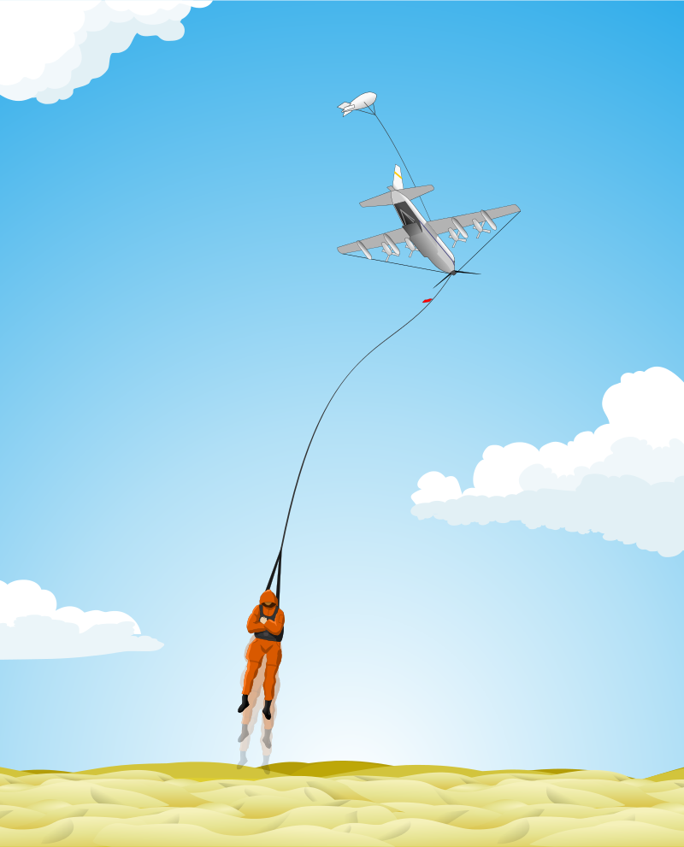

M
y hands also will I lift up unto thy commandments, which I have loved; and I will meditate in thy statutes. (Psalm 119:48)

A
s the Father hath loved me, so have I loved you: continue ye in my love. 10 If ye keep my commandments, ye shall abide in my love; even as I have kept my Father's commandments, and abide in his love. 11 These things have I spoken unto you, that my joy might remain in you, and that your joy might be full. 12 This is my commandment, That ye love one another, as I have loved you. 13 Greater love hath no man than this, that a man lay down his life for his friends. 14 Ye are my friends, if ye do whatsoever I command you. 15 Henceforth I call you not servants; for the servant knoweth not what his lord doeth: but I have called you friends; for all things that I have heard of my Father I have made known unto you. 16 Ye have not chosen me, but I have chosen you, and ordained you, that ye should go and bring forth fruit, and that your fruit should remain: that whatsoever ye shall ask of the Father in my name, he may give it you. 17 These things I command you, that ye love one another. (John 15:9-17)

This is a song that my mother sang almost daily while going about her household chores, or while doing her works of love in her flower and vegetable gardens. As a toddler, I could scarce catch the depth of meaning, but over the years, the lyrics have lingered in my heart and I have come to understand and appreciate its word with greater love and insight than I did at first.

The lyrics are the product of James Rowe in 1912, an Englishman who immigrated to New York in 1880. He dictated the lyrics as another fellow, Howard E. Smith, picked out the notes for the song on his piano. Mr. Smith had such crippling arthritis that many wondered how he could play a piano at all; but the two men finished this great old hymn in one sitting.

Love Lifted Me

I was sinking deep in sin, far from the peaceful shore,
Very deeply stained within, sinking to rise no more;
But the Master of the sea heard my despairing cry,
From the waters lifted me, now safe am I.
Refrain:
Love lifted me! Love lifted me!
When nothing else could help,
Love lifted me.
Love lifted me! Love lifted me!
When nothing else could help,
Love lifted me.

All my heart to Him I give, ever to Him I'll cling,
In his blessed presence live, ever his praises sing.
Love so mighty and so true merits my soul's best songs;
Faithful loving service, too, to Him belongs.
Refrain

Souls in danger, look above, Jesus completely saves;
He will lift you by His love out of the angry waves;
He's the master of the sea, billows His will obey;
He your Savior wants to be, be saved today.
Refrain

“I was sinking deep in sin, far from the peaceful shore, Very deeply stained within, sinking to rise no more; But the Master of the sea heard my despairing cry, From the waters lifted me, now safe am I.” Sin weighs our souls down in an ocean of guilt. Faith in Christ is the Life Preserver that lifts us from the angry sea and plants our feet on solid ground. Even the lack of faith will bear us to the depths of the sea as it did Peter when the Lord bade him to walk on the sea. With his eyes stayed upon Christ, Peter walked upon the Deep; but when he took his eyes off the Lord and focused on the turbid waters of the sea, he sank. He offered only a simple and short prayer: “Lord, Save ME!” In this life of trials and temptations, we often succumb to the doubts and questions of faith; but when we get concentrated once more on the Lord of our Salvation, we are made whole. The Lord will hear a despairing cry much sooner than one uttered out of security and comfort. He is not only the Master of the Sea, but the King of Love as well.

“All my heart to Him I give, ever to Him I'll cling, In his blessed presence live, ever his praises sing. Love so mighty and so true merits my soul's best songs; Faithful loving service, too, to Him belongs.” There is only one thing we can give the Lord, and that thing is our hearts. He owns the world and needs no material sacrifice. But love is a gift of eternal value. In fact, LOVE is the only possession our souls can bear with us beyond the grave. God’s great magnet of love will recognize the like properties of the metal of the Christian heart to lift them up when death claims the mortal body. “37 Nay, in all these things we are more than conquerors through him that loved us. 38 For I am persuaded, that neither death, nor life, nor angels, nor principalities, nor powers, nor things present, nor things to come, 39 Nor height, nor depth, nor any other creature, shall be able to separate us from the love of God, which is in Christ Jesus our Lord.” Romans 8:37-39 All of our faithful service and works of charity are not hours, but His alone working in and through us.

“Souls in danger, look above, Jesus completely saves; He will lift you by His love out of the angry waves; He's the master of the sea, billows His will obey; He your Savior wants to be, be saved today.” Peter could not have saved himself when he sank in the Sea of Galilee. He found that he must call upon the Master of the Sea. Just hoping to be saved will not save either. We must possess that kindred metal of the Magnet which it is able to draw. He is not only the Master of the Seas, but of the mountain heights, the valley deeps, and all the heaven above. He saves in ways that we may never have before comprehended, but His manner of Salvation is always the very perfection of salvation.

Refrain:
“Love lifted me! Love lifted me! When nothing else could help, Love lifted me. Love lifted me! Love lifted me! When nothing else could help, Love lifted me.” God has placed His seal IN the foreheads of all who belong to Him. We could not place it there on our own volition. It was a primitive act of God.“Now he which stablisheth us with you in Christ, and hath anointed us, is God; Who hath also sealed us, and given the earnest of the Spirit in our hearts.” (2 Cor 1:21-22) What seal can be placed IN the foreheads of His people that neither beast nor tyrant can remove? Is it not an undying love for Him who made us? “Hurt not the earth, neither the sea, nor the trees, till we have sealed the servants of our God in their foreheads.” (Rev 7:3) Many of the modern corrupted versions of the Bible mistranslate this passage grievously.

The NIV and ESV deceptively translate this same passage in this manner: “Do not harm the land or the sea or the trees until we put a seal on the foreheads of the servants of our God." Rev 7:3 (NIV, ESV) This is a wicked effort to mislead the believer, and many have been deceived thereby. We see books written about the Mark of the Beast being placed on the forehead, often forcibly, by a one-world government anti-Christ. But if a mark is involuntarily placed, by force, on your forehead, how could you be guilty of following the anti-Christ. The Mark, like the Seal, is IN the forehead. That is the part of the brain (frontal lobe) where our seats of judgment are fixed. The LOVE we have for our Lord is our Seal which God has placed in our foreheads.. And our inclinations in following the Dark Prince of this World are the Mark of the Beast IN our foreheads.

No need to worry about UPC codes on our foreheads, or the number 666 stamped there. Concern yourselves more with the treasures of the heart and the mind.

