Hymns of the Church – Lord, I’m Coming Home – 24 September 2019, Anno Domini (In the Year of our Lord)

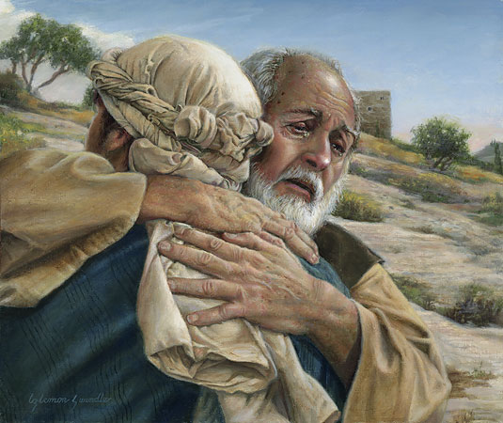

A
ND he said, A certain man had two sons: ¹² And the younger of them said to his father, Father, give me the portion of goods that falleth to me. And he divided unto them his living. ¹³ And not many days after the younger son gathered all together, and took his journey into a far country, and there wasted his substance with riotous living. ¹⁴ And when he had spent all, there arose a mighty famine in that land; and he began to be in want. ¹⁵And he went and joined himself to a citizen of that country; and he sent him into his fields to feed swine. ¹⁶ And he would fain have filled his belly with the husks that the swine did eat: and no man gave unto him. ¹⁷ And when he came to himself, he said, How many hired servants of my father's have bread enough and to spare, and I perish with hunger! ¹⁸ I will arise and go to my father, and will say unto him, Father, I have sinned against heaven, and before thee, ¹⁹ And am no more worthy to be called thy son: make me as one of thy hired servants. (Luke 15:11-18)

Though this hymn represents some emotional appeal typical of many modern Gospel songs, it nonetheless has an underlying biblical relevance. It expresses quite clearly the very sentiments of the Prodigal Son who went away from his father into as far country.

The author of this hymn, William J. Kirkpatrick, like Christ, was a carpenter of Duncannon, Pennsylvania. The hymn was published in 1892. The tune, COMING HOME, is also the composition of Mr. Kirkpatrick.

Lord, I’m Coming Home

I've wandered far away from God,
Now I'm coming home;
The paths of sin too long I've trod,
Lord, I'm coming home.

Chorus:
Coming home, coming home,
Nevermore to roam,
Open wide Thine arms of love,
Lord, I'm coming home.

I've wasted many precious years,
Now I'm coming home;
I now repent with bitter tears,
Lord, I'm coming home. [Chorus]

I've tired of sin and straying, Lord,
Now I'm coming home;
I'll trust Thy love, believe Thy word,
Lord, I'm coming home. [Chorus]

My soul is sick, my heart is sore,
Now I'm coming home;
My strength renew, my hope restore,
Lord, I'm coming home. [Chorus]

1 I've wandered far away from God, Now I'm coming home; The paths of sin too long I've trod, Lord, I'm coming home. Sometimes even the mind of a well taught child of God may drawn away by the glitter of the things of this world, and he wanders into a place far away from God His Father into a far country. The Prodigal did not make a snap decision in leaving the father. He had given this matter much thought and was gradually compelled by a strong self-will, and a weak binding of faith, to take his inheritance early and leave the good, old father who had cared for his every need from birth. I know this can happen, for I, too, was one such son for a time. We all have been to some extent. It is high time to go home, is it not?

2 I've wasted many precious years, Now I'm coming home; I now repent with bitter tears, Lord, I'm coming home. All years spent in sin are years of waste in a certain sense; but they also may be years of hard teaching. We may never learn the horrors of sin unless we are immersed, hand and foot, therein. It may be a means of the Holy Ghost to draw us kicking and screaming to Christ. Like the Prodigal, the day may come that we look upon our sad predicament, nurtured by sinful living, and weep bitter tears. Where did that innocent heart of the boy or girl of our youth get lost? Like the eagle at moating season, we become utterly disgusted, shed our old feathers of sin for the new robe of righteousness offered by our Lord. Then we may renew our strength as in the days of our youth to follow in the Holy teachings of our father and mother.

3 I've tired of sin and straying, Lord, Now I'm coming home; I'll trust Thy love, believe Thy word, Lord, I'm coming home. When we awaken to reality (come to our right minds), we look about at the ruins of our lives whether in a pig sty or a bar room. This is clearly not how we intended our lives to be. It was not what God intended either. In fact, we are incapable of ordering our lives or steps apart from God. He is the great Architect of righteous lives. An aircraft pilot, flying under instrument conditions in which there is no outside reference, must trust the instrument gages on the panel before him or perish. That instrument panel tells us where we are, and how to navigate to where we want to go. The Holy Ghost is our spiritual instrument panel. He tells us where we are, what direction we are headed, and how to get to the place God wants us to be.

4 My soul is sick, my heart is sore, Now I'm coming home; My strength renew, my hope restore, Lord, I'm coming home. The sin-sick soul suffers in the same way as the leper of New Testament. Times. He has an incurable blood disease which is highly contagious. All who closely associate with the sinner are influenced to sin. The disease, like leprosy, is usually insidious causing a slow and painful death. As the important things of our lives fall away, we have little desire to salvage them. We grow ugly – so much so that polite and decent people avoid us. We smell bad with the odor of sinful living. Our souls hurt deeply inside and we may not know what remedy we can claim for relief. But the call of the Holy Spirit has not ceased to sound. To those called and chosen, the alarm grows in intensity until the sinner can resist repentance no longer. In a moment of keen awareness, his eyes are opened to his miserable condition, and he weeps bitter tears of repentance. He resolves to go home to God, to confess his unworthiness, and become a lowly servant in the household of God. He then follows up on his resolution, and arises from the filth of sin, and returns to God his Father where he is warmly received despite the odor of the pig sty.

Chorus
Coming home, coming home, Nevermore to roam, Open wide Thine arms of love, Lord, I'm coming home. Once a sinner has been to the depths of the pits, and awakened to his dire predicament, it is not likely he will return to that mire and vomit of the pit. The lesson was a hard one, but a strong one. The arms of our Lord’s love for His elect never fail of that love. He loves His elect with an eternal love. He waits for us at the Temple Door. He saw when we left, and He sees when we are returning. He did not accompany us in that long journey to a far country, but when He sees us returning, He rushes on the road to meet us, embrace us, cover us with His fine Robe of Righteousness, place His ring of authority on our finger as a Prince or Princess of God, and shoes of Liberty upon our bare and hurting feet.

What a Father and Lord we have.

